Adelaide Show roundup……

Junior Champion Ram: Valma 348-15 Winning pair – Lambplan production class-Trade
Lot 4 – Online auction. Val 87-15 (Lot 6 online auction.) Val 515-15 retained (right)
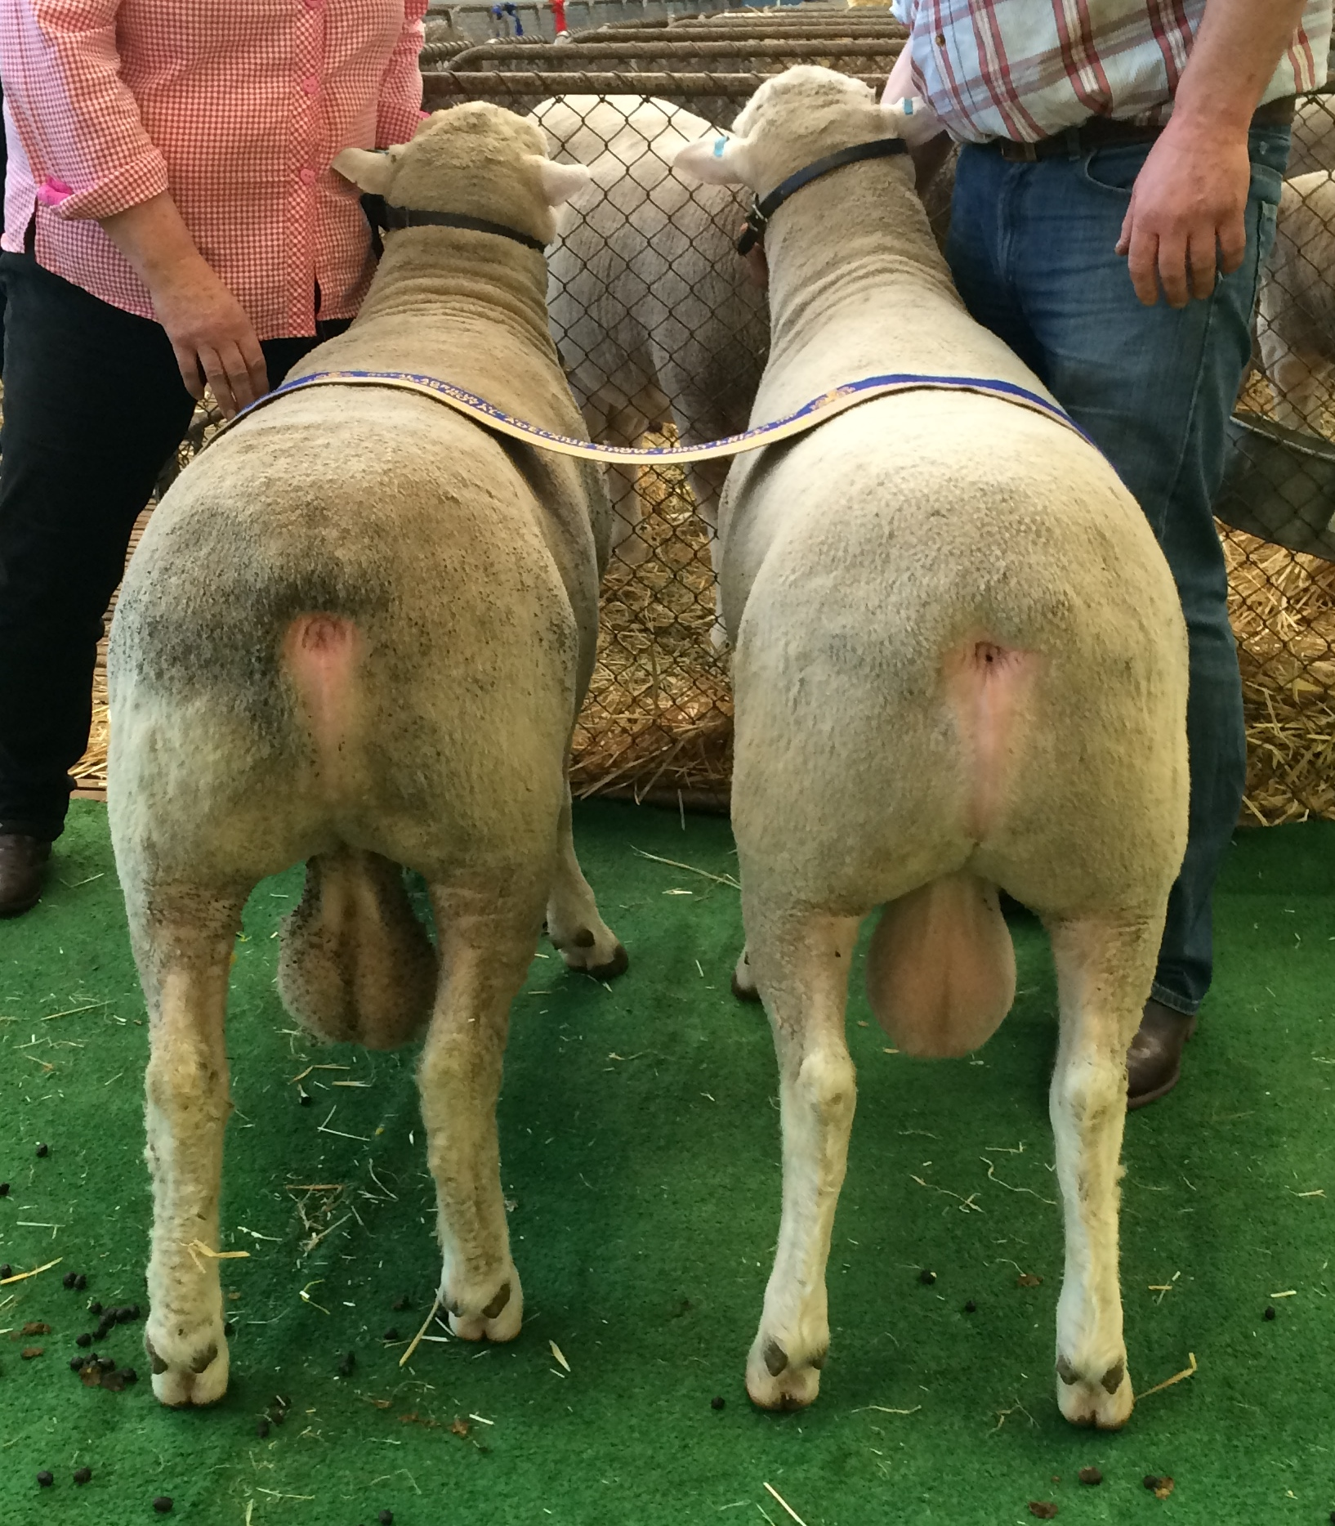
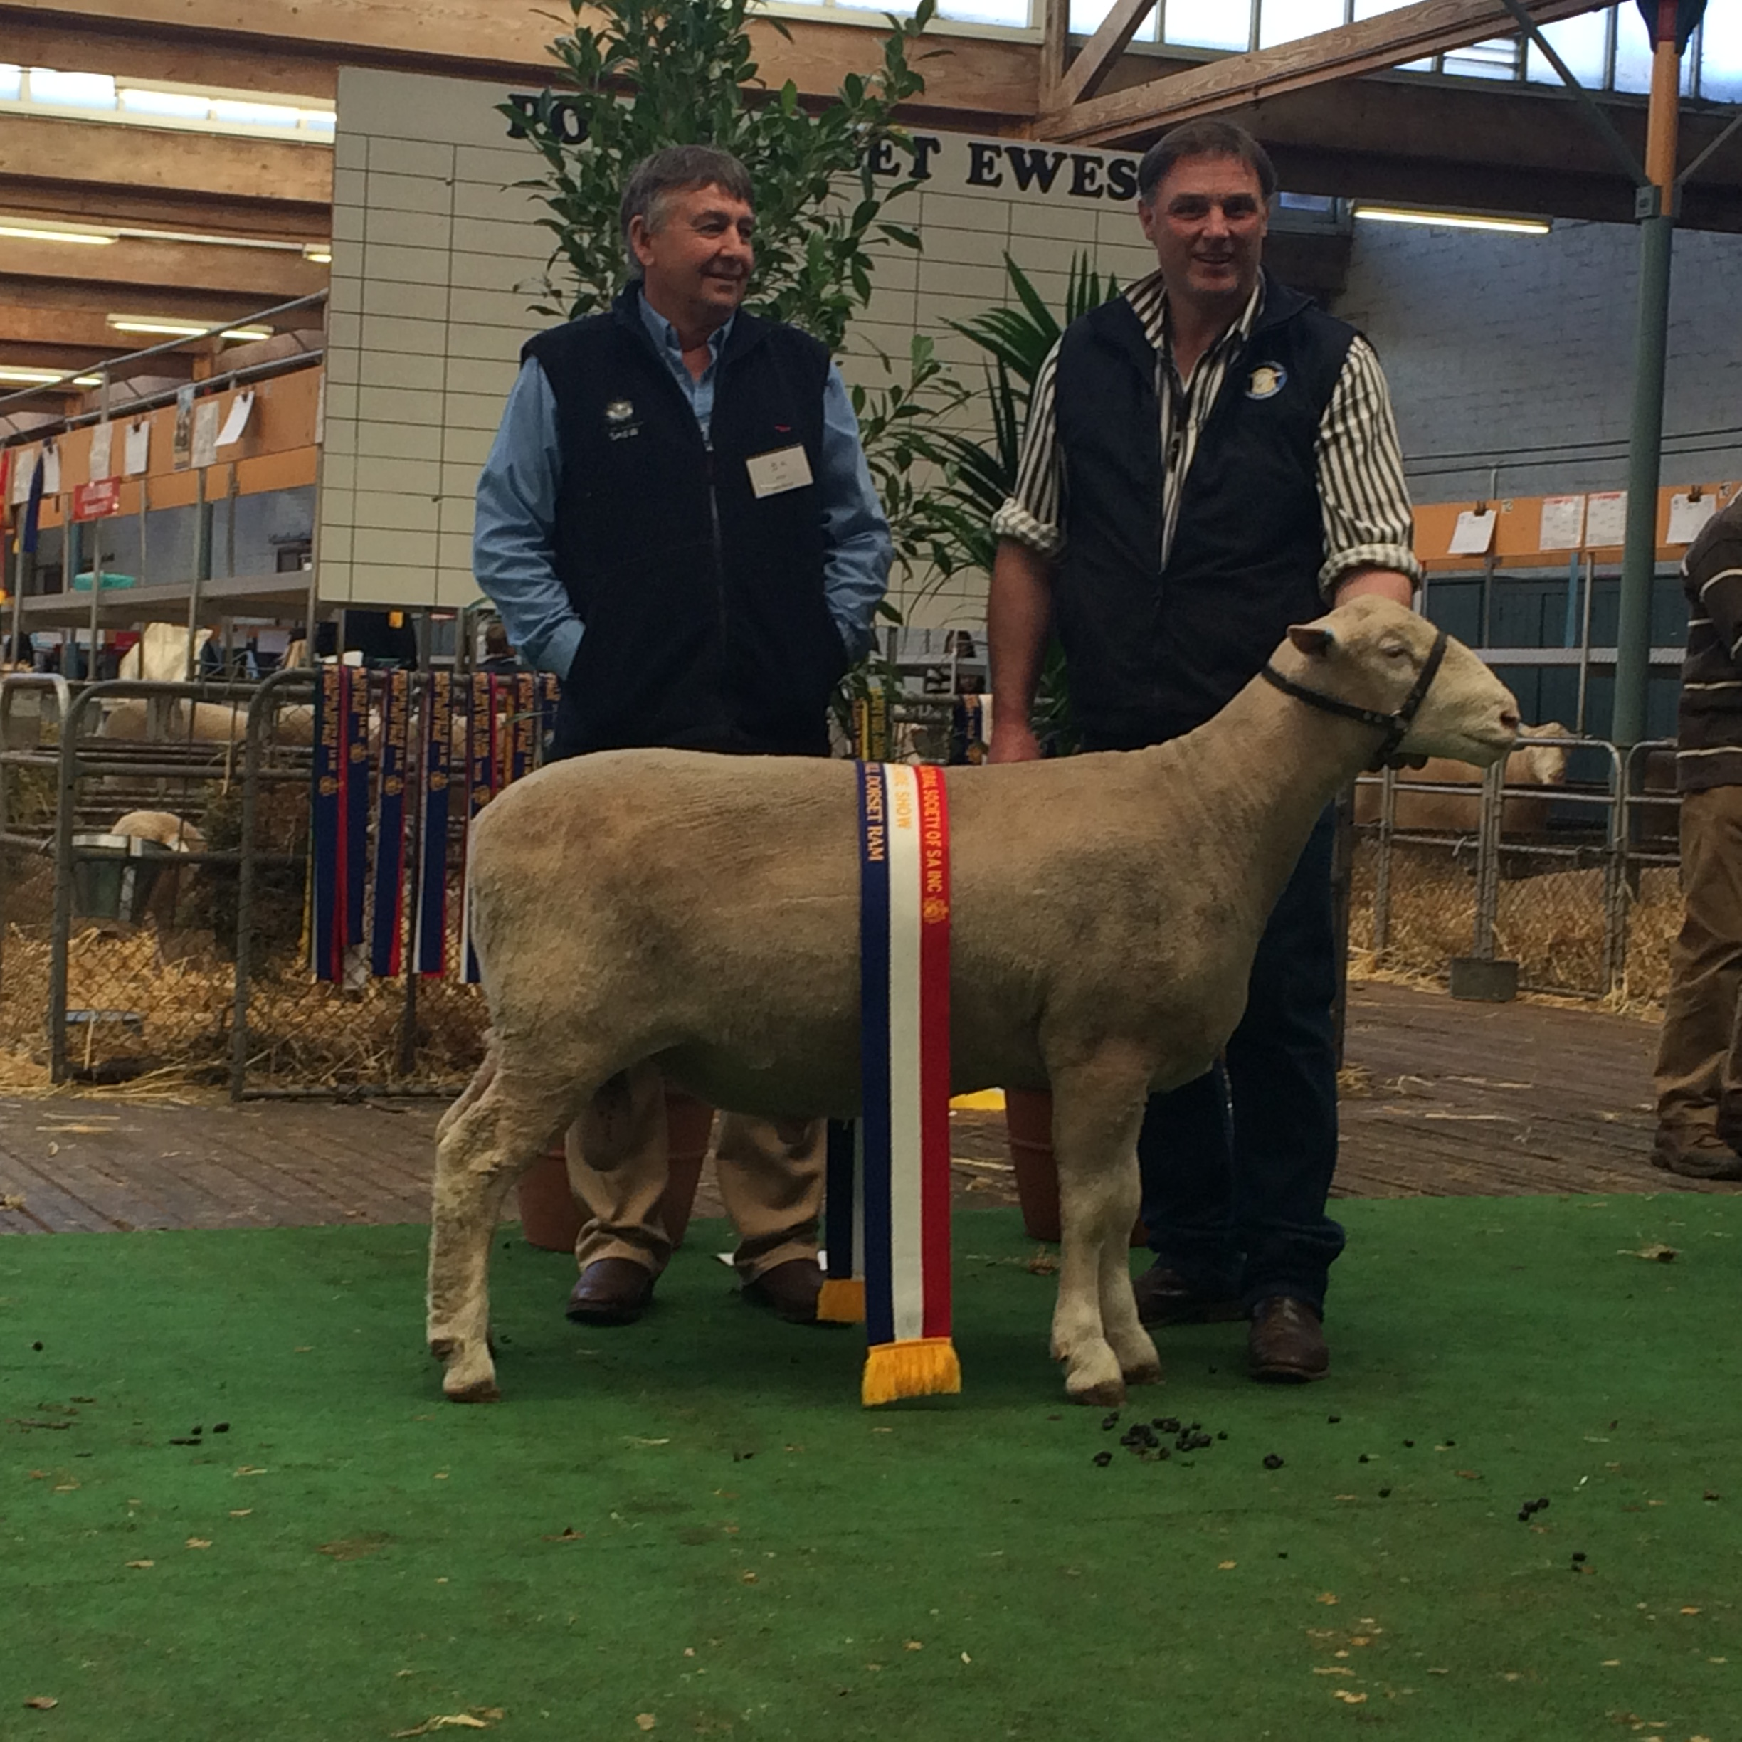

Other results:
Ram under 1 ½ yrs – Born on or after 1/7/15 - 1st Valma 348-15 Lot 4. 5th Valma 325-15 lot 8.
Born on or after 1/8/15 - 2nd Valma 424-15 Lot 2.
Pair of rams Born on or after 1/7/15 - 2nd Val 563-15 Lot 11. & 367-15 Lot 10.

Lambplan Born on or after 1/4/15 - 2nd Valma 291-15 (photo below) Lot 3.
3rd Valma 515-15 (retained but semen avail.)

Lambplan production class – Trade 1st Val 515-15 & 87-15 (photo above)
Lambplan production class – Export 2nd Val 97-15 (Lot 1) (front ram) & 367-15 Lot 10 (photo below)
Valma 291-15 Lot 3.
