Does the future of Australia’s cattle herd hinge on Victoria and the Riverina?
A previous AuctionsPlus Market Insight article “Southern Rain Spurs on Southern Buyers” outlined the buying power of Victorian’s online. Further to the previously published findings, we take an indepth look at what has been purchased in 2019.
Producers in Victoria and the Riverina region of NSW have been fortunate enough to have a more favourable season than the rest of the country, affording them the opportunity to take advantage of quality lines of cattle listed on AuctionsPlus. Victoria and the Riverina’s combined average purchases in 2019 totalled 30% of the AuctionsPlus cattle catalogues, compared to 19% in 2017 and 22% in 2018. The highest month recorded was November where 46% or 20,893 head were secured by purchasers in these regions.
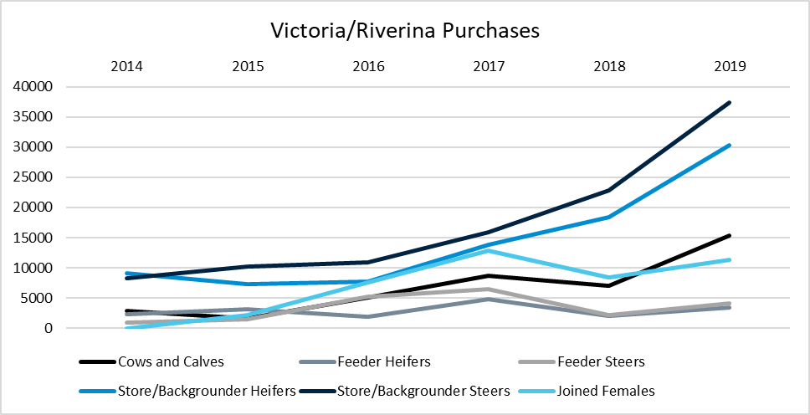
Figure 1: Total purchases for Victoria and the Riverina from 2014 - Nov 2019
Peter Rollason from Elders Pakenham said that “producers are looking for any trading opportunity to turn grass into dollars”, reflected not only in store/backgrounder purchasing, but also in cows and calves. Peter said that “when the seasons are good around the country you don’t get the opportunity to buy the best of the herd”; this is what southern producers have been taking advantage of this year. Peter highlights that the top-quality lines are always going to attract competition, and producers are happy to pay premiums in order to secure these lines.
Store/backgrounder steers have been the highest volume stock category purchased throughout the year with the intention to fatten and then trade. Producers are looking to profit off a strong feeder market which has been driven up due to lower supply of feedlot suitable cattle. Peter said when sourcing steers that the condition of the stock is not a deterrent as long as they are fit to load and can handle the long distance.
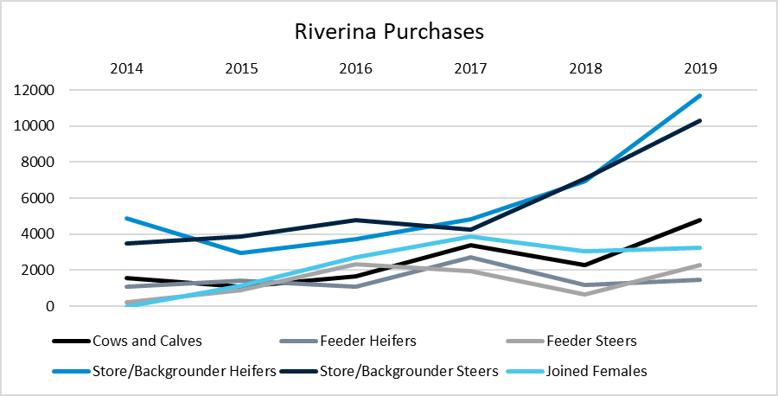Figure 2: Riverina Purchases 2014 – Nov 2019
Matt Tinkler, Elders Albury, backed up Peters comments and added “buyers have a full range of options from backgrounding into feeders or to go down the grass-fed option”. Matt went on to say that his clients have placed a increased emphasis on females. Matt’s clients are buying large quantities of cows and calves in anticipation of increased demand in the store market when the season turns and northern producers look to restock. Cows and calves have generally suited his clients as they can make an earlier return on the calf and then rejoin the cow with the intention to sell when demand is high for store cattle. Matt has been sourcing cattle as far north as the New England to reach better-quality lines that are coming onto the market. Clients of his that have an older breeding herd are purchasing quality younger breeders to boost their herds.
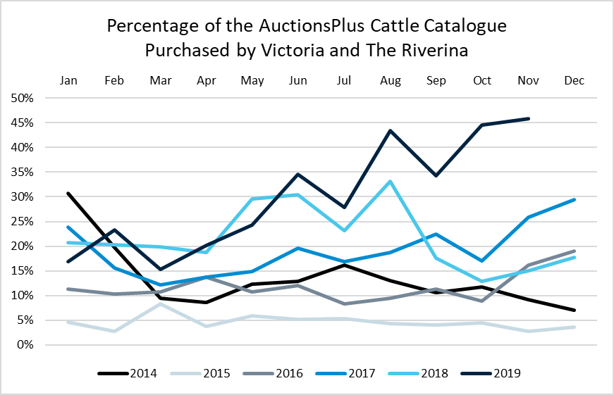
Figure 3: Percentage of AuctionsPlus Catalogue Purchased by Victoria and the Riverina Year on Year

With many tipping a strong cattle market over the next 12 months, dependant on rain. It appears that the South is in the drivers seat moving forward.

