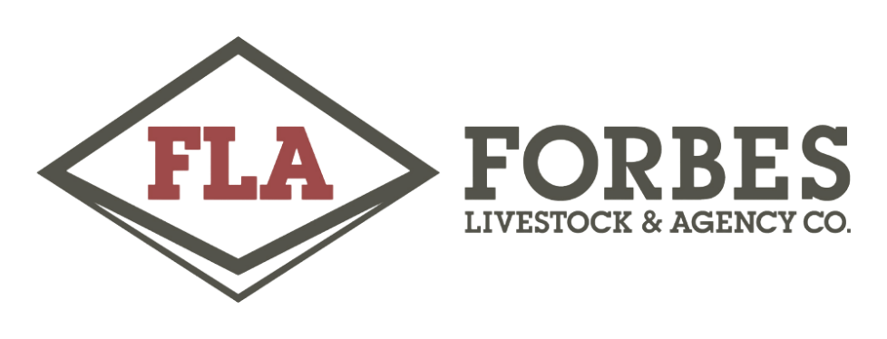
FLA EOFY MV Clearing Sale, Forbes
BIDDING: Purchasers will need to be registered with AuctionsPlus. Please register at least 24 hours before beginning of sale. Please click here for instructions on how to register http://media.auctionsplus.com.au/Uploads/Flyers/Step%20by%20step%20-%20Bidding.pdf
SALE START: 12pm, Wednesday 14th June, 2023
SALE FINISH: 7pm, Friday 16th June, 2023
ONSITE INSPECTIONS: By appointment with vendor on the 12th, 13th, 14th June.
PAYMENT: Successful bidders will receive an invoice by email on Saturday 17th June. Payment must be made within 48hrs of invoice being sent.
COLLECTION: By appointment with vendor- must be collected by Friday 30th June, 2023. Collection is the responsibility of the purchaser and must be conducted within the date specified. Collection is not the responsibility of the selling agent. If collection has not been made by the date specified the sale will become void and no refund will be issued. Full payment MUST be received before collection & proof of payment must be shown on collection day.
PURCHASERS PLEASE NOTE: Auction terms & Conditions – While all care has been taken by both the vendor and the agent in gathering the descriptions provided, neither the vendor or the agent bear any responsibility as to the accuracy of the descriptions or the suitability of the items for the purchasers needs. We strongly recommend prospective bidders inspect the items in person.
GST will be applied to all applicable items & there will be NO BUYER PREMIUM added.
SALE WILL BE CONDUCTED UNDER ALPA TERMS & CONDITIONS
EACH ITEM IS SOLD PER LOT.
Contact: Forbes Livestock & Agency Co
147 Lachlan Street, Forbes
Respective Agent or Vendor on Each Lot

