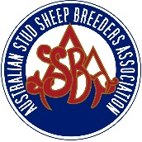

ELITE FLOCK RAM SALE
Meat Sheep
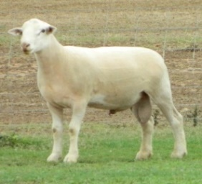 | Inglewood  Showgrounds  Friday 23 February 2018 | 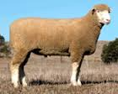
Inspection from 11.00am - Sale 1.00pm
21 – White Suffolk
15 - Poll Dorsets
8 – Texel
4 – Suffolk
2 - Border Leicester
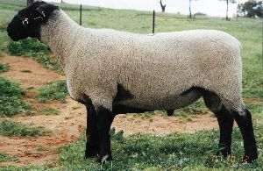
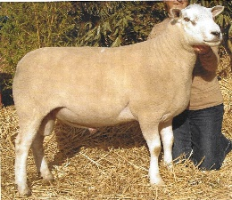

ELDERS INGLEWOOD: GEOFF LYONS 0427 623 564

PETER SEALY 0428 626 959 or ANDREW MEARA 0427 210 634
www.assba.com.au/queensland
a 2% vendor introducing agent rebate will be paid to those agents introducing clients at least 24hrs prior to the sale.
Supporting sponsors:- Coopers Animal Health & Riverina Stock Feeds

