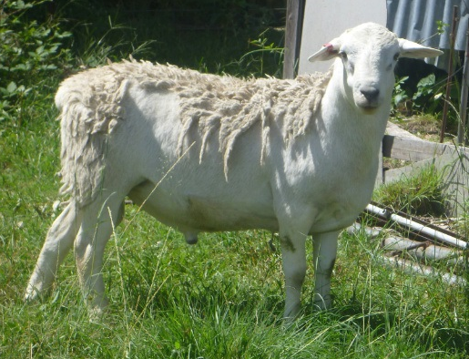

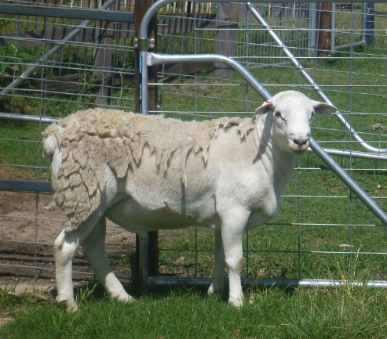
To be sold on AuctionsPlus Seedstock Sheep sale Tuesday 14th April 2015, 1pm
A/C – P CANNON
7 Australian White Rams
Ashford, NSW
11 months old
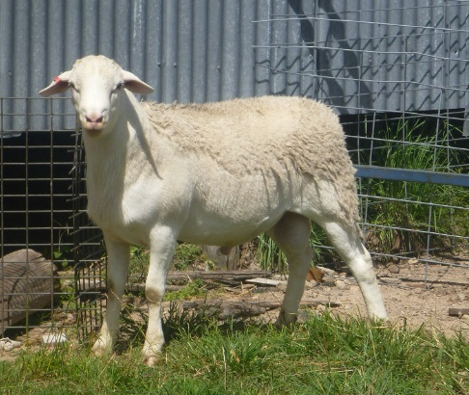
Average 66 kg
‘Fit young rams ready for work’
Please Contact
John Mair
0428 326 943

