To Be Sold in Eastern States Sale Friday 8th May

A/c Possum Point Pastoral Company Tooma NSW

EU ACCREDDITED

50 Angus Cows 6th Calves
Pure Rennylea blood, Possum Point station Bred

Depastured to Rennylea bulls 24/10/14 to 23/12/14.
Classed breeders

Vendor offering payment terms

Details contact Matt Tinkler
0429387939

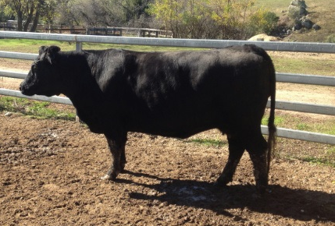
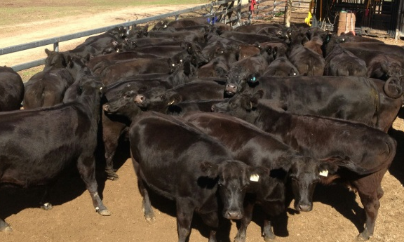
- Matt

