6TH ANNUAL A1 PRODUCTION SHEEP SALE

THURSDAY, 19th FEBRUARY, 2015

AUCTIONS PLUS – 1 pm

To be run in conjunction with regular

Thursday Sheep on AuctionsPlus

5,000

***MERINO EWES***

**A/C: NUGENT GRAZING “Balaclava”**

**800**  6 yrs, pure Egelabra blood. Nov shorn, N.S.M. Western Bred Ewes.

**A/C: CLINT NUGENT “Balaclava”**

**200** C.F.A 100% B/L & W-suff lambs at foot Nov/Dec drop lambs marked & vaccinated

**A/C: COLDWOOD “Bellevue”**

**415** Merino Ewes 4, 5, 6 yrs, July Shorn, Cressbrook blood.

***LAMBS***

**A/C: NUGENT GRAZING ”Balaclava”**

**750** 1st X Mixed Sex Border Leicester Lambs. Sept/Oct 2014 drop, unshorn, to be sexed. Wellingrove Blood.

**A/C: YARRAFORD TRUST “Yarraford Stn”**

**600** Char/W-Suff Merino X Store Lambs. Sept 2014 drop, unshorn, crutched, weaned Jan.

**A/C: DH & LHA STEVENSON “Nant Park”**

**600** W-Suffock X Merino lambs Aug/Sept 2014 unshorn

**A/C: SR & RK JOHNSTON “Oakhurst”**

**400** 1st X B/L- Merino m/sex lambs. Sept/Oct 2014 drop unshorn, to be sexed.

**A/C: BENETAL P/L “Big Ben”**

**300** Mixed sex W-Suffolk X Merino lambs, shorn.

***LAMBS***

**A/C: COLDWOOD ”Bellevue”**

**200**  Merino Ewe Lambs, Sept drop.

**JURA PASTROAL COMPANY “Jura”**

**130** 1st X BL x Merino Ewe Lambs,

Aug drop, unshorn.

**110** 1st X BL x Merino Wether Lambs,

Aug drop, Feb shorn.

5,000

***MERINO WETHERS***

**CAMLEA CHAROLLAIS RAMS**

**A/C: KA & G Feakins**

**Camlea Charollais Stud**

**80**  Charollais Rams (Pure Bred)

**40** Yearling Rams

**40** Ram Lambs

**50** Selected 2014 drop ewe lambs

shorn, Brucellosis accredited.

Shad Bailey Nathan Purvis Craig Thomas

0458 322 283 0427 324 078 0428 669 500

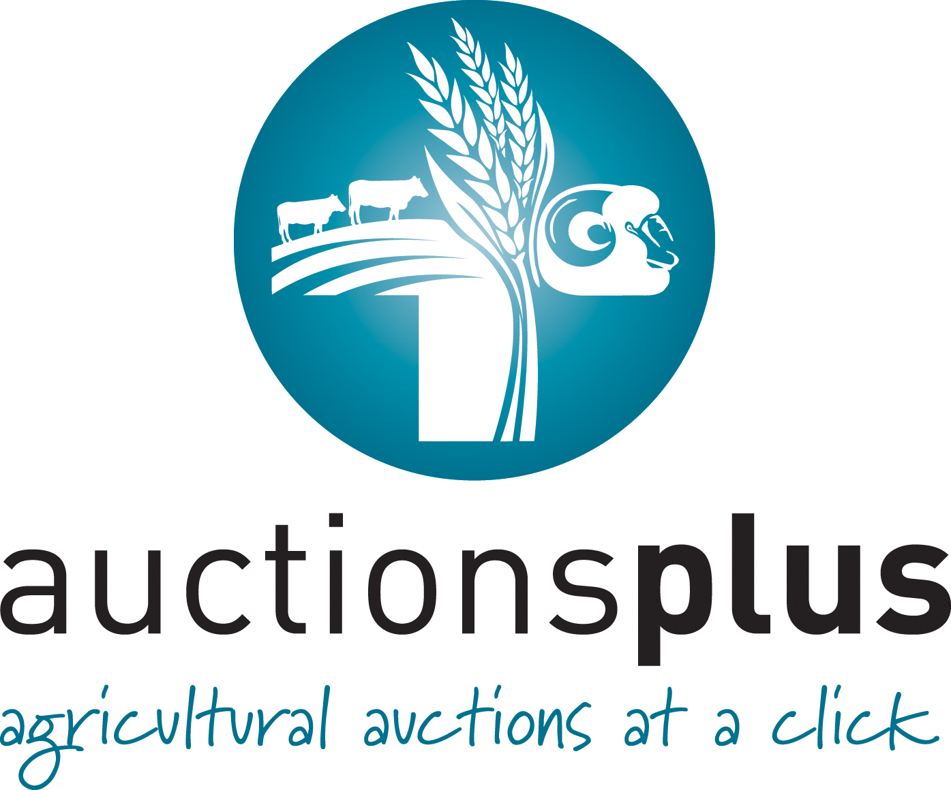

***The A1 Production Sale is the foremost multi-vendor sheep sale in our Northern Tablelands region. This offering comprises quality breeders sheep from renowned New England producers. All sheep come with the highest recommendation. Buyers who want good sheep are urged to view the catalogue.***

**THIS LOT WITHDRAWN**

**TO BE OFFERED AT A LATER DATE**

**BREEDING FLOCK DISPERSAL**

**RB & KM TURNER TRADING AS BOOLARWELL PARTNERSHIP TALLWOOD**

**300** M/E Lambs, Sept 2011 drop, unshorn

**100** M/E 1 ½ yrs, June Shorn

**500** M/E 2 ½ yrs June Shorn

Karbullah blood and all crutched.

**300** 5yrs Dohne x ewes (purchased), June Shorn.