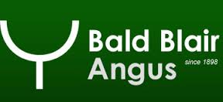

Dear Beef Producer, Agents, Processors and Feedlotters

White Angus will once again be holding a White Angus blood on-line commercial sale on Auctions Plus on Friday 10th April in conjunction with the normal Eastern States Cattle Sale. Bald Blair and Eastern Plains Angus Studs are happy for all agents and their vendors to be involved with the White Angus Sale and openly invite enquiries from anyone who uses White Angus bulls.

All descriptions and classes of cattle are welcome to become involved in the sale. Cattle must carry White Angus genetics in their breeding or be in calf to White Angus bulls to take part in the marketing. Therefore vendors must have purchased or used bulls from either Bald Blair or Eastern Plains Angus Studs in the past.

Marketing for the program will be running for a full month prior on Auctions Plus, although, assessing will not take place until much closer to the sale time. We would ask if all agents and assessors could keep us informed of any potential lots as they come to hand and we will be able to update the advertising on a regular basis.

A common theme to keep prospective purchasers and the wider beef industry alert to the sale and the genetics on offer is that if all assessors when entering your client’s assessment, please can we all add the following comment to the assessment. In the field after typing in the postcode for your cattle, could all assessors write WHITE ANGUS after the closest town cattle are assessed at?

*For example:* Guyra – WHITE ANGUS Armidale - WHITE ANGUS Inverell - WHITE ANGUS

This will just assist all in identifying the lots in the Eastern State Sale and any marketing involved. Both Eastern Plains and Bald Blair websites will be continuously updated as will the Auctions Pluswebsite. [www.whiteangus.com.au](http://www.whiteangus.com.au)

For any further information, please liaise with all involved in the sale

Sam & Kirsty White

0438 792 140

Bald Blair Angus Stud. [samwhite@baldblair.com.au](mailto:samwhite@baldblair.com.au)

Andrew & Sally White 0267794237

Eastern Plains Angus Stud.

[easternplains@activ8.net.au](mailto:easternplains@activ8.net.au)

Nick Hall

0427 437 203

Elders Armidale

[nick.hall@elders.com.au](mailto:nick.hall@elders.com.au)

Regards

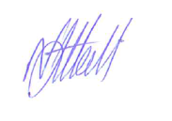

Nick Hall

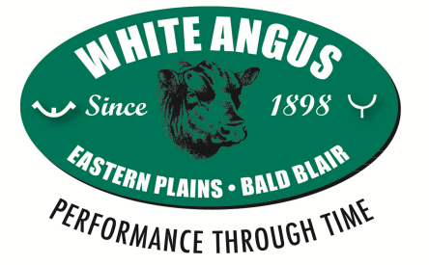

**WHITE ANGUS GENETIC SALE**

AUCTIONS PLUS

(Eastern States Cattle sale)

**FRIDAY 10TH APRIL**

**A/C Macarthur Pastoral Company (Cannabri) Pty Ltd**

50 Poll Hereford Heifers

2.5 Years Old

PTIC to Bald Blair Bulls

**A/c Bald Blair Pastoral Company**

200 Angus Weaner Heifers

EU Accredited

**A/c AD Commodities**

200 Angus Heifers

150 Angus Steers

25 Angus Cows 7/8 YO PTIC







Next Bull Sale: 4th August 2015 Next Bull Sale: 28th July 2015