A/C Gordon Welsh Pty Ltd
“Gunningbar West” Warren
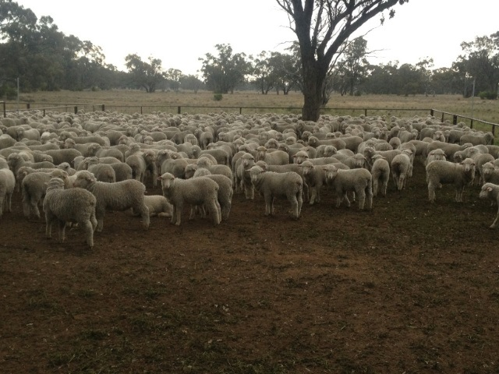
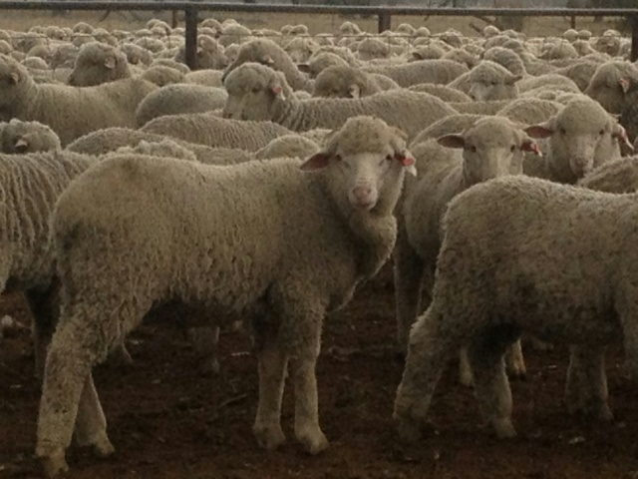
2900 Merino Wether lambs
April/May 2014 drop
Uardry-Kerin Poll blood
Muelsed, unshorn, top quality
Forward to very fresh condition

Bred from large framed Merino ewes
These lambs have the genetics to grow out or
Fatten, or will make fantastic wool cutters
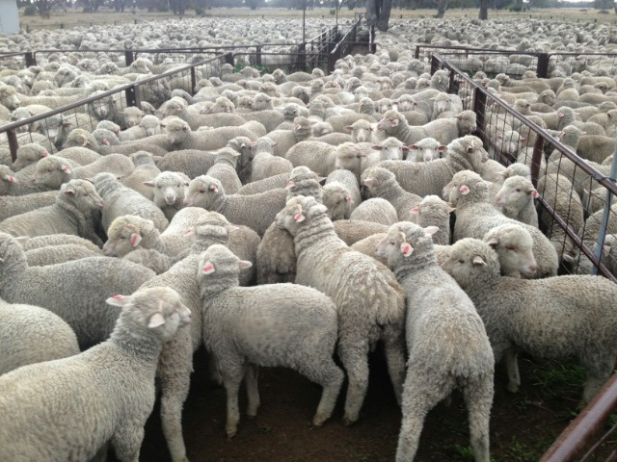
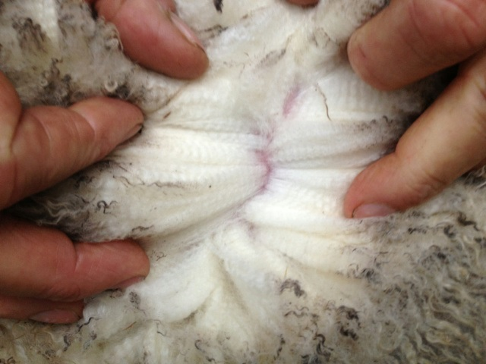
To be offered in B-Double loads

Contact;
Graham Anderson 0428 253 162
Danny Tink 0437 828 733
Aaron O’Leary 0429 866 118

