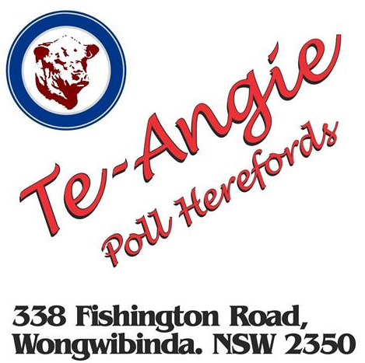

Saturday 18th July 2015
11:30am

36 bulls

119 commercial EU accredited females

Please Contact:
Geoff Hayes 0429 201 120
Chris Johnstone 0408 831 759
Brian Kennedy 0427 844 047

