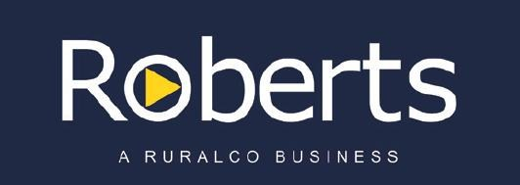

5th May 2016 at 9am

A/C IM MacKinnon & Co - Glen Esk, Conara
1300 Dorset crossed store lambs, April shorn, (to be sold in lines)
515 Corriedale ewes, April shorn, 2014-2009 drop joined to Poll Dorset rams 13 March, 6 week joining, mulsed, ‘V’ tag, to be offered in age groups.
1503 Merino ewes, April shorn, 2013-2009 drop, joined to poll Dorset rams 18.3.16, 6 week joining, mulsed, ‘V’ tag
784 Merino ewe hoggets, 214 drop – classed as keepers, joined to Merino rams 18 March, 6 week joining, mulsed, ‘V’ tag, to be offered in 2 lines.
936 Merino lambs, mixed sex, to be offered in 2 lines of ewes,
2 lines of wethers, s/o 2015 drop, mulsed ‘V’ tag, Glen Esk has no previous history of footrot or feet issues

Enquires:
Warren Johnston 0419 326 348

A/C Kelvedon, Swansea
250 Merino ewes, 5yr June shorn, Gudiar vaccination. Full sound mouth, 16.5 micron, flock average

A/C Wenlock, Orielton
100 3yr Merino ewes, due to the Suffolk mid
June

Enquires:
Chris Cusick 0408 146 022

