**NINDOOINBAH ANGUS FEMALE REDUCTION SALE**

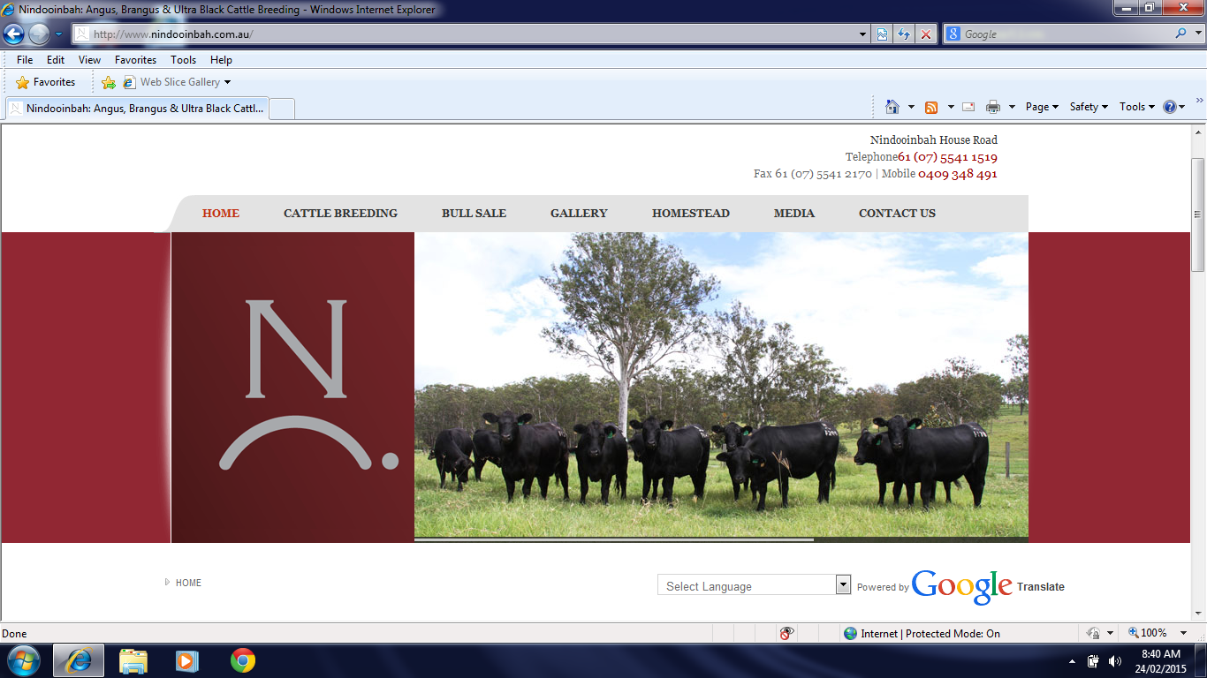

**AUCTIONSPLUS EASTERN STATES SALE FRIDAY 27TH FEBRUARY 2015.**

* 48 Registered Lawson’s Angus cows (A brand) scanned in calf to Brangus bulls.
* 55 Registered Lawson’s Angus cows (B brand) scanned in calf to Brangus and Angus bulls.
* 10 Registered Nindooinbah Angus heifers (G & H brand) scanned in calf to Brangus bulls.

**AUCTIONSPLUS SEEDSTOCK SALE FRIDAY 27TH FEBRUARY 2015**

* 19 Registered Lawson’s Angus cows scanned in calf to Angus and Brangus bulls.

(To be offered in single lots)

FOR FURTHER DETAILS

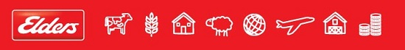

**ELDERS BEAUDESERT**

**07 55425903**

Mark Meldrum 0409 474064

Cameron Wilson 0428 657334