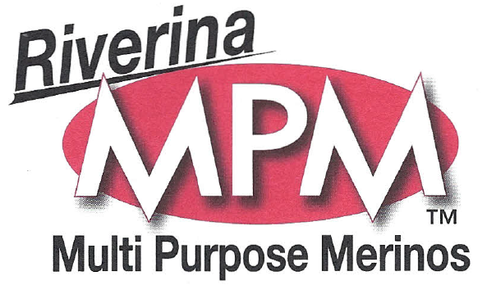

Riverina Multi Purpose Merino Stud Sale

On AuctionsPlus Tuesday 8th December 2015
12pm

2000 M/A Breeding Stud Ewes
550 Maiden Ewes Aug/Sept 2014 drop
900 Merino wether lambs
900 Stud ewe lambs Aug/Sept drop 2015
70 MPM mixed age sires.
Non Muelsed, Plain Bodied, July shorn, MPM blood and bred.

Geoff Mcdougall
0428 105 533
Landmark Hay

