Landmark WA
GRAINFED BEEF SALE

700 Head

Monday 4th May 2015
1:30 WST or 3:30 EST

On AuctionsPlus and in the Landmark Tent at Beef Week

For full details please contact:
Darren Chatley
0457 553 969
OR
Daniel Wood
0418 771 665
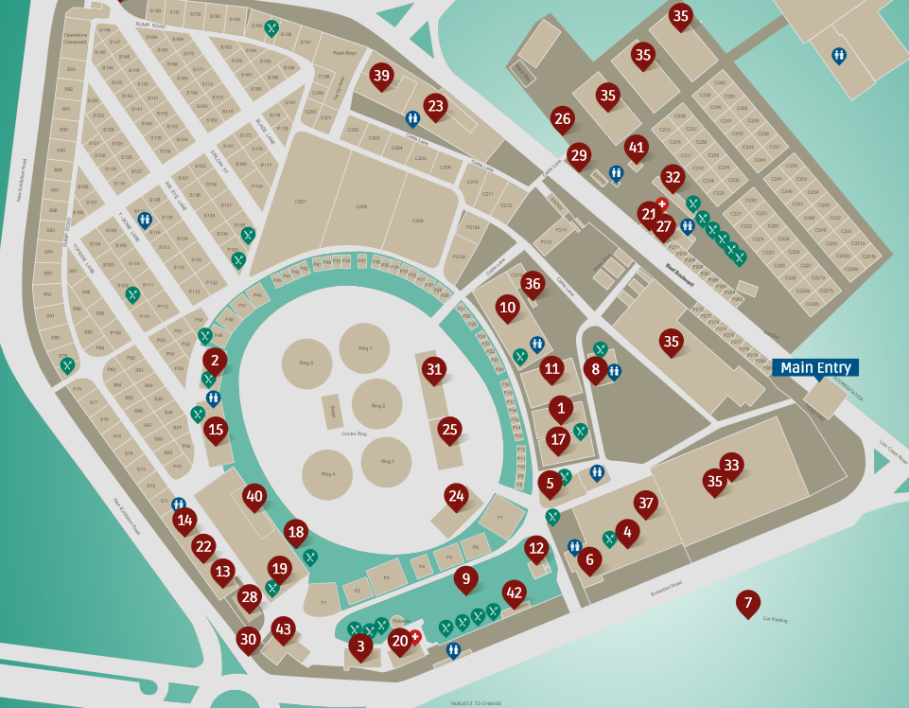

Landmark Tent (#25)

