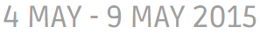

LANDMARK Special Santa & Santa Infused female sale
Friday 8th May 2015 12 pm
At the Landmark Site
Please contact
Col Campbell
0429 068 810

Or contact your Landmark Branch.

