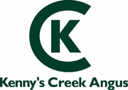

To be sold on AuctionsPlus Friday 18th March 2016

A/C-Kenny’s Creek Angus

30x30 2 year old Angus cows with Autumn CAF

NSM, ready to join in May

James Croker
0427753533
Landmark Yass

