To be sold on AuctionsPlus 27th November 2015.

A/c Irongate Nominees, Albany, WA
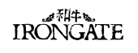
69 - 2014 drop Commercially registered parent verified Full Blood Wagyu steers.

32 - 2014 drop F1 to F3 Wagyu Steers and Heifers.

14 - 2014 drop F1 Wagyu Heifers.

10 - Rising 2yo AWA Registered Full Blood Bulls.

For more information please contact
Mitch Braithwaite 0427702311.

