To be sold on AuctionsPlus Thursday 18th June 2015

A/C CASHMORE PARK
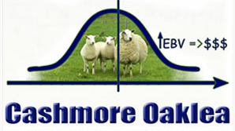

315 Joined Maternal Composite
Ewe Lambs

Aug / Sept 2014 drop, Gudair Vac,
Free to enter SA (Pooled faecal 350 )

December 2014 shorn

Joined 15/3/2015 at 2.5 % to Maternal Rams.

Well grown, high index ewe lambs suitable for starting a self replacing prime lamb flock.

Contact Tim Jewell
(Landmark Hamilton) 0429 390 033

