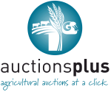
AUCTIONSPLUS SALE
FRIDAY 24TH APRIL 2015
A/C A.B. & R.L. BRUCE
“ULIMAN”, COONABARABRAN
110 EU ACCREDITED ANGUS COWS
TO BE OFFERED IN SINGLE DECK LOTS
22 X 2010 drop (PTIC to Raff and DSK Angus bulls)
44 X 2009 drop (PTIC to Kansas & DSK Angus bulls)
44 X 2008 drop (PTIC to Booroomooka & Kansas Angus bulls)
ALL COWS ARE PREGNANCY TESTED 6 – 7 MONTHS TO STUD ANGUS BULLS
FRONT PADDOCK CATTLE
GENUINE HERD REDUCTION SALE DUE TO PROPERTY BEING SOLD TO SETTLE FAMILY PARTNERSHIP
CONTACT
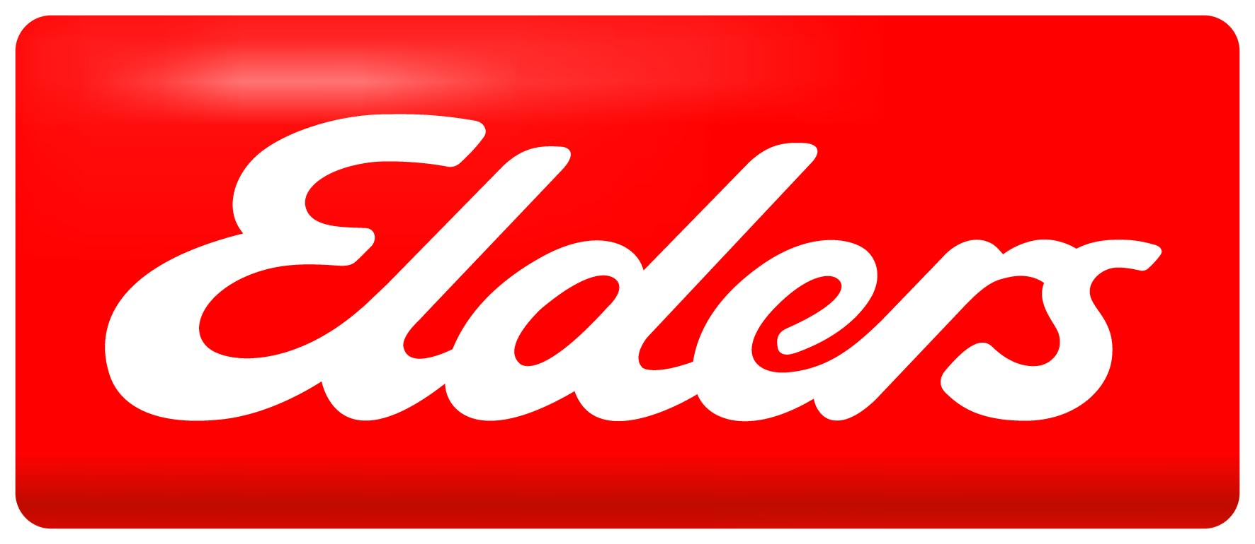
ELDERS GUNNEDAH
02-67483000
OR
NICK HANNAFORD
0417-201460

