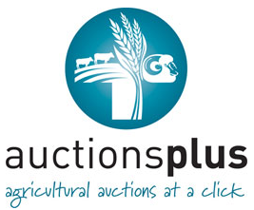
BUYERS, AGENTS AND ASSESSORS PLEASE NOTE:
AGENTS AND ASSESSORS – YOU CAN SUBMIT ASSESSMENTS UP UNITL 12PM MONDAY MARCH 9th
CLICK HERE for Pre-Auction details
CLICK HERE for further details on the National Breeder and Replacement Ewe Sale
Listings to include:
175 Merino Ewes, rising 3 years, SIL Merino; 196 Merino Ewes, rising 4 years, SIL Merino; 181 Merino Ewes, rising 5 years, SIL Poll Dorset; 120 mixed age Merino Ewes, SIL Border Leicester. Contact Tom Madden 0497 775 055.

