To be offered in AuctionsPlus Eastern States Sale – Friday 20th May 2016

YARRA BONSMARA.
The property is Norths of GOGANGO between Rockhampton and Duaringa.
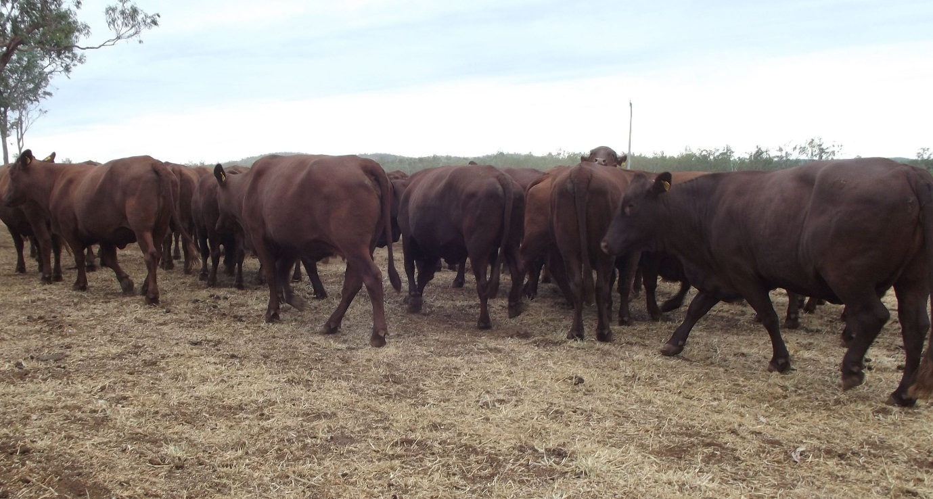
Herd dispersal 336 Bonsmara Breeders.
- Full breeding data available.
- 100 Mixed aged cows PTIC
- 115 Cows & Calves
- 18 Cows & Calves and PT back in Calf.
- 41 No 3 and 4 Heifers PTIC
- 62 No 5 Heifers

Joining Sire Details:
PTIC Dry cows: Wirlinga 08-175 (ABD08175) (ET) from 14.01.16 to 26.02.16
Wirlinga 11-074 (ABD110074) from 27.02.16 to 10.04.16
Wirlinga 12-089 (ABD12089) from 11.04.16 to 11.05.16
Wet NDP cows: as above
PTIC Wet cows: as above
No 13/14 heifers: AI sires Bolwell Shaka (IMP STH AF) (ET) from 26.01.16 to 13.02.16
GRC 97-37 (GRC9738) from 26.01.16 to 13.02.16
Clean-up bull Wirlinga 11-051 (ABD110051) from 26.02.16
No 5 heifers: not joined

Southern Producers – PLUNGE DIP – Pre-treatments on Property prior to delivery.
Landmark Rockhampton
Col Campbell 0429068810
James Saunders - 0418538830

