SEMEN STRAWS
Lots 1, 2, 3, 4 & 5 | Longford Mr Awesome (AI)(ET) | 5 x 2 Semen Straws

The successful purchaser of Lot 1 also has the right to purchase up to the next four lots for the same price. Decision must be made at the fall of the hammer.
All semen straws are sold per straw with GST added after. Australian domestic use only.
Stored in Armidale, NSW, 2350.

Lots 1 | Longford Mr Awesome (AI)(ET) | 2 Semen Straws

Bull name - Longford Mr Awesome (AI)(ET)
AWA ID - LFDFD12558
Buyer - _____________________________ Price $__________________

Lot 2 | Longford Mr Awesome (AI)(ET) | 2 Semen Straws

Bull name - Longford Mr Awesome (AI)(ET)
AWA ID - LFDFD12558
Buyer - _____________________________ Price $__________________

Lot 3 | Longford Mr Awesome (AI)(ET) | 2 Semen Straws

Bull name - Longford Mr Awesome (AI)(ET)
AWA ID - LFDFD12558
Buyer - _____________________________ Price $__________________

Lot 4 | Longford Mr Awesome (AI)(ET) | 2 Semen Straws

Bull name - Longford Mr Awesome (AI)(ET)
AWA ID - LFDFD12558
Buyer - _____________________________ Price $__________________

Lot 5 | Longford Mr Awesome (AI)(ET) | 2 Semen Straws

Bull name - Longford Mr Awesome (AI)(ET)
AWA ID - LFDFD12558
Buyer - _____________________________ Price $__________________

BULLS
Lot 6 | LONGFORD M0193 (AI) (ET) | Mature Bull

Identifier: | LFDFM0193 | 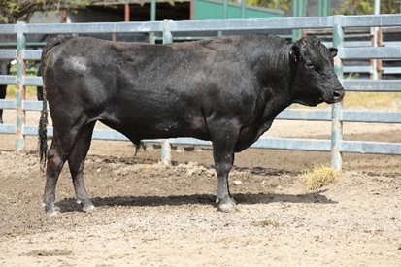
Sex: | Male
Birth Date: | 31/07/2016
Grade: | Fullblood
Colour: | Black
Genetic Condition | B3F, CHSF, CL16F, F11F, IARSF
PEDFA10632 SHIGESHIGENAMI J10632
IMUFQTF148 ITOSHIGENAMI (IMP USA)
PEDFA661 FUKUYUKI
Sire: LFDFD12558 LONGFORD MR AWESOME (AI) (ET)
IMUFQTF147 ITOSHIGEFUJI (IMP USA)
LFDFZ0570 LONGFORD LFDB570 (AI) (ET)
LFDFV0078 LONGFORD 0078 (AI) (ET)
Animal: LFDFM0193 LONGFORD M0193 (AI) (ET)
WKSFM0164 WORLD K'S MICHIFUKU
LFDFT0476 LONGFORD ZAKI (AI) (ET)
WKSFMJ913 WORLD K'S RIKITANI J913 (ET)
Dam: LFDFB8566 LONGFORD B8566
IMJFAJ2810 KITATERUYASUDOI J2810 (IMP JAP)
LFDFZ1065 LONGFORD LFDB1065 (AI) (ET)
LFDFU0691 LONGFORD TAISHA (AI) (ET)

 | GL  (days) | BWT  (kg) | 200  (kg) | 400  (kg) | 600  (kg) | MCW  (kg) | Milk  (kg) | SS  (cm) | CWT  (kg) | EMA  (sqcm) | RUMP  (mm) | RBY  (%) | MS | MF  (%) | WBI  ($) | SRI ($) | FTI ($) | F1TI  ($)
EBV | +1.6 | +4.1 | +22 | +24 | +38 | +28 | +3 | -0.1 | +18 | +3.3 | -2.8 | +1.1 | +1.3 | +0.13 | +$186 | +$172 | +$137 | +$113
ACC | 55% | 68% | 71% | 70% | 71% | 63% | 63% | 59% | 72% | 68% | 67% | 59% | 71% | 60%

Buyer - _____________________________ Price $__________________

Lot 7 | LONGFORD S0263 (AI) (ET) | Junior Bull

Identifier: | LFDFS0263 | 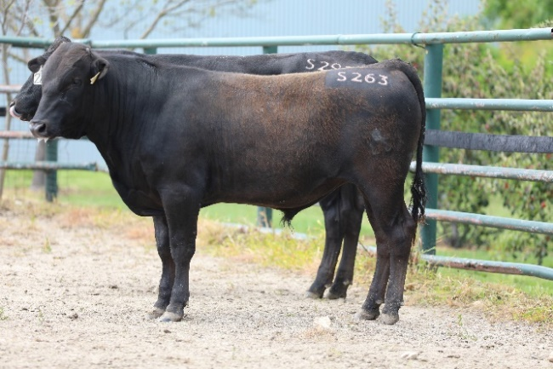
Sex: | Male
Birth Date: | 31/07/2021
Grade: | Fullblood
Colour: | Black
Gene Tests: | F11-Carrier, CHS-Free, CL16-Free, B3-Free, IARS-Carrier
PEDFAJ472 YASUTANI DOI J472
PEDFAJ930 YASUFUKU J930
PEDFM004 CHIZURU 85545
Sire: WKSFS0100 WORLD K'S YASUFUKU JR (FB5061)
PEDFA201 MONJIRO J11550
PEDFQ5 KANEKO 5
PEDFAJ47492 KANEKO J47492
Animal: LFDFS0263 LONGFORD S0263 (AI) (ET)
PEDFAJ1606 TANIFUKU DOI J1606
IMUFRTF146 KIKUTSURUDOI TF146 (IMP USA)
PEDFAJ509605 YASUTSURU J509605
Dam: LFDFD12795 LONGFORD D12795 (AI) (ET)
IMUFQ3218 TF MITSUHIKOKURA 43 (IMP USA) (AI)
LFDFB8580 LONGFORD B8580 (AI) (ET)
LFDFZ0581 LONGFORD LFDB581 (AI) (ET)

 | GL  (days) | BWT  (kg) | 200  (kg) | 400  (kg) | 600  (kg) | MCW  (kg) | Milk  (kg) | SS  (cm) | CWT  (kg) | EMA  (sqcm) | RUMP  (mm) | RBY  (%) | MS | MF  (%) | WBI  ($) | SRI ($) | FTI ($) | F1TI  ($)
EBV | +1.1 | -3.3 | -3 | -10 | -9 | -10 | -5 | -1.4 | -4 | +1.5 | +0.6 | -0.6 | +2.0 | +0.25 | +$122 | +$157 | +$144 | +$155
ACC | 62% | 71% | 73% | 72% | 72% | 65% | 66% | 61% | 70% | 65% | 65% | 59% | 67% | 62%

Buyer - _____________________________ Price $__________________

Lot 8 | LONGFORD S0272 (AI) (ET) | Junior Bull

Identifier: | LFDFS0272 | 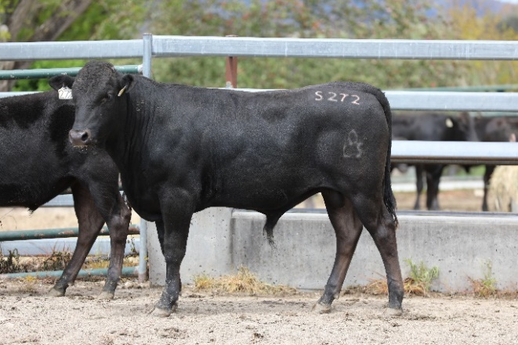
Sex: | Male
Birth Date: | 31/07/2021
Grade: | Fullblood
Colour: | Black
Gene Tests: | IARS-Carrier, CL16-Free, B3-Free, CHS-Free, F11-Carrier
PEDFAJ1081 ITOKITATSURU J1081
IMUFLTF151 ITOZURUDOI TF151 (IMP USA)
PEDFAJ433313 YASUHIME J433313
Sire: SWSFB0119 SHER ZURUSHIGE B119 (AI) (ET)
IMUFQTF147 ITOSHIGEFUJI (IMP USA)
BYWFY0224 BLACKMORE TETUFUKU Y224 (AI) (ET)
BYWFV0235 BLACKMORE TETUFUKU V235 (AI)
Animal: LFDFS0272 LONGFORD S0272 (AI) (ET)
PEDFAJ1606 TANIFUKU DOI J1606
IMUFRTF146 KIKUTSURUDOI TF146 (IMP USA)
PEDFAJ509605 YASUTSURU J509605
Dam: LFDFD12795 LONGFORD D12795 (AI) (ET)
IMUFQ3218 TF MITSUHIKOKURA 43 (IMP USA) (AI)
LFDFB8580 LONGFORD B8580 (AI) (ET)
LFDFZ0581 LONGFORD LFDB581 (AI) (ET)

 | GL  (days) | BWT  (kg) | 200  (kg) | 400  (kg) | 600  (kg) | MCW  (kg) | Milk  (kg) | SS  (cm) | CWT  (kg) | EMA  (sqcm) | RUMP  (mm) | RBY  (%) | MS | MF  (%) | WBI  ($) | SRI ($) | FTI ($) | F1TI  ($)
EBV | +0.3 | +0.5 | +11 | +18 | +21 | +22 | +1 | +0.1 | +23 | -0.8 | -1.7 | +0.5 | +1.1 | +0.12 | +$125 | +$118 | +$103 | +$91
ACC | 52% | 67% | 69% | 69% | 69% | 60% | 61% | 55% | 67% | 60% | 60% | 53% | 63% | 54%

Buyer - _____________________________ Price $__________________

Lot 9 | LONGFORD S0276 (AI) (ET) | Junior Bull

Identifier: | LFDFS0276 | 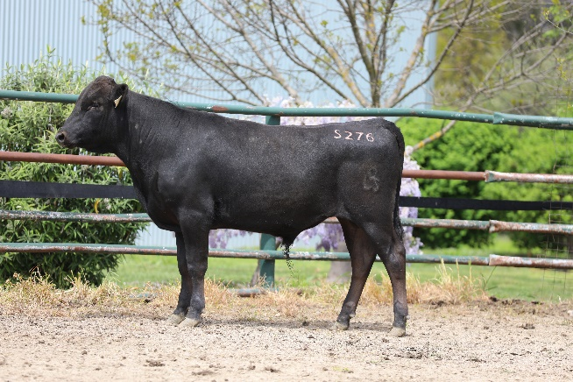
Sex: | Male
Birth Date: | 31/07/2021
Grade: | Fullblood
Colour: | Black
Gene Tests: | F11-Affected, IARS-Carrier, CL16-Free, CHS-Free, B3-Free
PEDFAJ10787 KIKUTERU DOI J10787
PEDFAJ1742 TERUNAGADOI 1742
PEDFAJ240580 TERUNAHO J240580
Sire: IMJFAJ2810 KITATERUYASUDOI J2810 (IMP JAP)
PEDFAJ472 YASUTANI DOI J472
PEDFAJ601124 YOSHIMI 3 601124
PEDFAJ206526 YOSHIMI J206526 - KURO IKU
Animal: LFDFS0276 LONGFORD S0276 (AI) (ET)
PEDFAJ1606 TANIFUKU DOI J1606
IMUFRTF146 KIKUTSURUDOI TF146 (IMP USA)
PEDFAJ509605 YASUTSURU J509605
Dam: LFDFD12795 LONGFORD D12795 (AI) (ET)
IMUFQ3218 TF MITSUHIKOKURA 43 (IMP USA) (AI)
LFDFB8580 LONGFORD B8580 (AI) (ET)
LFDFZ0581 LONGFORD LFDB581 (AI) (ET)

 | GL  (days) | BWT  (kg) | 200  (kg) | 400  (kg) | 600  (kg) | MCW  (kg) | Milk  (kg) | SS  (cm) | CWT  (kg) | EMA  (sqcm) | RUMP  (mm) | RBY  (%) | MS | MF  (%) | WBI  ($) | SRI ($) | FTI ($) | F1TI  ($)
EBV | -1.2 | -0.5 | +9 | +12 | +21 | +17 | +2 | -0.7 | +10 | -0.2 | -4.1 | +1.0 | +1.0 | +0.12 | +$131 | +$127 | +$104 | +$92
ACC | 65% | 73% | 75% | 74% | 74% | 68% | 69% | 65% | 72% | 67% | 68% | 63% | 69% | 64%

Buyer - _____________________________ Price $__________________

Lot 10 | LONGFORD S0278 (AI) (ET) | Junior Bull

Identifier: | LFDFS0278 | 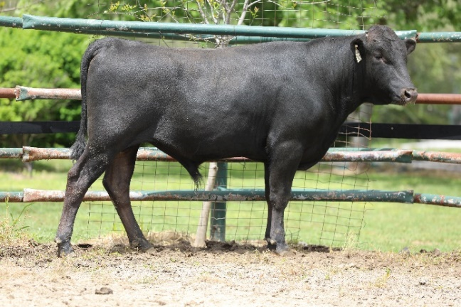
Sex: | Male
Birth Date: | 31/07/2021
Grade: | Fullblood
Colour: | Black
Gene Tests: | B3-Free, IARS-Carrier, CHS-Free, CL16-Free, F11-Carrier
PEDFAJ1081 ITOKITATSURU J1081
IMUFLTF151 ITOZURUDOI TF151 (IMP USA)
PEDFAJ433313 YASUHIME J433313
Sire: SWSFB0119 SHER ZURUSHIGE B119 (AI) (ET)
IMUFQTF147 ITOSHIGEFUJI (IMP USA)
BYWFY0224 BLACKMORE TETUFUKU Y224 (AI) (ET)
BYWFV0235 BLACKMORE TETUFUKU V235 (AI)
Animal: LFDFS0278 LONGFORD S0278 (AI) (ET)
PEDFAJ1606 TANIFUKU DOI J1606
IMUFRTF146 KIKUTSURUDOI TF146 (IMP USA)
PEDFAJ509605 YASUTSURU J509605
Dam: LFDFD12795 LONGFORD D12795 (AI) (ET)
IMUFQ3218 TF MITSUHIKOKURA 43 (IMP USA) (AI)
LFDFB8580 LONGFORD B8580 (AI) (ET)
LFDFZ0581 LONGFORD LFDB581 (AI) (ET)

 | GL  (days) | BWT  (kg) | 200  (kg) | 400  (kg) | 600  (kg) | MCW  (kg) | Milk  (kg) | SS  (cm) | CWT  (kg) | EMA  (sqcm) | RUMP  (mm) | RBY  (%) | MS | MF  (%) | WBI  ($) | SRI ($) | FTI ($) | F1TI  ($)
EBV | -1.4 | -3.3 | -5 | -6 | -9 | -10 | 0 | -1.2 | -8 | -1.0 | +1.6 | -0.5 | +1.0 | +0.05 | +$54 | +$72 | +$71 | +$80
ACC | 54% | 69% | 71% | 70% | 71% | 62% | 63% | 56% | 68% | 62% | 62% | 54% | 65% | 56%

Buyer - _____________________________ Price $__________________

Lot 11 | LONGFORD S0289 (AI) | Junior Bull

Identifier: | LFDFS0289 | 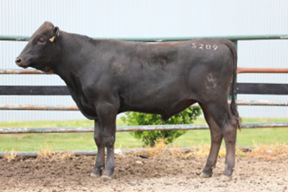
Sex: | Male
Birth Date: | 31/07/2021
Grade: | Fullblood
Colour: | Black
Gene Tests: | B3-Free, IARS-Non Carrier (Free), F11-Free, CL16-Free, CHS-Free
PEDFA10632 SHIGESHIGENAMI J10632
IMUFQTF148 ITOSHIGENAMI (IMP USA)
PEDFA661 FUKUYUKI
Sire: LFDFD12558 LONGFORD MR AWESOME (AI) (ET)
IMUFQTF147 ITOSHIGEFUJI (IMP USA)
LFDFZ0570 LONGFORD LFDB570 (AI) (ET)
LFDFV0078 LONGFORD 0078 (AI) (ET)
Animal: LFDFS0289 LONGFORD S0289 (AI)
LFDFT0475 LONGFORD HONJO (AI) (ET)
LFDFA8328 LONGFORD LFDR8328
LFDFX0152 LONGFORD F X152 (AI) (ET)
Dam: LFDFD12711 LONGFORD D12711
WESFTH001 WESTHOLME SEKITAYASU 98/1 (IMP USA) (AI) (ET)
LFDFZ0522 LONGFORD LFDB522
LFDFX0191 LONGFORD F X191 (AI) (ET)

 | GL  (days) | BWT  (kg) | 200  (kg) | 400  (kg) | 600  (kg) | MCW  (kg) | Milk  (kg) | SS  (cm) | CWT  (kg) | EMA  (sqcm) | RUMP  (mm) | RBY  (%) | MS | MF  (%) | WBI  ($) | SRI ($) | FTI ($) | F1TI  ($)
EBV | +0.4 | +3.8 | +22 | +32 | +49 | +42 | +2 | -0.8 | +26 | +1.4 | -1.4 | +0.3 | +2.1 | +0.19 | +$250 | +$240 | +$192 | +$163
ACC | 53% | 67% | 69% | 68% | 69% | 61% | 62% | 56% | 67% | 62% | 62% | 54% | 64% | 56%

Buyer - _____________________________ Price $__________________

Lot 12 | LONGFORD S0290 (AI) | Junior Bull

Identifier: | LFDFS0290 | 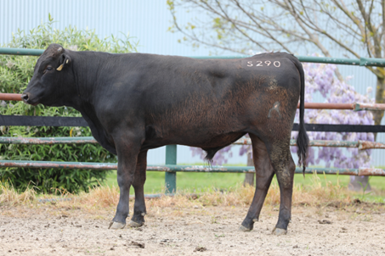
Sex: | Male
Birth Date: | 31/07/2021
Grade: | Fullblood
Colour: | Black
Gene Tests: | CL16-Free, F11-Free, CHS-Free, IARS-Non Carrier (Free), B3-Free
PEDFA10632 SHIGESHIGENAMI J10632
IMUFQTF148 ITOSHIGENAMI (IMP USA)
PEDFA661 FUKUYUKI
Sire: LFDFD12558 LONGFORD MR AWESOME (AI) (ET)
IMUFQTF147 ITOSHIGEFUJI (IMP USA)
LFDFZ0570 LONGFORD LFDB570 (AI) (ET)
LFDFV0078 LONGFORD 0078 (AI) (ET)
Animal: LFDFS0290 LONGFORD S0290 (AI)
IMJFAJ2351 HIRASHIGETAYASU J2351 HONGEN (IMP JAP)
LFDFU0695 LONGFORD KARIYA (AI) (ET)
PEDFNJ1205 SEKITSUYAFUKU W46 J1941824
Dam: LFDFC11832 LONGFORD F C11832
IMJFAJ2810 KITATERUYASUDOI J2810 HONGEN (IMP JAP)
LFDFZ0577 LONGFORD LFDB577 (AI) (ET)
LFDFV0660 LONGFORD 660 (AI)

 | GL  (days) | BWT  (kg) | 200  (kg) | 400  (kg) | 600  (kg) | MCW  (kg) | Milk  (kg) | SS  (cm) | CWT  (kg) | EMA  (sqcm) | RUMP  (mm) | RBY  (%) | MS | MF  (%) | WBI  ($) | SRI ($) | FTI ($) | F1TI  ($)
EBV | +0.6 | +0.3 | +13 | +14 | +13 | +4 | +2 | -0.6 | -2 | -0.2 | -2.1 | +0.1 | +2.3 | +0.25 | +$184 | +$196 | +$181 | +$177
ACC | 57% | 70% | 72% | 72% | 72% | 66% | 66% | 60% | 71% | 67% | 66% | 60% | 69% | 62%

Buyer - _____________________________ Price $__________________

Lot 13 | LONGFORD S0292 | Junior Bull

Identifier: | LFDFS0292 | 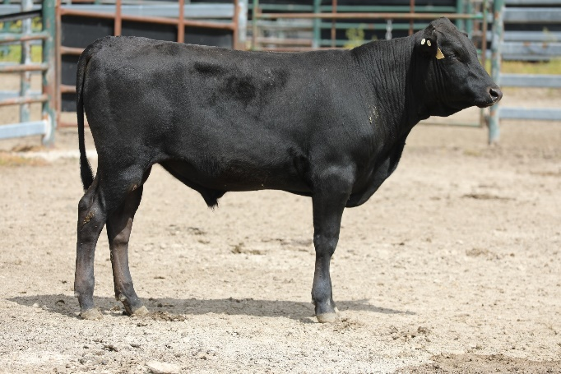
Sex: | Male
Birth Date: | 31/07/2021
Grade: | Fullblood
Colour: | Black
Gene Tests: | IARS-Non Carrier (Free), CHS-Free, F11-Free, CL16-Free, B3-Free
IMUFQTF148 ITOSHIGENAMI (IMP USA)
LFDFD12558 LONGFORD MR AWESOME (AI) (ET)
LFDFZ0570 LONGFORD LFDB570 (AI) (ET)
Sire: LFDFM0184 LONGFORD M0184 (AI) (ET)
LFDFT0475 LONGFORD HONJO (AI) (ET)
LFDFC11859 LONGFORD F C11859
LFDFY0011 LONGFORD 011 (AI) (ET)
Animal: LFDFS0292 LONGFORD S0292
IMUFLTF151 ITOZURUDOI TF151 (IMP USA)
LFDFZ0503 LONGFORD LFDB503 (AI)
LFDFX0131 LONGFORD F X131 (AI) (ET)
Dam: LFDFG0772 LONGFORD 772 (ET)
LFDFT0476 LONGFORD ZAKI (AI) (ET)
LFDFA8341 LONGFORD R8341 (ET)
LFDFU0692 LONGFORD YOKOTE (AI) (ET)

 | GL  (days) | BWT  (kg) | 200  (kg) | 400  (kg) | 600  (kg) | MCW  (kg) | Milk  (kg) | SS  (cm) | CWT  (kg) | EMA  (sqcm) | RUMP  (mm) | RBY  (%) | MS | MF  (%) | WBI  ($) | SRI ($) | FTI ($) | F1TI  ($)
EBV | +0.4 | +2.1 | +14 | +25 | +33 | +33 | +2 | -0.5 | +16 | +2.6 | -2.5 | +0.5 | +1.8 | +0.26 | +$223 | +$221 | +$193 | +$175
ACC | 50% | 64% | 66% | 65% | 65% | 56% | 58% | 50% | 62% | 55% | 55% | 47% | 57% | 50%

Buyer - _____________________________ Price $__________________

Lot 14 | LONGFORD S0293 | Junior Bull

Identifier: | LFDFS0293 | Sorry no image
Sex: | Male
Birth Date: | 31/07/2021
Grade: | Fullblood
Colour: | Black
Gene Tests: | IARS-Non Carrier (Free), F11-Free, CL16-Free, CHS-Free, B3-Free
IMUFQTF148 ITOSHIGENAMI (IMP USA)
LFDFD12558 LONGFORD MR AWESOME (AI) (ET)
LFDFZ0570 LONGFORD LFDB570 (AI) (ET)
Sire: LFDFM0184 LONGFORD M0184 (AI) (ET)
LFDFT0475 LONGFORD HONJO (AI) (ET)
LFDFC11859 LONGFORD F C11859
LFDFY0011 LONGFORD 011 (AI) (ET)
Animal: LFDFS0293 LONGFORD S0293
PEDFAJ1555 ITOHIRASHIGE J1555
IMJFAJ2703 ITOMORITAKA J2703 HONGEN (IMP JAP)
PEDFAJ565554 DAI 6 OEFUJII J565554 - KURO KOH
Dam: LFDFB8597 LONGFORD B8597 (AI) (ET)
IMUFM2100 KIKUYASU 400 (IMP JAP)
TMBFT0019 DENI 019A (AI) (ET)
TMBFR0034 DENI HARUTOMI (IMP USA) (ET)

 | GL  (days) | BWT  (kg) | 200  (kg) | 400  (kg) | 600  (kg) | MCW  (kg) | Milk  (kg) | SS  (cm) | CWT  (kg) | EMA  (sqcm) | RUMP  (mm) | RBY  (%) | MS | MF  (%) | WBI  ($) | SRI ($) | FTI ($) | F1TI  ($)
EBV | +1.0 | +4.7 | +25 | +37 | +55 | +54 | -1 | +0.5 | +28 | +3.3 | -3.0 | +1.4 | +0.8 | +0.07 | +$216 | +$190 | +$137 | +$101
ACC | 53% | 66% | 69% | 68% | 68% | 59% | 61% | 54% | 65% | 58% | 58% | 51% | 60% | 53%

Buyer - _____________________________ Price $__________________

Lot 15 | LONGFORD S0295 (AI) | Junior Bull

Identifier: | LFDFS0295 | Sorry no image
Sex: | Male
Birth Date: | 31/07/2021
Grade: | Fullblood
Colour: | Black
Gene Tests: | F11-Free, CL16-Free, CHS-Free, IARS-Non Carrier (Free), B3-Free
PEDFA10632 SHIGESHIGENAMI J10632
IMUFQTF148 ITOSHIGENAMI (IMP USA)
PEDFA661 FUKUYUKI
Sire: LFDFD12558 LONGFORD MR AWESOME (AI) (ET)
IMUFQTF147 ITOSHIGEFUJI (IMP USA)
LFDFZ0570 LONGFORD LFDB570 (AI) (ET)
LFDFV0078 LONGFORD 0078 (AI) (ET)
Animal: LFDFS0295 LONGFORD S0295 (AI)
WKSFM0164 WORLD K'S MICHIFUKU
LFDFT0476 LONGFORD ZAKI (AI) (ET)
WKSFMJ913 WORLD K'S RIKITANI J913 (ET)
Dam: LFDFC11847 LONGFORD F C11847
IMUFQ2599 TF YUKIHARUNAMI 4 (IMP USA)
LFDFZ0584 LONGFORD LFDB584 (AI) (ET)
LFDFT0479 LONGFORD IKEDA (AI) (ET)

 | GL  (days) | BWT  (kg) | 200  (kg) | 400  (kg) | 600  (kg) | MCW  (kg) | Milk  (kg) | SS  (cm) | CWT  (kg) | EMA  (sqcm) | RUMP  (mm) | RBY  (%) | MS | MF  (%) | WBI  ($) | SRI ($) | FTI ($) | F1TI  ($)
EBV | +0.7 | +3.3 | +17 | +21 | +26 | +15 | +1 | -0.5 | +7 | +4.1 | -1.0 | +0.6 | +1.7 | +0.13 | +$206 | +$207 | +$171 | +$156
ACC | 55% | 68% | 70% | 69% | 69% | 62% | 63% | 57% | 67% | 62% | 62% | 55% | 64% | 58%

Buyer - _____________________________ Price $__________________

Lot 16 | LONGFORD S0296 | Junior Bull

Identifier: | LFDFS0296 | 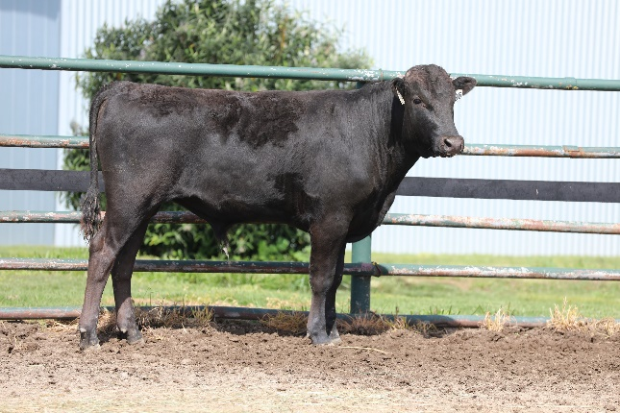
Sex: | Male
Birth Date: | 31/07/2021
Grade: | Fullblood
Colour: | Black
Gene Tests: | CL16-Free, IARS-Non Carrier (Free), F11-Free, CHS-Free, B3-Free
IMUFQTF148 ITOSHIGENAMI (IMP USA)
LFDFD12558 LONGFORD MR AWESOME (AI) (ET)
LFDFZ0570 LONGFORD LFDB570 (AI) (ET)
Sire: LFDFN0136 LONGFORD N0136 (AI) (ET)
LFDFT0476 LONGFORD ZAKI (AI) (ET)
LFDFB8566 LONGFORD B8566
LFDFZ1065 LONGFORD LFDB1065 (AI) (ET)
Animal: LFDFS0296 LONGFORD S0296
IMUFLTF151 ITOZURUDOI TF151 (IMP USA)
LFDFZ0503 LONGFORD LFDB503 (AI)
LFDFX0131 LONGFORD F X131 (AI) (ET)
Dam: LFDFD12641 LONGFORD D12641
IMUFQTF148 ITOSHIGENAMI (IMP USA)
LFDFA8358 LONGFORD R8358 (AI) (ET)
LFDFV0664 LONGFORD 664 (AI)

 | GL  (days) | BWT  (kg) | 200  (kg) | 400  (kg) | 600  (kg) | MCW  (kg) | Milk  (kg) | SS  (cm) | CWT  (kg) | EMA  (sqcm) | RUMP  (mm) | RBY  (%) | MS | MF  (%) | WBI  ($) | SRI ($) | FTI ($) | F1TI  ($)
EBV | +0.7 | +0.4 | +6 | +8 | +4 | -8 | -1 | -0.8 | -10 | +4.0 | +1.3 | +0.1 | +1.5 | +0.19 | +$154 | +$173 | +$152 | +$152
ACC | 50% | 64% | 67% | 65% | 66% | 56% | 57% | 49% | 62% | 55% | 55% | 46% | 57% | 49%

Buyer - _____________________________ Price $__________________

Lot 17 | LONGFORD S0297 | Junior Bull

Identifier: | LFDFS0297 | 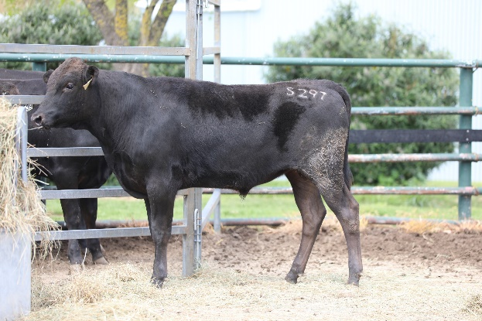
Sex: | Male
Birth Date: | 31/07/2021
Grade: | Fullblood
Colour: | Black
Gene Tests: | B3-Free, IARS-Non Carrier (Free), F11-Free, CHS-Free, CL16-Free
IMUFQTF148 ITOSHIGENAMI (IMP USA)
LFDFD12558 LONGFORD MR AWESOME (AI) (ET)
LFDFZ0570 LONGFORD LFDB570 (AI) (ET)
Sire: LFDFM0184 LONGFORD M0184 (AI) (ET)
LFDFT0475 LONGFORD HONJO (AI) (ET)
LFDFC11859 LONGFORD F C11859
LFDFY0011 LONGFORD 011 (AI) (ET)
Animal: LFDFS0297 LONGFORD S0297
WKSFN2892 WORLD K'S TAKAZAKURA
TWAFR0007 TWA SHIKIKAN (IMP USA) (ET)
WKSFL0976 WORLD K'S SUZUTANI (FB1617)
Dam: LFDFC11790 LONGFORD F C11790 (AI) (ET)
IMUFQ2599 TF YUKIHARUNAMI 4 (IMP USA)
LFDFZ0600 LONGFORD LFDB600 (AI) (ET)
LFDFT0479 LONGFORD IKEDA (AI) (ET)

 | GL  (days) | BWT  (kg) | 200  (kg) | 400  (kg) | 600  (kg) | MCW  (kg) | Milk  (kg) | SS  (cm) | CWT  (kg) | EMA  (sqcm) | RUMP  (mm) | RBY  (%) | MS | MF  (%) | WBI  ($) | SRI ($) | FTI ($) | F1TI  ($)
EBV | -0.3 | -1.1 | 0 | +1 | 0 | -6 | +1 | -1.1 | -12 | +3.0 | -2.4 | +0.6 | +1.7 | +0.15 | +$125 | +$140 | +$132 | +$135
ACC | 50% | 63% | 65% | 64% | 64% | 56% | 56% | 50% | 61% | 55% | 55% | 48% | 57% | 50%

Buyer - _____________________________ Price $__________________

Lot 18 | LONGFORD S0298 (AI) | Junior Bull

Identifier: | LFDFS0298 | 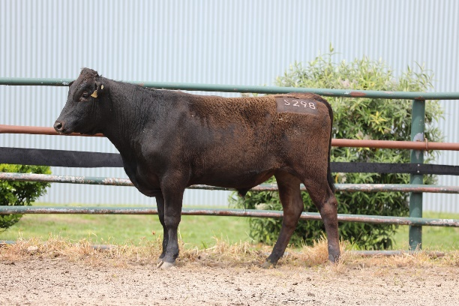
Sex: | Male
Birth Date: | 31/07/2021
Grade: | Fullblood
Colour: | Black
Gene Tests: | IARS-Non Carrier (Free), B3-Free, CL16-Free, CHS-Free, F11-Carrier
PEDFA10632 SHIGESHIGENAMI J10632
IMUFQTF148 ITOSHIGENAMI (IMP USA)
PEDFA661 FUKUYUKI
Sire: LFDFD12558 LONGFORD MR AWESOME (AI) (ET)
IMUFQTF147 ITOSHIGEFUJI (IMP USA)
LFDFZ0570 LONGFORD LFDB570 (AI) (ET)
LFDFV0078 LONGFORD 0078 (AI) (ET)
Animal: LFDFS0298 LONGFORD S0298 (AI)
PEDFA10632 SHIGESHIGENAMI J10632
IMUFQTF148 ITOSHIGENAMI (IMP USA)
PEDFA661 FUKUYUKI
Dam: LFDFB8574 LONGFORD B8574 (AI) (ET)
IMJFAJ2703 ITOMORITAKA J2703 HONGEN (IMP JAP)
LFDFY0042 LONGFORD 042Y (AI) (ET)
LFDFU0102 LONGFORD JOSAN (AI)

 | GL  (days) | BWT  (kg) | 200  (kg) | 400  (kg) | 600  (kg) | MCW  (kg) | Milk  (kg) | SS  (cm) | CWT  (kg) | EMA  (sqcm) | RUMP  (mm) | RBY  (%) | MS | MF  (%) | WBI  ($) | SRI ($) | FTI ($) | F1TI  ($)
EBV | -0.4 | +1.4 | +14 | +20 | +31 | +22 | -1 | -0.5 | +16 | +5.1 | -1.5 | +1.1 | +2.5 | +0.22 | +$257 | +$265 | +$219 | +$202
ACC | 60% | 71% | 73% | 73% | 73% | 66% | 67% | 62% | 71% | 66% | 66% | 59% | 68% | 62%

Buyer - _____________________________ Price $__________________

Lot 19 | LONGFORD S0299 | Junior Bull

Identifier: | LFDFS0299 | 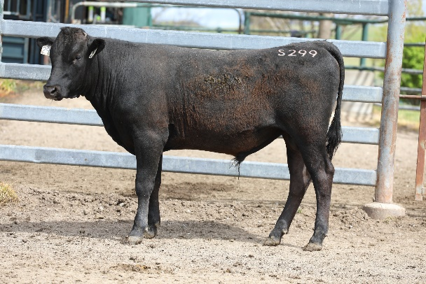
Sex: | Male
Birth Date: | 31/07/2021
Grade: | Fullblood
Colour: | Black
Gene Tests: | CL16-Free, IARS-Non Carrier (Free), F11-Free, B3-Free, CHS-Free
IMUFQTF148 ITOSHIGENAMI (IMP USA)
LFDFD12558 LONGFORD MR AWESOME (AI) (ET)
LFDFZ0570 LONGFORD LFDB570 (AI) (ET)
Sire: LFDFN0136 LONGFORD N0136 (AI) (ET)
LFDFT0476 LONGFORD ZAKI (AI) (ET)
LFDFB8566 LONGFORD B8566
LFDFZ1065 LONGFORD LFDB1065 (AI) (ET)
Animal: LFDFS0299 LONGFORD S0299
LFDFT0475 LONGFORD HONJO (AI) (ET)
LFDFA8323 LONGFORD LFDR8323
GKMFU0040 LONGBOW SAINT ANNE (AI) (ET)
Dam: LFDFF0355 LONGFORD F F355
WESFTH001 WESTHOLME SEKITAYASU 98/1 (IMP USA) (AI) (ET)
LFDFY0034 LONGFORD 034Y
LFDFU0693 LONGFORD SUSAK (AI) (ET)

 | GL  (days) | BWT  (kg) | 200  (kg) | 400  (kg) | 600  (kg) | MCW  (kg) | Milk  (kg) | SS  (cm) | CWT  (kg) | EMA  (sqcm) | RUMP  (mm) | RBY  (%) | MS | MF  (%) | WBI  ($) | SRI ($) | FTI ($) | F1TI  ($)
EBV | +1.5 | +1.1 | +11 | +16 | +17 | +9 | 0 | -0.5 | +3 | +2.9 | +0.7 | +0.2 | +1.9 | +0.17 | +$195 | +$206 | +$176 | +$168
ACC | 50% | 64% | 66% | 65% | 66% | 56% | 58% | 50% | 62% | 56% | 56% | 48% | 58% | 51%

Buyer - _____________________________ Price $__________________

Lot 20 | LONGFORD S0300 (AI) | Junior Bull

Identifier: | LFDFS0300 | 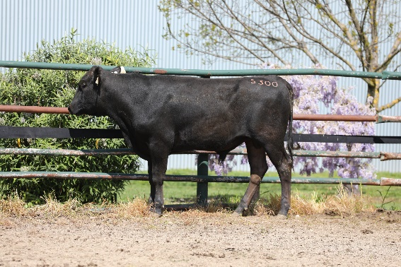
Sex: | Male
Birth Date: | 31/07/2021
Grade: | Fullblood
Colour: | Black
Gene Tests: | CHS-Free, B3-Free, IARS-Non Carrier (Free), F11-Carrier, CL16-Free
PEDFA10632 SHIGESHIGENAMI J10632
IMUFQTF148 ITOSHIGENAMI (IMP USA)
PEDFA661 FUKUYUKI
Sire: LFDFD12558 LONGFORD MR AWESOME (AI) (ET)
IMUFQTF147 ITOSHIGEFUJI (IMP USA)
LFDFZ0570 LONGFORD LFDB570 (AI) (ET)
LFDFV0078 LONGFORD 0078 (AI) (ET)
Animal: LFDFS0300 LONGFORD S0300 (AI)
WKSFN2892 WORLD K'S TAKAZAKURA
TWAFR0003 TWA ICHIRYUNO (IMP USA) (ET)
WKSFM14091 WORLD K'S OKAHANA J1409
Dam: LFDFD12602 LONGFORD F D12602 (AI) (ET)
IMJFAJ2703 ITOMORITAKA J2703 HONGEN (IMP JAP)
LFDFU0692 LONGFORD YOKOTE (AI) (ET)
PEDFPJ4347 TAKEHARU J4347 - W277

 | GL  (days) | BWT  (kg) | 200  (kg) | 400  (kg) | 600  (kg) | MCW  (kg) | Milk  (kg) | SS  (cm) | CWT  (kg) | EMA  (sqcm) | RUMP  (mm) | RBY  (%) | MS | MF  (%) | WBI  ($) | SRI ($) | FTI ($) | F1TI  ($)
EBV | +0.9 | +2.8 | +18 | +23 | +36 | +26 | +7 | 0.0 | +18 | +1.7 | -3.4 | +0.8 | +1.9 | +0.18 | +$194 | +$180 | +$167 | +$146
ACC | 58% | 69% | 71% | 70% | 70% | 64% | 65% | 60% | 69% | 64% | 64% | 58% | 66% | 59%

Buyer - _____________________________ Price $__________________

Lot 21 | LONGFORD S0301 | Junior Bull

Identifier: | LFDFS0301 | 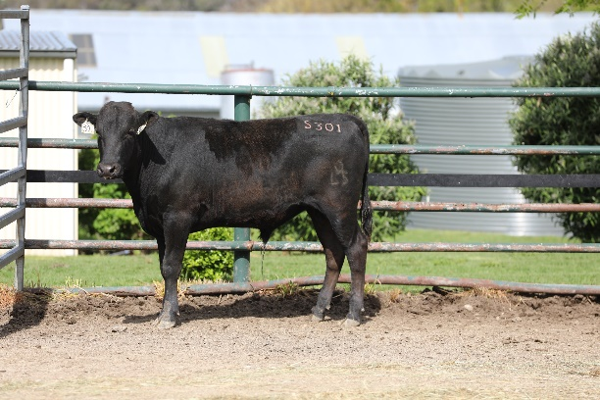
Sex: | Male
Birth Date: | 31/07/2021
Grade: | Fullblood
Colour: | Black
Gene Tests: | F11-Free, CL16-Free, IARS-Non Carrier (Free), CHS-Carrier, B3-Free
IMUFQTF148 ITOSHIGENAMI (IMP USA)
LFDFD12558 LONGFORD MR AWESOME (AI) (ET)
LFDFZ0570 LONGFORD LFDB570 (AI) (ET)
Sire: LFDFN0136 LONGFORD N0136 (AI) (ET)
LFDFT0476 LONGFORD ZAKI (AI) (ET)
LFDFB8566 LONGFORD B8566
LFDFZ1065 LONGFORD LFDB1065 (AI) (ET)
Animal: LFDFS0301 LONGFORD S0301
IMUFQ2599 TF YUKIHARUNAMI 4 (IMP USA)
LFDFB8743 LONGFORD B8743 (AI) (ET)
LFDFZ0550 LONGFORD LFDB550 (AI) (ET)
Dam: LFDFH0003 LONGFORD H0003
WKSFS0100 WORLD K'S YASUFUKU JR (FB5061)
LFDFD12781 LONGFORD D12781 (AI) (ET)
LFDFA8380 LONGFORD R8380 (AI) (ET)

 | GL  (days) | BWT  (kg) | 200  (kg) | 400  (kg) | 600  (kg) | MCW  (kg) | Milk  (kg) | SS  (cm) | CWT  (kg) | EMA  (sqcm) | RUMP  (mm) | RBY  (%) | MS | MF  (%) | WBI  ($) | SRI ($) | FTI ($) | F1TI  ($)
EBV | +1.5 | +2.2 | +14 | +17 | +21 | +18 | 0 | -0.7 | +11 | +5.2 | -1.2 | +1.0 | +1.6 | +0.15 | +$201 | +$205 | +$163 | +$163
ACC | 50% | 64% | 67% | 65% | 66% | 55% | 57% | 49% | 62% | 55% | 55% | 46% | 57% | 49%

Buyer - _____________________________ Price $__________________

Lot 22 | LONGFORD S0302 | Junior Bull

Identifier: | LFDFS0302 | 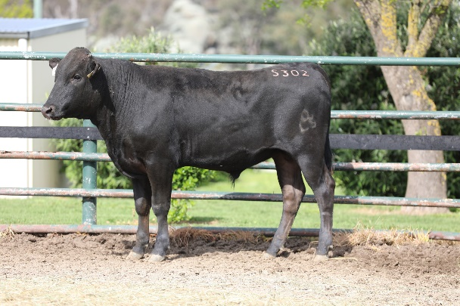
Sex: | Male
Birth Date: | 31/07/2021
Grade: | Fullblood
Colour: | Black
Gene Tests: | F11-Free, CHS-Free, B3-Free, CL16-Free, IARS-Non Carrier (Free)
IMUFQTF148 ITOSHIGENAMI (IMP USA)
LFDFD12558 LONGFORD MR AWESOME (AI) (ET)
LFDFZ0570 LONGFORD LFDB570 (AI) (ET)
Sire: LFDFM0184 LONGFORD M0184 (AI) (ET)
LFDFT0475 LONGFORD HONJO (AI) (ET)
LFDFC11859 LONGFORD F C11859
LFDFY0011 LONGFORD 011 (AI) (ET)
Animal: LFDFS0302 LONGFORD S0302
WKSFM0164 WORLD K’S MICHIFUKU
LFDFT0475 LONGFORD HONJO (AI) (ET)
WKSFMJ913 WORLD K’S RIKITANI J913 (ET)
Dam: LFDFB8527 LONGFORD B8527
IMJFAJ2703 ITOMORITAKA J2703 (IMP JAP)
LFDFU0689 LONGFORD YUZA (AI) (ET)
PEDFPJ4187 SHIGEKO J4187 - W276

 | GL  (days) | BWT  (kg) | 200  (kg) | 400  (kg) | 600  (kg) | MCW  (kg) | Milk  (kg) | SS  (cm) | CWT  (kg) | EMA  (sqcm) | RUMP  (mm) | RBY  (%) | MS | MF  (%) | WBI  ($) | SRI ($) | FTI ($) | F1TI  ($)
EBV | +1.4 | +5.9 | +32 | +52 | +70 | +76 | +4 | +0.5 | +38 | +1.5 | -1.9 | +0.4 | +2.4 | +0.33 | +$333 | +$309 | +$264 | +$221
ACC | 51% | 65% | 68% | 67% | 67% | 58% | 59% | 51% | 64% | 57% | 57% | 49% | 60% | 52%

Buyer - _____________________________ Price $__________________

Lot 23 | LONGFORD S0304 | Junior Bull

Identifier: | LFDFS0304 | 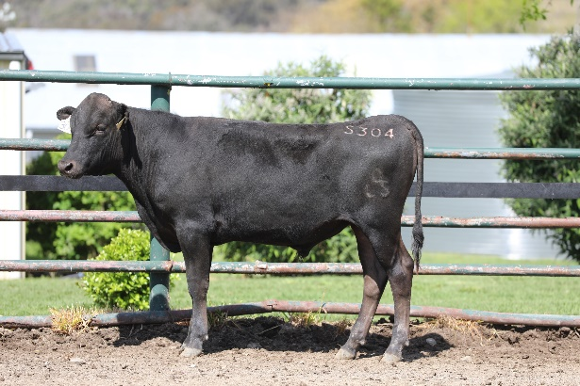
Sex: | Male
Birth Date: | 31/07/2021
Grade: | Fullblood
Colour: | Black
Gene Tests: | IARS-Non Carrier (Free), F11-Free, CL16-Free, CHS-Free, B3-Free
IMUFQTF148 ITOSHIGENAMI (IMP USA)
LFDFD12558 LONGFORD MR AWESOME (AI) (ET)
LFDFZ0570 LONGFORD LFDB570 (AI) (ET)
Sire: LFDFM0184 LONGFORD M0184 (AI) (ET)
LFDFT0475 LONGFORD HONJO (AI) (ET)
LFDFC11859 LONGFORD F C11859
LFDFY0011 LONGFORD 011 (AI) (ET)
Animal: LFDFS0304 LONGFORD S0304
IMJFAJ2351 HIRASHIGETAYASU J2351 HONGEN (IMP JAP)
WESFTH001 WESTHOLME SEKITAYASU 98/1 (IMP USA) (AI) (ET)
PEDFNJ1936979 SEKITANAKA 3 W17 J1936979
Dam: LFDFB8533 LONGFORD B8533
IMJFAJ2810 KITATERUYASUDOI J2810 HONGEN (IMP JAP)
LFDFV0659 LONGFORD 659 (AI)
LFDFU0692 LONGFORD YOKOTE (AI) (ET)

 | GL  (days) | BWT  (kg) | 200  (kg) | 400  (kg) | 600  (kg) | MCW  (kg) | Milk  (kg) | SS  (cm) | CWT  (kg) | EMA  (sqcm) | RUMP  (mm) | RBY  (%) | MS | MF  (%) | WBI  ($) | SRI ($) | FTI ($) | F1TI  ($)
EBV | +0.7 | +0.6 | +7 | +15 | +17 | +22 | +1 | -0.8 | -2 | +2.5 | -2.0 | +0.6 | +1.5 | +0.16 | +$173 | +$175 | +$149 | +$140
ACC | 53% | 67% | 70% | 69% | 69% | 60% | 62% | 53% | 65% | 58% | 59% | 51% | 60% | 53%

Buyer - _____________________________ Price $__________________

Lot 24 | LONGFORD S0305 |  | Junior Bull

Identifier: | LFDFS0305 | 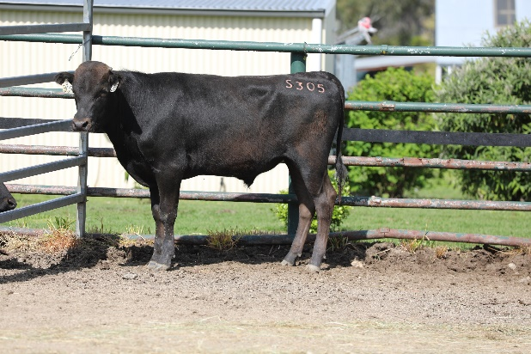
Sex: | Male
Birth Date: | 31/07/2021
Grade: | Fullblood
Colour: | Black
Gene Tests: | IARS-Non Carrier (Free), CL16-Free, CHS-Free, B3-Free, F11-Free
IMUFQTF148 ITOSHIGENAMI (IMP USA)
LFDFD12558 LONGFORD MR AWESOME (AI) (ET)
LFDFZ0570 LONGFORD LFDB570 (AI) (ET)
Sire: LFDFM0184 LONGFORD M0184 (AI) (ET)
LFDFT0475 LONGFORD HONJO (AI) (ET)
LFDFC11859 LONGFORD F C11859
LFDFY0011 LONGFORD 011 (AI) (ET)
Animal: LFDFS0305 LONGFORD S0305
IMJFMJ068 FUKUTSURU J068 (IMP JAP)
LFDFW0464 LONGFORD 464 (AI)
LFDFU0690 LONGFORD KOFU (AI) (ET)
Dam: LFDFC11800 LONGFORD F C11800
LFDFV0087 LONGFORD 0087 (AI) (ET)
LFDFZ1076 LONGFORD LFDB1076 (ET)
GKMFV0052 LONGBOW MOON SHADOW

 | GL  (days) | BWT  (kg) | 200  (kg) | 400  (kg) | 600  (kg) | MCW  (kg) | Milk  (kg) | SS  (cm) | CWT  (kg) | EMA  (sqcm) | RUMP  (mm) | RBY  (%) | MS | MF  (%) | WBI  ($) | SRI ($) | FTI ($) | F1TI  ($)
EBV | +0.6 | +0.4 | +9 | +17 | +21 | +15 | -1 | -1.2 | +7 | +4.8 | -1.6 | +1.4 | +1.4 | +0.07 | +$203 | +$210 | +$159 | +$147
ACC | 49% | 63% | 66% | 65% | 65% | 56% | 57% | 49% | 62% | 54% | 55% | 47% | 57% | 49%

Buyer - _____________________________ Price $__________________

Lot 25 | LONGFORD S0306 (AI) | Junior Bull

Identifier: | LFDFS0306 | 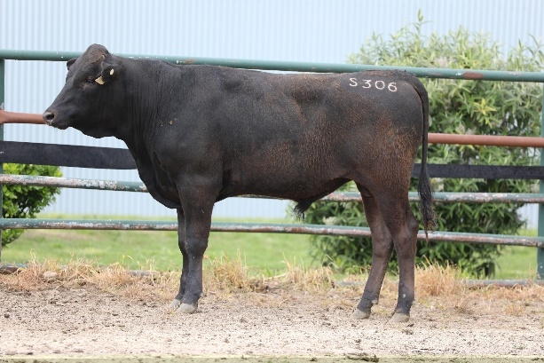
Sex: | Male
Birth Date: | 31/07/2021
Grade: | Fullblood
Colour: | Black
Gene Tests: | CL16-Free, B3-Free, IARS-Non Carrier (Free), CHS-Free, F11-Free
PEDFA10632 SHIGESHIGENAMI J10632
IMUFQTF148 ITOSHIGENAMI (IMP USA)
PEDFA661 FUKUYUKI
Sire: LFDFD12558 LONGFORD MR AWESOME (AI) (ET)
IMUFQTF147 ITOSHIGEFUJI (IMP USA)
LFDFZ0570 LONGFORD LFDB570 (AI) (ET)
LFDFV0078 LONGFORD 0078 (AI) (ET)
Animal: LFDFS0306 LONGFORD S0306 (AI)
WKSFM0164 WORLD K'S MICHIFUKU
LFDFT0475 LONGFORD HONJO (AI) (ET)
WKSFMJ913 WORLD K'S RIKITANI J913 (ET)
Dam: LFDFD12724 LONGFORD D12724
IMUFNTF149 MITSUHIKOKURA (IMP USA)
GKMFU0040 LONGBOW SAINT ANNE (AI) (ET)
TWAFS0308 TWA SAKURA (AI) (ET)

 | GL  (days) | BWT  (kg) | 200  (kg) | 400  (kg) | 600  (kg) | MCW  (kg) | Milk  (kg) | SS  (cm) | CWT  (kg) | EMA  (sqcm) | RUMP  (mm) | RBY  (%) | MS | MF  (%) | WBI  ($) | SRI ($) | FTI ($) | F1TI  ($)
EBV | +0.8 | +0.4 | +6 | +6 | +12 | +13 | 0 | -0.9 | +7 | +7.2 | +0.7 | +0.6 | +2.3 | +0.21 | +$216 | +$235 | +$201 | +$196
ACC | 53% | 66% | 68% | 67% | 68% | 61% | 61% | 55% | 66% | 61% | 61% | 54% | 63% | 56%

Buyer - _____________________________ Price $__________________

Lot 26 | LONGFORD S0308 |  | Junior Bull

Identifier: | LFDFS0308 | 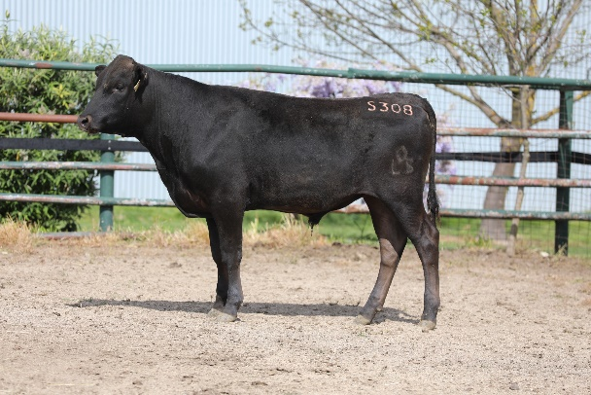
Sex: | Male
Birth Date: | 31/07/2021
Grade: | Fullblood
Colour: | Black
Gene Tests: | IARS-Non Carrier (Free), B3-Free, F11-Free, CHS-Free, CL16-Free
IMUFQTF148 ITOSHIGENAMI (IMP USA)
LFDFD12558 LONGFORD MR AWESOME (AI) (ET)
LFDFZ0570 LONGFORD LFDB570 (AI) (ET)
Sire: LFDFM0184 LONGFORD M0184 (AI) (ET)
LFDFT0475 LONGFORD HONJO (AI) (ET)
LFDFC11859 LONGFORD F C11859
LFDFY0011 LONGFORD 011 (AI) (ET)
Animal: LFDFS0308 LONGFORD S0308
PEDFA201 MONJIRO J11550
WKSFM0164 WORLD K'S MICHIFUKU
PEDFA215 MICHIKO J655635 (AI)
Dam: LFDFL0929 LONGFORD L929 (AI) (ET)
WKSFM0164 WORLD K'S MICHIFUKU
LFDFT0478 LONGFORD KANDA (AI) (ET)
IMUFP0102 KANADAGENE 102D (IMP USA) (AI) (ET)

 | GL  (days) | BWT  (kg) | 200  (kg) | 400  (kg) | 600  (kg) | MCW  (kg) | Milk  (kg) | SS  (cm) | CWT  (kg) | EMA  (sqcm) | RUMP  (mm) | RBY  (%) | MS | MF  (%) | WBI  ($) | SRI ($) | FTI ($) | F1TI  ($)
EBV | 0.0 | -0.1 | +2 | +7 | +1 | +3 | -2 | -2.2 | -19 | +4.3 | -0.6 | -0.2 | +2.5 | +0.31 | +$208 | +$241 | +$208 | +$211
ACC | 55% | 66% | 68% | 67% | 68% | 60% | 61% | 55% | 65% | 59% | 60% | 52% | 61% | 55%

Buyer - _____________________________ Price $__________________

Lot 27 | LONGFORD S0310 |  | Junior Bull

Identifier: | LFDFS0310 | 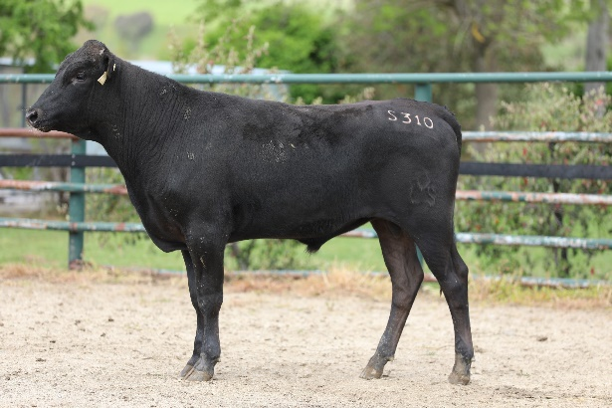
Sex: | Male
Birth Date: | 31/07/2021
Grade: | Fullblood
Colour: | Black
Gene Tests: | B3-Free, IARS-Non Carrier (Free), F11-Free, CL16-Free, CHS-Free
IMUFQTF148 ITOSHIGENAMI (IMP USA)
LFDFD12558 LONGFORD MR AWESOME (AI) (ET)
LFDFZ0570 LONGFORD LFDB570 (AI) (ET)
Sire: LFDFM0184 LONGFORD M0184 (AI) (ET)
LFDFT0475 LONGFORD HONJO (AI) (ET)
LFDFC11859 LONGFORD F C11859
LFDFY0011 LONGFORD 011 (AI) (ET)
Animal: LFDFS0310 LONGFORD S0310
IMJFAJ2351 HIRASHIGETAYASU J2351 HONGEN (IMP JAP)
LFDFV0086 LONGFORD 0086 (AI) (ET)
LFDFT0479 LONGFORD IKEDA (AI) (ET)
Dam: LFDFD12734 LONGFORD D12734
IMJFAJ2810 KITATERUYASUDOI J2810 HONGEN (IMP JAP)
LFDFX0131 LONGFORD F X131 (AI) (ET)
TMBFT0019 DENI 019A (AI) (ET)

 | GL  (days) | BWT  (kg) | 200  (kg) | 400  (kg) | 600  (kg) | MCW  (kg) | Milk  (kg) | SS  (cm) | CWT  (kg) | EMA  (sqcm) | RUMP  (mm) | RBY  (%) | MS | MF  (%) | WBI  ($) | SRI ($) | FTI ($) | F1TI  ($)
EBV | -0.2 | -0.4 | +9 | +15 | +12 | +6 | -1 | -1.2 | -1 | +3.8 | -4.5 | +1.6 | +1.5 | +0.11 | +$184 | +$192 | +$153 | +$146
ACC | 51% | 65% | 68% | 66% | 67% | 57% | 59% | 51% | 63% | 56% | 57% | 48% | 59% | 51%

Buyer - _____________________________ Price $__________________

Lot 28 | LONGFORD S0539 |  | Junior Bull

Identifier: | LFDFS0539 | 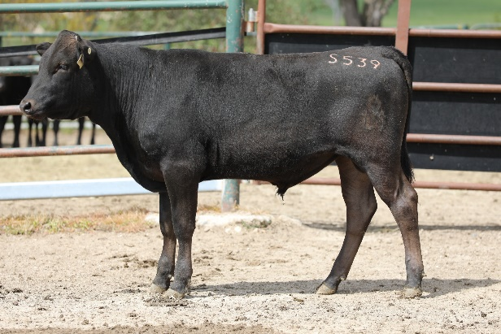
Sex: | Male
Birth Date: | 31/07/2021
Grade: | Fullblood
Colour: | Black
Gene Tests: | F11-Carrier, CL16-Free, CHS-Free, B3-Free, IARS-Non Carrier (Free)
WKSFM0164 WORLD K'S MICHIFUKU
LFDFT0476 LONGFORD ZAKI (AI) (ET)
WKSFMJ913 WORLD K'S RIKITANI J913 (ET)
Sire: LFDFC11712 LONGFORD F C11712
IMUFQTF147 ITOSHIGEFUJI (IMP USA)
LFDFZ0581 LONGFORD LFDB581 (AI) (ET)
LFDFV0078 LONGFORD 0078 (AI) (ET)
Animal: LFDFS0539 LONGFORD S0539
IMUFQTF148 ITOSHIGENAMI (IMP USA)
LFDFD12558 LONGFORD MR AWESOME (AI) (ET)
LFDFZ0570 LONGFORD LFDB570 (AI) (ET)
Dam: LFDFP0181 LONGFORD P0181 (AI) (ET)
TWAFU0623 TWA YUSHO (AI) (ET)
LFDFB8643 LONGFORD B8643
LFDFX0188 LONGFORD F X188 (AI) (ET)

 | GL  (days) | BWT  (kg) | 200  (kg) | 400  (kg) | 600  (kg) | MCW  (kg) | Milk  (kg) | SS  (cm) | CWT  (kg) | EMA  (sqcm) | RUMP  (mm) | RBY  (%) | MS | MF  (%) | WBI  ($) | SRI ($) | FTI ($) | F1TI  ($)
EBV | 0.0 | +3.2 | +20 | +24 | +30 | +16 | -2 | -1.0 | +7 | +3.9 | -3.1 | +1.2 | +1.5 | +0.08 | +$218 | +$220 | +$164 | +$146
ACC | 47% | 61% | 64% | 63% | 63% | 56% | 56% | 51% | 61% | 56% | 56% | 48% | 58% | 51%

Buyer - _____________________________ Price $__________________

Lot 29 | LONGFORD S0541 |  | Junior Bull

Identifier: | LFDFS0541 | 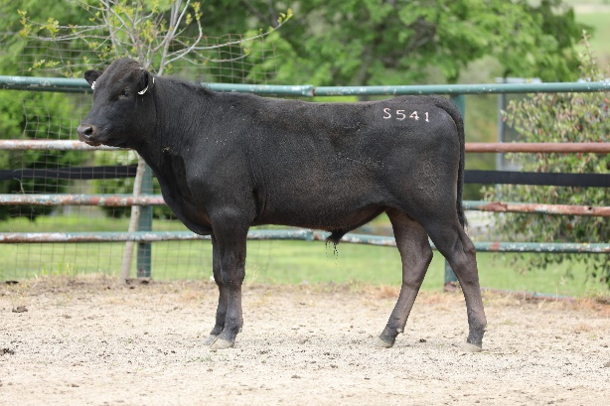
Sex: | Male
Birth Date: | 31/07/2021
Grade: | Fullblood
Colour: | Black
Gene Tests: | IARS-Non Carrier (Free), F11-Free, CL16-Free, CHS-Free, B3-Free
WKSFM0164 WORLD K'S MICHIFUKU
LFDFT0476 LONGFORD ZAKI (AI) (ET)
WKSFMJ913 WORLD K'S RIKITANI J913 (ET)
Sire: LFDFC11712 LONGFORD F C11712
IMUFQTF147 ITOSHIGEFUJI (IMP USA)
LFDFZ0581 LONGFORD LFDB581 (AI) (ET)
LFDFV0078 LONGFORD 0078 (AI) (ET)
Animal: LFDFS0541 LONGFORD S0541
IMUFQTF148 ITOSHIGENAMI (IMP USA)
LFDFD12558 LONGFORD MR AWESOME (AI) (ET)
LFDFZ0570 LONGFORD LFDB570 (AI) (ET)
Dam: LFDFP0191 LONGFORD P0191 (AI) (ET)
TWAFU0623 TWA YUSHO (AI) (ET)
LFDFB8643 LONGFORD B8643
LFDFX0188 LONGFORD F X188 (AI) (ET)

 | GL  (days) | BWT  (kg) | 200  (kg) | 400  (kg) | 600  (kg) | MCW  (kg) | Milk  (kg) | SS  (cm) | CWT  (kg) | EMA  (sqcm) | RUMP  (mm) | RBY  (%) | MS | MF  (%) | WBI  ($) | SRI ($) | FTI ($) | F1TI  ($)
EBV | +0.4 | +3.6 | +23 | +29 | +36 | +28 | 0 | -0.7 | +14 | +0.9 | -1.2 | +0.5 | +0.7 | +0.05 | +$180 | +$170 | +$118 | +$95
ACC | 52% | 67% | 69% | 68% | 69% | 60% | 61% | 54% | 66% | 59% | 60% | 51% | 62% | 54%

Buyer - _____________________________ Price $__________________

Lot 30 | LONGFORD S0542 (AI) |  | Junior Bull

Identifier: | LFDFS0542 | 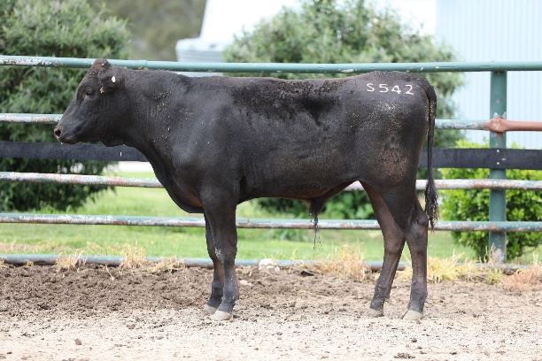
Sex: | Male
Birth Date: | 31/07/2021
Grade: | Fullblood
Colour: | Black
Gene Tests: | F11-Carrier, IARS-Non Carrier (Free), B3-Free, CL16-Free, CHS-Free
WKSFN2892 WORLD K'S TAKAZAKURA
TWAFR0003 TWA ICHIRYUNO (IMP USA) (ET)
WKSFM14091 WORLD K'S OKAHANA J1409
Sire: DEWFC0003 EDGEFERN ICHIRYUNO C0003 (AI)(ET)
IMJFAJ2810 KITATERUYASUDOI J2810 (IMP JAP)
LFDFZ1065 LONGFORD LFDB1065 (AI) (ET)
LFDFU0691 LONGFORD TAISHA (AI) (ET)
Animal: LFDFS0542 LONGFORD S0542 (AI)
IMUFQTF148 ITOSHIGENAMI (IMP USA)
LFDFD12558 LONGFORD MR AWESOME (AI) (ET)
LFDFZ0570 LONGFORD LFDB570 (AI) (ET)
Dam: LFDFN0113 LONGFORD N0113 (AI) (ET)
LFDFT0476 LONGFORD ZAKI (AI) (ET)
LFDFB8566 LONGFORD B8566
LFDFZ1065 LONGFORD LFDB1065 (AI) (ET)

 | GL  (days) | BWT  (kg) | 200  (kg) | 400  (kg) | 600  (kg) | MCW  (kg) | Milk  (kg) | SS  (cm) | CWT  (kg) | EMA  (sqcm) | RUMP  (mm) | RBY  (%) | MS | MF  (%) | WBI  ($) | SRI ($) | FTI ($) | F1TI  ($)
EBV | -0.6 | +3.7 | +26 | +39 | +49 | +47 | +7 | +0.5 | +27 | +3.1 | -4.6 | +1.7 | +1.1 | +0.15 | +$227 | +$198 | +$166 | +$135
ACC | 53% | 66% | 68% | 67% | 67% | 58% | 59% | 53% | 64% | 56% | 57% | 50% | 59% | 51%

Buyer - _____________________________ Price $__________________

Lot 31 | LONGFORD S0549 (AI) |  | Junior Bull

Identifier: | LFDFS0549 | Sorry no image
Sex: | Male
Birth Date: | 31/07/2021
Grade: | Fullblood
Colour: | Black
Gene Tests: | F11-Carrier, IARS-Non Carrier (Free), CL16-Free, CHS-Free, B3-Free
WKSFN2892 WORLD K'S TAKAZAKURA
TWAFR0003 TWA ICHIRYUNO (IMP USA) (ET)
WKSFM14091 WORLD K'S OKAHANA J1409
Sire: DEWFC0003 EDGEFERN ICHIRYUNO C0003 (AI) (ET)
IMJFAJ2810 KITATERUYASUDOI J2810 (IMP JAP)
LFDFZ1065 LONGFORD LFDB1065 (AI) (ET)
LFDFU0691 LONGFORD TAISHA (AI) (ET)
Animal: LFDFS0549 LONGFORD S0549 (AI)
IMUFQTF148 ITOSHIGENAMI (IMP USA)
LFDFD12558 LONGFORD MR AWESOME (AI) (ET)
LFDFZ0570 LONGFORD LFDB570 (AI) (ET)
Dam: LFDFH0141 LONGFORD H0141
LFDFT0476 LONGFORD ZAKI (AI) (ET)
LFDFB8555 LONGFORD B8555
LFDFZ0570 LONGFORD LFDB570 (AI) (ET)

 | GL  (days) | BWT  (kg) | 200  (kg) | 400  (kg) | 600  (kg) | MCW  (kg) | Milk  (kg) | SS  (cm) | CWT  (kg) | EMA  (sqcm) | RUMP  (mm) | RBY  (%) | MS | MF  (%) | WBI  ($) | SRI ($) | FTI ($) | F1TI  ($)
EBV | -0.4 | +2.4 | +17 | +23 | +35 | +31 | +1 | -0.4 | +17 | +1.7 | -3.5 | +1.1 | +1.2 | +0.08 | +$188 | +$178 | +$138 | +$117
ACC | 52% | 65% | 67% | 66% | 66% | 58% | 59% | 52% | 63% | 56% | 57% | 49% | 58% | 51%

Buyer - _____________________________ Price $__________________

Lot 32 | LONGFORD S0550 |  | Junior Bull

Identifier: | LFDFS0550 | 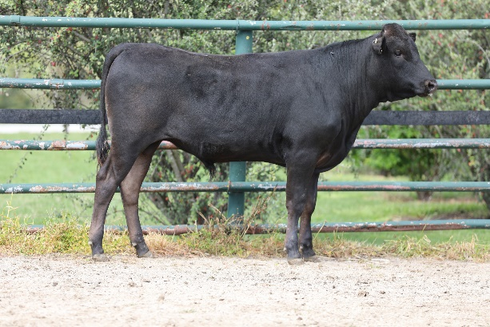
Sex: | Male
Birth Date: | 31/07/2021
Grade: | Fullblood
Colour: | Black
Gene Tests: | B3-Free, CL16-Free, IARS-Non Carrier (Free), CHS-Free, F11-Free
WKSFM0164 WORLD K'S MICHIFUKU
LFDFT0476 LONGFORD ZAKI (AI) (ET)
WKSFMJ913 WORLD K'S RIKITANI J913 (ET)
Sire: LFDFC11712 LONGFORD F C11712
IMUFQTF147 ITOSHIGEFUJI (IMP USA)
LFDFZ0581 LONGFORD LFDB581 (AI) (ET)
LFDFV0078 LONGFORD 0078 (AI) (ET)
Animal: LFDFS0550 LONGFORD S0550
IMUFQTF148 ITOSHIGENAMI (IMP USA)
LFDFD12558 LONGFORD MR AWESOME (AI) (ET)
LFDFZ0570 LONGFORD LFDB570 (AI) (ET)
Dam: LFDFP0192 LONGFORD P0192 (AI) (ET)
LFDFT0476 LONGFORD ZAKI (AI) (ET)
LFDFB8566 LONGFORD B8566
LFDFZ1065 LONGFORD LFDB1065 (AI) (ET)

 | GL  (days) | BWT  (kg) | 200  (kg) | 400  (kg) | 600  (kg) | MCW  (kg) | Milk  (kg) | SS  (cm) | CWT  (kg) | EMA  (sqcm) | RUMP  (mm) | RBY  (%) | MS | MF  (%) | WBI  ($) | SRI ($) | FTI ($) | F1TI  ($)
EBV | +0.4 | +1.3 | +14 | +12 | +14 | +7 | -1 | -1.0 | -14 | +1.7 | -0.7 | 0.0 | +2.1 | +0.18 | +$197 | +$213 | +$176 | +$171
ACC | 54% | 68% | 71% | 70% | 70% | 61% | 62% | 56% | 67% | 61% | 61% | 53% | 63% | 55%

Buyer - _____________________________ Price $__________________

Takeda Farms Itoshigenami TF148
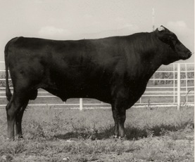

FEMALES
Lot 33 | LONGFORD R0378 (AI) |  | PTIC Heifer

Identifier: | LFDFR0378 | 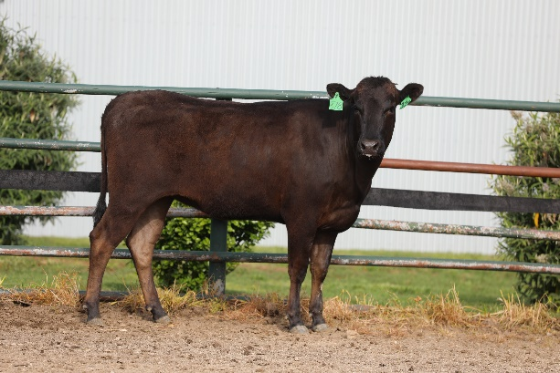
Sex: | Female
Birth Date: | 31/07/2020
Grade: | Fullblood
Colour: | Black
Genetic Condition: | B3FU, CHSFU, CL16FU, F1125%, IARSFU
PEDFA10632 SHIGESHIGENAMI J10632
IMUFQTF148 ITOSHIGENAMI (IMP USA)
PEDFA661 FUKUYUKI
Sire: LFDFD12558 LONGFORD MR AWESOME (AI) (ET)
IMUFQTF147 ITOSHIGEFUJI (IMP USA)
LFDFZ0570 LONGFORD LFDB570 (AI) (ET)
LFDFV0078 LONGFORD 0078 (AI) (ET)
Animal: LFDFR0378 LONGFORD R0378 (AI)
WKSFN2892 WORLD K'S TAKAZAKURA
TWAFR0007 TWA SHIKIKAN (IMP USA) (ET)
WKSFL0976 WORLD K'S SUZUTANI (FB1617)
Dam: LFDFP0187 LONGFORD P0187 (AI) (ET)
IMUFRTF146 KIKUTSURUDOI TF146 (IMP USA)
LFDFD12795 LONGFORD D12795 (AI) (ET)
LFDFB8580 LONGFORD B8580 (AI) (ET)

 | GL  (days) | BWT  (kg) | 200  (kg) | 400  (kg) | 600  (kg) | MCW  (kg) | Milk  (kg) | SS  (cm) | CWT  (kg) | EMA  (sqcm) | RUMP  (mm) | RBY  (%) | MS | MF  (%) | WBI  ($) | SRI ($) | FTI ($) | F1TI  ($)
EBV | +0.1 | +1.1 | +13 | +13 | +21 | +18 | +1 | -0.7 | +13 | +3.2 | -2.2 | +0.8 | +2.8 | +0.28 | +$225 | +$235 | +$200 | +$200
ACC | 56% | 68% | 70% | 69% | 70% | 63% | 63% | 58% | 67% | 63% | 63% | 56% | 64% | 58%

Buyer - _____________________________ Price $__________________

Lot 34 | LONGFORD R0394 (AI) | PTIC Heifer

Identifier: | LFDFR0394 | 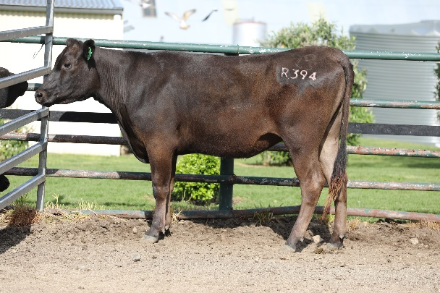
Sex: | Female
Birth Date: | 31/07/2020
Grade: | Fullblood
Colour: | Black
Genetic Condition: | B3FU, CHS7%, CL16FU, F117%, IARSFU
PEDFA10632 SHIGESHIGENAMI J10632
IMUFQTF148 ITOSHIGENAMI (IMP USA)
PEDFA661 FUKUYUKI
Sire: LFDFD12558 LONGFORD MR AWESOME (AI) (ET)
IMUFQTF147 ITOSHIGEFUJI (IMP USA)
LFDFZ0570 LONGFORD LFDB570 (AI) (ET)
LFDFV0078 LONGFORD 0078 (AI) (ET)
Animal: LFDFR0394 LONGFORD R0394 (AI)
BKEFR0061 BON KING TWA R061 (IMP USA) (AI) (ET)
LFDFH0892 LONGFORD H892 (AI)
LFDFF0406 LONGFORD F F406
Dam: LFDFP0485 LONGFORD P0485
LFDFZ1190 LONGFORD LFDB1190 (AI) (ET)
LFDFE0128 LONGFORD 128
LFDFB8564 LONGFORD B8564

 | GL  (days) | BWT  (kg) | 200  (kg) | 400  (kg) | 600  (kg) | MCW  (kg) | Milk  (kg) | SS  (cm) | CWT  (kg) | EMA  (sqcm) | RUMP  (mm) | RBY  (%) | MS | MF  (%) | WBI  ($) | SRI ($) | FTI ($) | F1TI  ($)
EBV | 0.0 | +3.6 | +22 | +34 | +49 | +36 | +6 | -0.2 | +30 | +3.1 | -4.0 | +1.4 | +1.8 | +0.14 | +$235 | +$215 | +$184 | +$153
ACC | 55% | 69% | 71% | 70% | 70% | 63% | 63% | 57% | 68% | 64% | 63% | 56% | 65% | 58%

Buyer - _____________________________ Price $__________________

Lot 35 | LONGFORD R0410 (AI) |  | PTIC Heifer

Identifier: | LFDFR0410 | 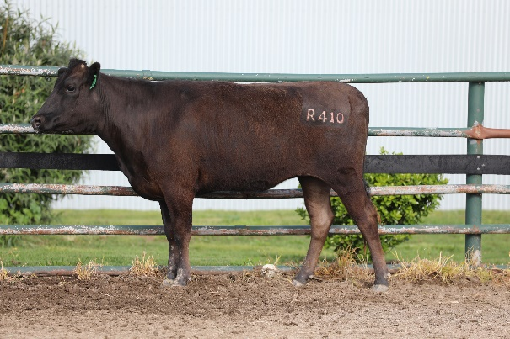
Sex: | Female
Birth Date: | 31/07/2020
Grade: | Fullblood
Colour: | Black
Genetic Condition: | B3FU, CHSFU, CL16FU, F11FU, IARSFU
PEDFA10632 SHIGESHIGENAMI J10632
IMUFQTF148 ITOSHIGENAMI (IMP USA)
PEDFA661 FUKUYUKI
Sire: LFDFD12558 LONGFORD MR AWESOME (AI) (ET)
IMUFQTF147 ITOSHIGEFUJI (IMP USA)
LFDFZ0570 LONGFORD LFDB570 (AI) (ET)
LFDFV0078 LONGFORD 0078 (AI) (ET)
Animal: LFDFR0410 LONGFORD R0410 (AI)
WKSFS0100 WORLD K'S YASUFUKU JR (FB5061)
LFDFD12759 LONGFORD F D12759 (AI) (ET)
LFDFA8380 LONGFORD R8380 (AI) (ET)
Dam: LFDFP0548 LONGFORD P0548
LFDFT0476 LONGFORD ZAKI (AI) (ET)
LFDFB8566 LONGFORD B8566
LFDFZ1065 LONGFORD LFDB1065 (AI) (ET)

 | GL  (days) | BWT  (kg) | 200  (kg) | 400  (kg) | 600  (kg) | MCW  (kg) | Milk  (kg) | SS  (cm) | CWT  (kg) | EMA  (sqcm) | RUMP  (mm) | RBY  (%) | MS | MF  (%) | WBI  ($) | SRI ($) | FTI ($) | F1TI  ($)
EBV | -0.2 | +0.7 | +12 | +14 | +20 | +15 | -1 | -1.1 | +7 | +4.5 | -0.1 | +0.2 | +2.7 | +0.27 | +$249 | +$272 | +$231 | +$223
ACC | 55% | 68% | 70% | 69% | 69% | 62% | 63% | 56% | 67% | 63% | 62% | 55% | 65% | 57%

Buyer - _____________________________ Price $__________________

Lot 36 | LONGFORD S0001 (AI) |  | PTIC Heifer

Identifier: | LFDFS0001 | 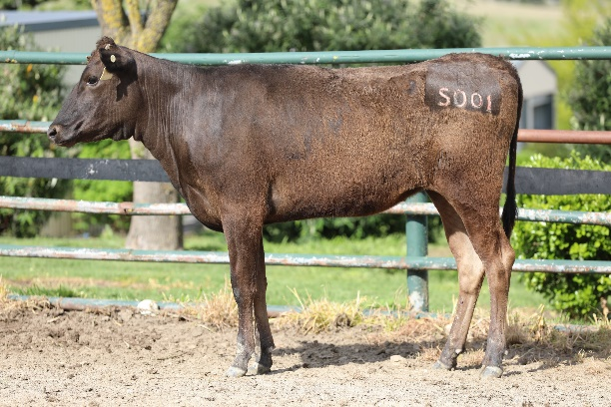
Sex: | Female
Birth Date: | 30/04/2021
Grade: | Fullblood
Colour: | Black
Genetic Condition: | B3FU, CHS4%, CL16FU, F1128%, IARSFU
PEDFA10632 SHIGESHIGENAMI J10632
IMUFQTF148 ITOSHIGENAMI (IMP USA)
PEDFA661 FUKUYUKI
Sire: LFDFD12558 LONGFORD MR AWESOME (AI) (ET)
IMUFQTF147 ITOSHIGEFUJI (IMP USA)
LFDFZ0570 LONGFORD LFDB570 (AI) (ET)
LFDFV0078 LONGFORD 0078 (AI) (ET)
Animal: LFDFS0001 LONGFORD S0001 (AI)
LFDFT0475 LONGFORD HONJO (AI) (ET)
LFDFC11690 LONGFORD F C11690
GKMFU0040 LONGBOW SAINT ANNE (AI) (ET)
Dam: LFDFQ0004 LONGFORD Q0004
LFDFB8720 LONGFORD B8720 (AI) (ET)
LFDFG0811 LONGFORD 811
LFDFB8549 LONGFORD B8549

 | GL  (days) | BWT  (kg) | 200  (kg) | 400  (kg) | 600  (kg) | MCW  (kg) | Milk  (kg) | SS  (cm) | CWT  (kg) | EMA  (sqcm) | RUMP  (mm) | RBY  (%) | MS | MF  (%) | WBI  ($) | SRI ($) | FTI ($) | F1TI  ($)
EBV | +0.5 | +1.6 | +11 | +13 | +22 | +16 | +1 | -1.3 | -1 | +3.1 | -1.1 | +0.3 | +2.4 | +0.18 | +$209 | +$218 | +$181 | +$170
ACC | 54% | 67% | 69% | 69% | 69% | 62% | 63% | 56% | 67% | 62% | 62% | 55% | 64% | 57%

Buyer - _____________________________ Price $__________________

Lot 37 | LONGFORD S0002 (AI) |  | PTIC Heifer

Identifier: | LFDFS0002 | 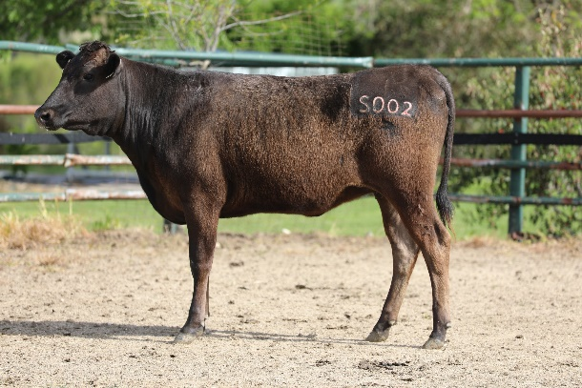
Sex: | Female
Birth Date: | 30/04/2021
Grade: | Fullblood
Colour: | Black
Genetic Condition: | B3FU, CHSFU, CL16FU, F1114%, IARSFU
PEDFA10632 SHIGESHIGENAMI J10632
IMUFQTF148 ITOSHIGENAMI (IMP USA)
PEDFA661 FUKUYUKI
Sire: LFDFD12558 LONGFORD MR AWESOME (AI) (ET)
IMUFQTF147 ITOSHIGEFUJI (IMP USA)
LFDFZ0570 LONGFORD LFDB570 (AI) (ET)
LFDFV0078 LONGFORD 0078 (AI) (ET)
Animal: LFDFS0002 LONGFORD S0002 (AI)
WKSFN2892 WORLD K'S TAKAZAKURA
LFDFJ0413 LONGFORD J413 (AI) (ET)
LFDFA8353 LONGFORD R8353 (AI)
Dam: LFDFQ0074 LONGFORD Q0074
IMUFQ2599 TF YUKIHARUNAMI 4 (IMP USA)
LFDFE1018 LONGFORD 1018 (AI)
LFDFB8555 LONGFORD B8555

 | GL  (days) | BWT  (kg) | 200  (kg) | 400  (kg) | 600  (kg) | MCW  (kg) | Milk  (kg) | SS  (cm) | CWT  (kg) | EMA  (sqcm) | RUMP  (mm) | RBY  (%) | MS | MF  (%) | WBI  ($) | SRI ($) | FTI ($) | F1TI  ($)
EBV | -0.4 | +0.6 | +15 | +17 | +25 | +14 | +6 | -0.5 | +7 | +0.5 | -2.5 | +0.5 | +2.2 | +0.14 | +$194 | +$193 | +$176 | +$163
ACC | 56% | 69% | 71% | 70% | 71% | 63% | 64% | 58% | 68% | 63% | 63% | 56% | 65% | 58%

Buyer - _____________________________ Price $__________________

World Ks Suzutani
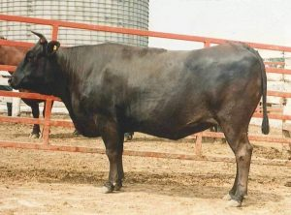

Lot 38 | LONGFORD S0009 (AI) |  | PTIC Heifer

Identifier: | LFDFS0009 | Sorry no image
Sex: | Female
Birth Date: | 30/04/2021
Grade: | Fullblood
Colour: | Black
Genetic Condition: | B3FU, CHSFU, CL16FU, F117%, IARS50%
PEDFA10632 SHIGESHIGENAMI J10632
IMUFQTF148 ITOSHIGENAMI (IMP USA)
PEDFA661 FUKUYUKI
Sire: LFDFD12558 LONGFORD MR AWESOME (AI) (ET)
IMUFQTF147 ITOSHIGEFUJI (IMP USA)
LFDFZ0570 LONGFORD LFDB570 (AI) (ET)
LFDFV0078 LONGFORD 0078 (AI) (ET)
Animal: LFDFS0009 LONGFORD S0009 (AI)
IMUFN2294 TF ITOHANA 2 (IMP USA)
LFDFK0060 LONGFORD K0060 (AI) (ET)
LFDFZ0579 LONGFORD LFDB579 (AI) (ET)
Dam: LFDFP0168 LONGFORD P0168
LFDFE0327 LONGFORD F E0327
LFDFL0285 LONGFORD L285
CLEFC0053 CLEVELANDS WAGYU F C0053 (AI) (ET)

 | GL  (days) | BWT  (kg) | 200  (kg) | 400  (kg) | 600  (kg) | MCW  (kg) | Milk  (kg) | SS  (cm) | CWT  (kg) | EMA  (sqcm) | RUMP  (mm) | RBY  (%) | MS | MF  (%) | WBI  ($) | SRI ($) | FTI ($) | F1TI  ($)
EBV | +0.6 | +1.3 | +10 | +13 | +20 | +9 | +2 | -0.5 | +7 | +4.6 | +0.2 | +0.9 | +2.0 | +0.12 | +$197 | +$203 | +$172 | +$161
ACC | 56% | 69% | 71% | 71% | 71% | 64% | 64% | 58% | 69% | 64% | 64% | 57% | 66% | 59%

Buyer - _____________________________ Price $_________________

Lot 39 | LONGFORD S0014 (AI) |  | PTIC Heifer

Identifier: | LFDFS0014 | 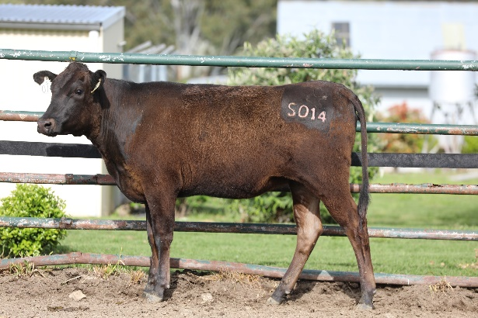
Sex: | Female
Birth Date: | 30/04/2021
Grade: | Fullblood
Colour: | Black
Genetic Condition: | B3FU, CHSFU, CL16FU, F1120%, IARSFU
PEDFA10632 SHIGESHIGENAMI J10632
IMUFQTF148 ITOSHIGENAMI (IMP USA)
PEDFA661 FUKUYUKI
Sire: LFDFD12558 LONGFORD MR AWESOME (AI) (ET)
IMUFQTF147 ITOSHIGEFUJI (IMP USA)
LFDFZ0570 LONGFORD LFDB570 (AI) (ET)
LFDFV0078 LONGFORD 0078 (AI) (ET)
Animal: LFDFS0014 LONGFORD S0014 (AI)
WKSFN2892 WORLD K'S TAKAZAKURA
LFDFJ0413 LONGFORD J413 (AI) (ET)
LFDFA8353 LONGFORD R8353 (AI)
Dam: LFDFQ0072 LONGFORD Q0072
LFDFB8720 LONGFORD B8720 (AI) (ET)
LFDFG0738 LONGFORD 738
LFDFB8572 LONGFORD B8572 (AI) (ET)

 | GL  (days) | BWT  (kg) | 200  (kg) | 400  (kg) | 600  (kg) | MCW  (kg) | Milk  (kg) | SS  (cm) | CWT  (kg) | EMA  (sqcm) | RUMP  (mm) | RBY  (%) | MS | MF  (%) | WBI  ($) | SRI ($) | FTI ($) | F1TI  ($)
EBV | +0.6 | +2.0 | +10 | +11 | +20 | +10 | +4 | -0.7 | +1 | 0.0 | -1.8 | +0.3 | +1.2 | +0.04 | +$111 | +$105 | +$91 | +$80
ACC | 55% | 68% | 70% | 70% | 70% | 63% | 63% | 57% | 68% | 63% | 63% | 56% | 64% | 57%

Buyer - _____________________________ Price $__________________

Lot 40 | LONGFORD S0006 (AI) |  | Unjoined Heifer

Identifier: | LFDFS0006 | 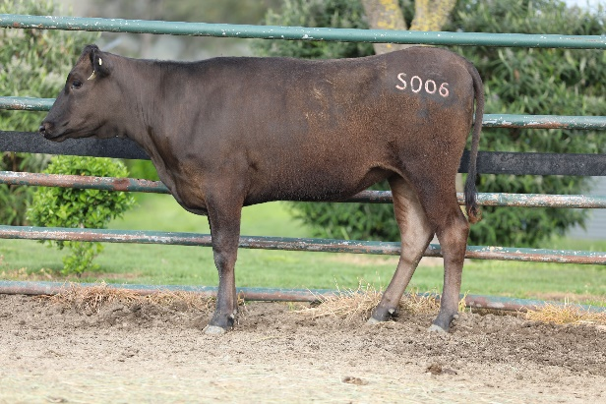
Sex: | Female
Birth Date: | 30/04/2021
Grade: | Fullblood
Colour: | Black
Genetic Condition: | B3FU, CHSFU, CL16FU, F1126%, IARSFU
PEDFA10632 SHIGESHIGENAMI J10632
IMUFQTF148 ITOSHIGENAMI (IMP USA)
PEDFA661 FUKUYUKI
Sire: LFDFD12558 LONGFORD MR AWESOME (AI) (ET)
IMUFQTF147 ITOSHIGEFUJI (IMP USA)
LFDFZ0570 LONGFORD LFDB570 (AI) (ET)
LFDFV0078 LONGFORD 0078 (AI) (ET)
Animal: LFDFS0006 LONGFORD S0006 (AI)
LFDFT0475 LONGFORD HONJO (AI) (ET)
LFDFC11690 LONGFORD F C11690
GKMFU0040 LONGBOW SAINT ANNE (AI) (ET)
Dam: LFDFQ0006 LONGFORD Q0006
LFDFC11678 LONGFORD F C11678 (AI) (ET)
LFDFG0830 LONGFORD 830
LFDFD12710 LONGFORD D12710

 | GL  (days) | BWT  (kg) | 200  (kg) | 400  (kg) | 600  (kg) | MCW  (kg) | Milk  (kg) | SS  (cm) | CWT  (kg) | EMA  (sqcm) | RUMP  (mm) | RBY  (%) | MS | MF  (%) | WBI  ($) | SRI ($) | FTI ($) | F1TI  ($)
EBV | +0.4 | +2.3 | +15 | +17 | +30 | +24 | +4 | -0.4 | +15 | +7.8 | -0.7 | +1.2 | +2.1 | +0.18 | +$245 | +$246 | +$209 | +$192
ACC | 54% | 67% | 69% | 69% | 69% | 62% | 62% | 56% | 67% | 62% | 62% | 55% | 64% | 56%

Buyer - _____________________________ Price $__________________

Lot 41 | LONGFORD S0026 |  | Unjoined Heifer

Identifier: | LFDFS0026 | 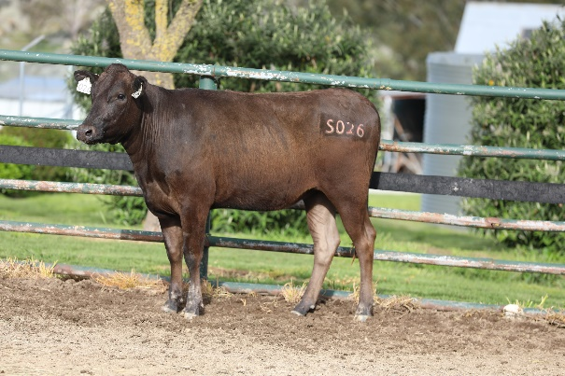
Sex: | Female
Birth Date: | 30/04/2021
Grade: | Fullblood
Colour: | Black
Genetic Condition: | B3FU, CHSFU, CL16FU, F119%, IARSFU
IMUFQTF148 ITOSHIGENAMI (IMP USA)
LFDFD12558 LONGFORD MR AWESOME (AI) (ET)
LFDFZ0570 LONGFORD LFDB570 (AI) (ET)
Sire: LFDFP0203 LONGFORD P0203 (AI) (ET)
LFDFT0476 LONGFORD ZAKI (AI) (ET)
LFDFB8566 LONGFORD B8566
LFDFZ1065 LONGFORD LFDB1065 (AI) (ET)
Animal: LFDFS0026 LONGFORD S0026
WKSFN2892 WORLD K'S TAKAZAKURA
LFDFJ0413 LONGFORD J413 (AI) (ET)
LFDFA8353 LONGFORD R8353 (AI)
Dam: LFDFQ0079 LONGFORD Q0079
LFDFB8768 LONGFORD B8768 (ET)
LFDFE0109 LONGFORD 109
LFDFZ1054 LONGFORD LFDB1054 (AI) (ET)

 | GL  (days) | BWT  (kg) | 200  (kg) | 400  (kg) | 600  (kg) | MCW  (kg) | Milk  (kg) | SS  (cm) | CWT  (kg) | EMA  (sqcm) | RUMP  (mm) | RBY  (%) | MS | MF  (%) | WBI  ($) | SRI ($) | FTI ($) | F1TI  ($)
EBV | -0.6 | +1.8 | +11 | +14 | +18 | +16 | +1 | -1.3 | -9 | -0.3 | -2.4 | 0.0 | +1.8 | +0.24 | +$165 | +$169 | +$139 | +$130
ACC | 48% | 63% | 65% | 64% | 64% | 55% | 56% | 48% | 60% | 53% | 53% | 45% | 55% | 47%

Buyer - _____________________________ Price $__________________

Lot 42 | LONGFORD S0126 |  | Unjoined Heifer

Identifier: | LFDFS0126 | 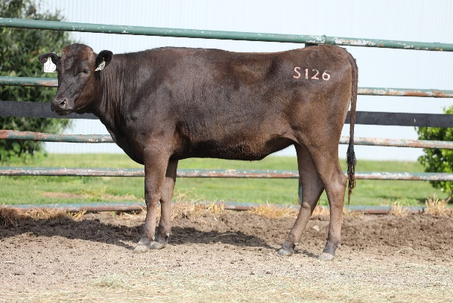
Sex: | Female
Birth Date: | 30/04/2021
Grade: | Fullblood
Colour: | Black
Genetic Condition: | B3FU, CHSFU, CL16FU, F112%, IARSFU
IMUFQTF148 ITOSHIGENAMI (IMP USA)
LFDFD12558 LONGFORD MR AWESOME (AI) (ET)
LFDFZ0570 LONGFORD LFDB570 (AI) (ET)
Sire: LFDFN0139 LONGFORD N0139 (AI) (ET)
LFDFT0476 LONGFORD ZAKI (AI) (ET)
LFDFB8566 LONGFORD B8566
LFDFZ1065 LONGFORD LFDB1065 (AI) (ET)
Animal: LFDFS0126 LONGFORD S0126
WKSFN2892 WORLD K'S TAKAZAKURA
LFDFF0495 LONGFORD 495 (AI) (ET)
LFDFA8401 LONGFORD R8401 (AI) (ET)
Dam: LFDFM0368 LONGFORD M0368
LFDFD12553 LONGFORD F D12553 (AI) (ET)
LFDFH0083 LONGFORD H0083
LFDFE0221 LONGFORD 221

 | GL  (days) | BWT  (kg) | 200  (kg) | 400  (kg) | 600  (kg) | MCW  (kg) | Milk  (kg) | SS  (cm) | CWT  (kg) | EMA  (sqcm) | RUMP  (mm) | RBY  (%) | MS | MF  (%) | WBI  ($) | SRI ($) | FTI ($) | F1TI  ($)
EBV | -2.0 | -0.1 | +15 | +16 | +24 | +14 | +4 | 0.0 | +8 | +0.3 | +1.0 | +0.2 | +1.0 | +0.09 | +$144 | +$139 | +$115 | +$103
ACC | 49% | 63% | 65% | 64% | 65% | 55% | 55% | 48% | 61% | 55% | 54% | 46% | 57% | 48%

Buyer - _____________________________ Price $__________________

If you’re worried about the price
of getting started,
you should see the cost
of staying exactly where you are.
- Author unknown

SEMEN STRAWS

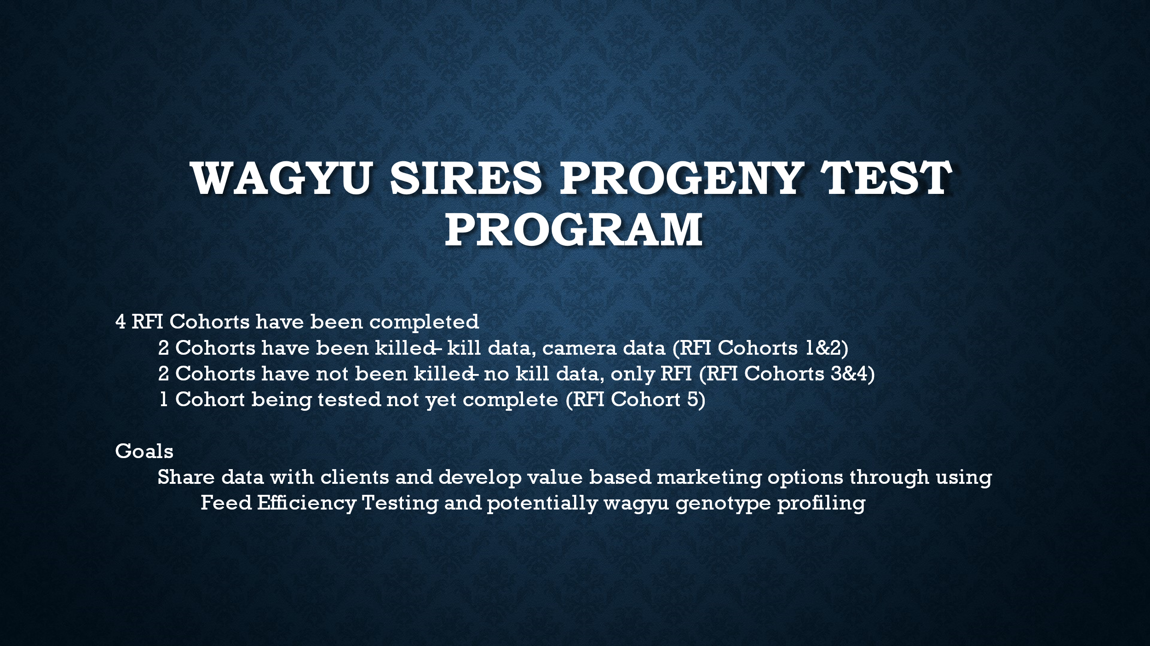
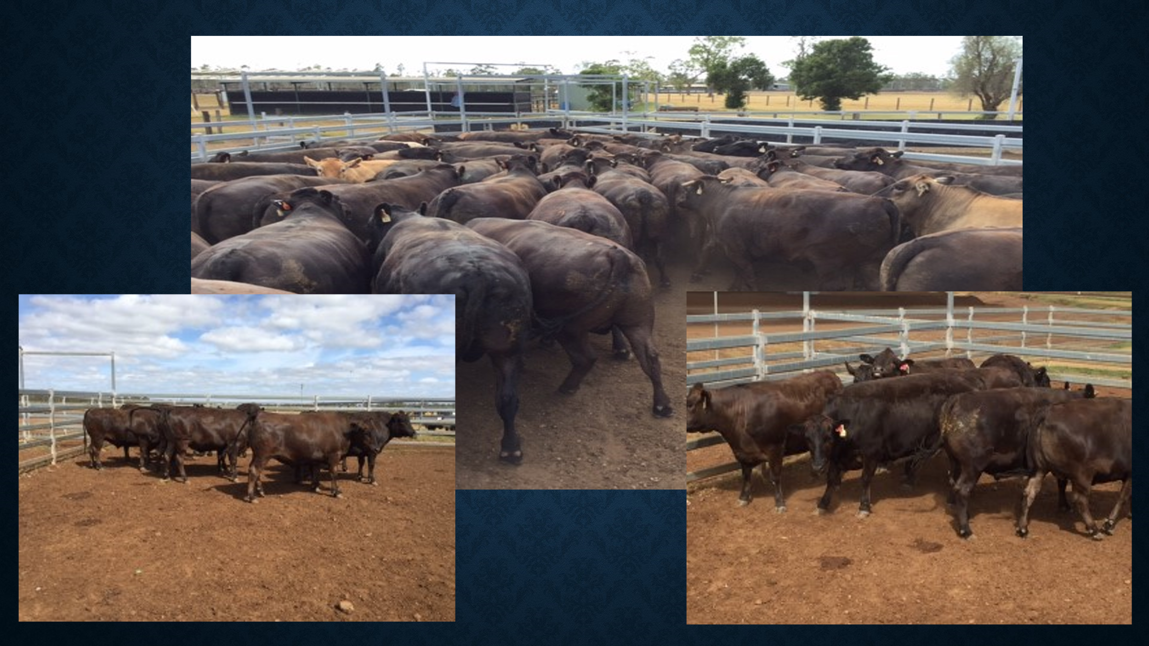

*As FB steers were unavailable for the trial, F3 Steers were used instead.

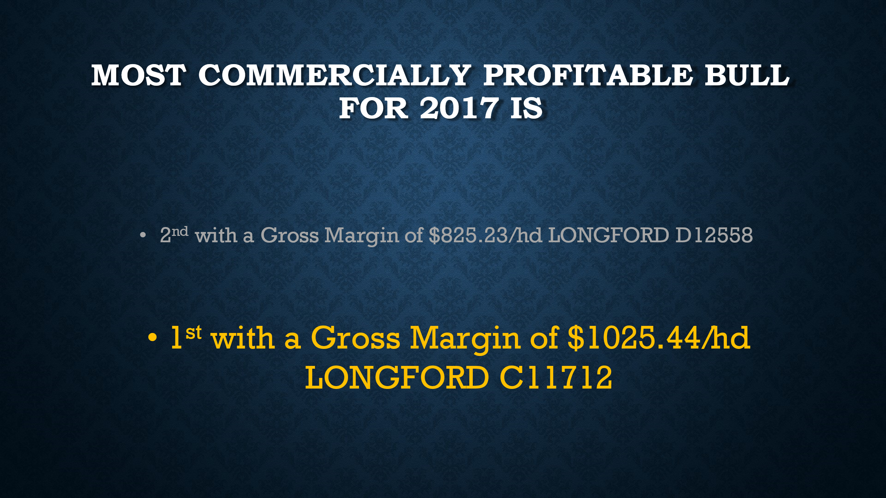

"It's difficult to find bulls that produce this well and produce it consistently. It took us a long time to breed our top sire Mr Awesome, and bulls like this are rare.”

- Arthur Dew, Longford Station Wagyu
- QCL 8th March 2022

Lot 43 | LONGFORD F C11712 |  | 5 straws with the option of 10 more semen straws

All semen straws are sold per straw with GST added after. Australian domestic use only.
Stored in Armidale, NSW, 2350.
Identifier: | LFDFC11712 | Sorry no image
Sex: | Male
Birth Date: | 10/09/2007
Grade: | Fullblood
Colour: | Black
Genetic Condition: | B3FU, CHSF, CL16FU, F11FU, IARSF
PEDFA201 MONJIRO J11550
WKSFM0164 WORLD K'S MICHIFUKU
PEDFA215 MICHIKO J655635 (AI)
Sire: LFDFT0476 LONGFORD ZAKI (AI) (ET)
PEDFA211 TANISHIGE 1526 - KURO KOH
WKSFMJ913 WORLD K'S RIKITANI J913 (ET)
PEDFAJ608671 SHIGEKANE J608671
Animal: LFDFC11712 LONGFORD F C11712
PEDFAJ483 ITOFUJI J483
IMUFQTF147 ITOSHIGEFUJI (IMP USA)
PEDFAJ920752 DAI 30 NOBORU J920752
Dam: LFDFZ0581 LONGFORD LFDB581 (AI) (ET)
IMJFAJ2810 KITATERUYASUDOI J2810 HONGEN (IMP JAP)
LFDFV0078 LONGFORD 0078 (AI) (ET)
LFDFT0479 LONGFORD IKEDA (AI) (ET)

 | GL  (days) | BWT  (kg) | 200  (kg) | 400  (kg) | 600  (kg) | MCW  (kg) | Milk  (kg) | SS  (cm) | CWT  (kg) | EMA  (sqcm) | RUMP  (mm) | RBY  (%) | MS | MF  (%) | WBI  ($) | SRI ($) | FTI ($) | F1TI  ($)
EBV | -0.2 | +3.0 | +20 | +24 | +23 | +19 | -6 | -0.9 | 0 | +2.2 | -2.3 | +0.7 | +1.0 | +0.07 | +$191 | +$195 | +$134 | +$120
ACC | 57% | 79% | 81% | 81% | 81% | 72% | 72% | 69% | 80% | 75% | 73% | 66% | 78% | 67%

LFDFC11712 is a son of T0476 Longford Zaki, a Michifuku x Rikitani successful sire. The female side is like that of Mr Awesome with the dam being a full sister to Mr Awesome’s dam. C11712 produced high grade carcasses in Japan & the small amount of Australian fullblood carcass data is excellent. He won the Kerwee 2017 trials for the Most Commercially Profitable Bull with a Gross Margin of $1,025.44/hd. His Wagyu Breed plan Marble Score is +1.0 with 78% accuracy & EMA +2.2 with 75% accuracy. His mature weight was approximately 900kg.

Buyer - _____________________________ Price $__________________

2017 – 2019 Australian Carcase Data (Fullblood Steers)
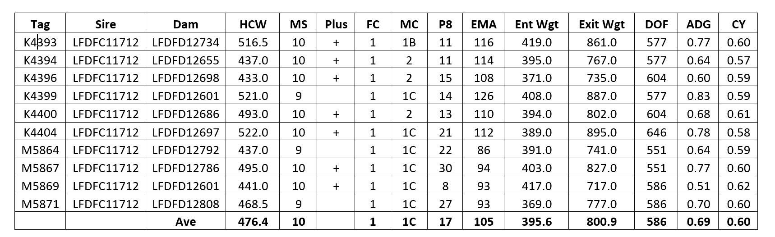

Lot 44 | LONGFORD F D12758 (AI) (ET) | 5 straws with the option of 10 more semen straws

All semen straws are sold per straw with GST added after. Australian domestic use only.
Stored in Armidale, NSW, 2350.
Identifier: | LFDFD12758 | Sorry no image
Sex: | Male
Birth Date: | 22/08/2008
Grade: | Fullblood
Colour: | Black
Genetic Condition: | B3FU, CHSF, CL1699%, F11FU, IARSF
PEDFAJ472 YASUTANI DOI J472
PEDFAJ930 YASUFUKU J930
PEDFM004 CHIZURU 85545
Sire: WKSFS0100 WORLD K'S YASUFUKU JR (FB5061)
PEDFA201 MONJIRO J11550
PEDFQ5 KANEKO 5
PEDFAJ47492 KANEKO J47492
Animal: LFDFD12758 LONGFORD F D12758 (AI) (ET)
PEDFAJ483 ITOFUJI J483
IMUFQTF147 ITOSHIGEFUJI (IMP USA)
PEDFAJ920752 DAI 30 NOBORU J920752
Dam: LFDFA8380 LONGFORD R8380 (AI) (ET)
WKSFM0164 WORLD K'S MICHIFUKU
LFDFT0478 LONGFORD KANDA (AI) (ET)
IMUFP0102 KANADAGENE 102D (IMP USA) (AI) (ET)

 | GL  (days) | BWT  (kg) | 200  (kg) | 400  (kg) | 600  (kg) | MCW  (kg) | Milk  (kg) | SS  (cm) | CWT  (kg) | EMA  (sqcm) | RUMP  (mm) | RBY  (%) | MS | MF  (%) | WBI  ($) | SRI ($) | FTI ($) | F1TI  ($)
EBV | +1.8 | -2.1 | -7 | -12 | -18 | -16 | -2 | -1.5 | -11 | +6.3 | +2.8 | -0.6 | +2.7 | +0.33 | +$151 | +$197 | +$193 | +$208
ACC | 63% | 75% | 79% | 79% | 80% | 75% | 76% | 69% | 85% | 83% | 78% | 72% | 86% | 73%

LFDFD12758 is a high performing son of Yasufuku Jr from a daughter of TF147 Itoshigefuji & Michifuku as maternal grandsire, with the grand dam also from the Suzutani line. D12758 is a full brother to D12759 who was second placed in the 2022 Australian Wagyu Association & Stockyard’s Kerwee Feedlot Sires Progeny Test Program Net Feed Intake Awards, being the second highest efficiency sire based on progeny testing. His Wagyu Breed plan Marble Score is +2.7 with 86% accuracy & EMA +6.3 with 83% accuracy. His mature weight was approximately 900kg.

Buyer - _____________________________ Price $__________________

2018 Australian Carcase Data (F1 Steers)

Tag | Sire | HCW | MS | FC | MC | P8 | Ent Wgt | Exit Wgt | DOF | ADG | CY
M4806 | LFDFD12758 | 486.0 | 7 | 1 | 1C | 40 | 400.0 | 826.0 | 414 | 1.1 | 0.59
M4809 | LFDFD12758 | 508.0 | 7 | 1 | 1C | 26 | 408.0 | 866.0 | 409 | 1.1 | 0.59
M4812 | LFDFD12758 | 450.0 | 9 | 1 | 1C | 24 | 340.0 | 765.0 | 414 | 1.1 | 0.59
M4816 | LFDFD12758 | 458.0 | 8 | 1 | 1B | 25 | 346.0 | 777.0 | 407 | 1.1 | 0.59
M4820 | LFDFD12758 | 461.5 | 9 | 1 | 2 | 23 | 352.0 | 811.0 | 407 | 1.2 | 0.57
 |  | 472.7 | 8 | 1 | 1C | 28 | 369.2 | 809.0 | 410 | 1.1 | 0.58

LONGFORD F D12758 - SON OF YASUFUKU JR

2018 - 2021 Australian Carcase Data (Fullblood Steers)

Tag |  | Sire |  | Dam | HCW |  | MS |  | MSA MS |  | FC |  | MC |  | P8 |  | EMA |  | DOF |  | ADG |  | CY
P6628 |  | LFDFD12758 |  | LFDFH0197 | 379.5 |  | 6 |  | N/A |  | 0 |  | 2 |  | 15 |  | 76 |  | 393 |  | 0.8 |  | 0.57
P6640 |  | LFDFD12758 |  | LFDFJ1181 | 407.5 |  | 7 |  | N/A |  | 1 |  | 2 |  | 15 |  | 85 |  | 414 |  | 0.9 |  | 0.56
P6646 |  | LFDFD12758 |  | LFDFH0223 | 371.5 |  | 9 |  | N/A |  | 0 |  | 1B |  | 20 |  | 99 |  | 393 |  | 0.7 |  | 0.57
P6658 |  | LFDFD12758 |  | LFDFH0144 | 391.5 |  | 9 |  | N/A |  | 0 |  | 1B |  | 10 |  | 73 |  | 393 |  | 0.8 |  | 0.57
P6929 |  | LFDFD12758 |  | LFDFJ1069 | 391.0 |  | 9 |  | N/A |  | 0 |  | 2 |  | 15 |  | 99 |  | 393 |  | 0.9 |  | 0.57
P6933 |  | LFDFD12758 |  | LFDFJ1080 | 395.0 |  | 9 |  | 1180 |  | 0 |  | 1C |  | 14 |  | 88 |  | 490 |  | N/A |  | N/A
P6935 |  | LFDFD12758 |  | LFDFJ1116 | 428.0 |  | 10 |  | 1190 |  | 0 |  | 1C |  | 19 |  | 111 |  | 490 |  | N/A |  | N/A
P6937 |  | LFDFD12758 |  | LFDFJ1153 | 380.0 |  | 9 |  | 1170 |  | 0 |  | 1C |  | 16 |  | 83 |  | 490 |  | N/A |  | N/A
P6942 |  | LFDFD12758 |  | LFDFJ0929 | 419.0 |  | 9 |  | 1120 |  | 0 |  | 2 |  | 14 |  | 89 |  | 490 |  | N/A |  | N/A
P6945 |  | LFDFD12758 |  | LFDFJ1111 | 503.0 |  | 10 |  | 1190 |  | 2 |  | 1C |  | 12 |  | 108 |  | 490 |  | N/A |  | N/A
P6947 |  | LFDFD12758 |  | LFDFJ1128 | 409.0 |  | 8 |  | 1080 |  | 0 |  | 1C |  | 14 |  | 109 |  | 490 |  | N/A |  | N/A
P6948 |  | LFDFD12758 |  | LFDFJ0971 | 379.0 |  | 9 |  | N/A |  | 0 |  | 2 |  | 15 |  | 69 |  | 393 |  | 0.8 |  | 0.57
Q7466 |  | LFDFD12758 |  | LFDFC11859 | 430.0 |  | 9 |  | 1190 |  | 0 |  | 1C |  | 15 |  | 96 |  | 397 |  | 1.0 |  | 0.57
 |  |  |  | Ave | 406.5 |  | 9 |  | 1160 |  | 0 |  | 1C |  | 15 |  | 91 |  | 440 |  | 0.8 |  | 0.57

LIFE MEMBERSHIP FOR NSW CATTLE BREEDER
Extract of article from Beef Central, written by Jon Condon 06/12/2019
Former President of the Association, Keith Hammond, from Robbins Island Wagyu in Tasmania said everything Mr Dew had achieved had been based on a lot of research and hard work to build the Longford genetics, and that he has always had full knowledge of cattle performance.

“Arthur is a first-class operator, and has been nothing but positive for the industry,” Mr Hammond said. “He has always been open to sharing information and knowledge and it is clear that it has been of benefit to the Australian Wagyu industry.”

Another early industry pioneer, David Blackmore, worked with Mr Dew in the early days of the Australian Wagyu industry, and has had regular dealings and conversations with him ever since.

“Arthur has a deep knowledge of pedigree and bloodlines and is able to see the possibilities with his progeny,” Mr Blackmore said.

“Combined with an astute business sense, and a straightforward no-nonsense approach, he is one of the quiet achievers in the Wagyu industry establishing a successful business relationship with live export to Japan and well-regarded genetics. I have the deepest respect for his knowledge and approach to the industry.”

Lot 45 | LONGFORD F D12759 (AI) (ET) | 5 straws with the option of 10 more semen straws

All semen straws are sold per straw with GST added after. Australian domestic use only.
Stored in Armidale, NSW, 2350.
Identifier: | LFDFD12759 | Sorry no image
Sex: | Male
Birth Date: | 18/08/2008
Grade: | Fullblood
Colour: | Black
Genetic Condition: | B3FU, CHSF, CL16FU, F11FU, IARSF
Gene Tests: | CHS-Free, IARS-Non Carrier (Free)
PEDFAJ472 YASUTANI DOI J472
PEDFAJ930 YASUFUKU J930
PEDFM004 CHIZURU 85545
Sire: WKSFS0100 WORLD K'S YASUFUKU JR (FB5061)
PEDFA201 MONJIRO J11550
PEDFQ5 KANEKO 5
PEDFAJ47492 KANEKO J47492
Animal: LFDFD12759 LONGFORD F D12759 (AI) (ET)
PEDFAJ483 ITOFUJI J483
IMUFQTF147 ITOSHIGEFUJI (IMP USA)
PEDFAJ920752 DAI 30 NOBORU J920752
Dam: LFDFA8380 LONGFORD R8380 (AI) (ET)
WKSFM0164 WORLD K'S MICHIFUKU
LFDFT0478 LONGFORD KANDA (AI) (ET)
IMUFP0102 KANADAGENE 102D (IMP USA) (AI) (ET)

 | GL  (days) | BWT  (kg) | 200  (kg) | 400  (kg) | 600  (kg) | MCW  (kg) | Milk  (kg) | SS  (cm) | CWT  (kg) | EMA  (sqcm) | RUMP  (mm) | RBY  (%) | MS | MF  (%) | WBI  ($) | SRI ($) | FTI ($) | F1TI  ($)
EBV | +0.9 | -3.2 | -16 | -22 | -32 | -36 | -9 | -2.6 | -27 | +6.2 | +0.4 | -0.2 | +2.5 | +0.22 | +$108 | +$165 | +$153 | +$176
ACC | 64% | 78% | 83% | 83% | 83% | 79% | 83% | 71% | 89% | 88% | 83% | 74% | 90% | 78%

LFDFD12759 is a high performing son of Yasufuku Jnr from a daughter of TF147 Itoshigefuji & Michifuku as maternal grandsire, with the grand dam also from the Suzutani line. D12759 placed second in the 2022 Australian Wagyu Association & Stockyard’s Kerwee Feedlot Sires Progeny Test Program Net Feed Intake Awards, being the second highest efficiency sire based on progeny testing. His Wagyu Breed plan Marble Score is +2.5 with 90% accuracy & EMA +6.2 with 88% accuracy. His mature weight was approximately 900kg.

Buyer - _____________________________ Price $__________________

2018 Australian Carcase Data (F1 Steers)

Tag | Sire | HCW | MS | FC | MC | P8 | Ent Wgt | Exit Wgt | DOF | ADG | CY
M4821 | LFDFD12759 | 469.5 | 8 | 1 | 2 | 38 | 374.0 | 798.0 | 414 | 1.1 | 0.59
M4823 | LFDFD12759 | 451.0 | 6 | 0 | 2 | 15 | 366.0 | 765.0 | 407 | 1.0 | 0.59
M4824 | LFDFD12759 | 501.0 | 8 | 2 | 2 | 46 | 402.0 | 852.0 | 414 | 1.1 | 0.59
M4826 | LFDFD12759 | 471.0 | 7 | 0 | 2 | 35 | 370.0 | 814.0 | 414 | 1.1 | 0.58
M4830 | LFDFD12759 | 456.5 | 6 | 0 | 1C | 37 | 406.0 | 802.0 | 407 | 1.0 | 0.57
M4831 | LFDFD12759 | 468.5 | 8 | 0 | 1C | 26 | 350.0 | 796.0 | 414 | 1.1 | 0.59
M4844 | LFDFD12759 | 523.5 | 7 | 2 | 2 | 30 | 408.0 | 890.0 | 414 | 1.2 | 0.59
 |  | 477.3 | 7 | 1 | 2 | 32 | 382.3 | 816.7 | 412 | 1.1 | 0.58

LONGFORD F D12759 - SON OF YASUFUKU JR

2018 - 2021 Australian Carcase Data (Fullblood Steers)

Tag | Sire | Dam | HCW | MS | MSA MS | FC | MC | P8 | EMA | DOF | ADG | CY
N6371 | LFDFD12759 | LFDFF0363 | 475.5 | 10 | N/A | 1 | 2 | 25 | 90 | 527 | 0.6 | 0.58
P0310 | LFDFD12759 | LFDFM0940 | 421.5 | 9 | N/A | 0 | 2 | 13 | 89 | 393 | 0.9 | 0.57
P0469 | LFDFD12759 | LFDFD12698 | 448.0 | 7 | 990 | 0 | 1C | 15 | 89 | 490 | N/A | N/A
P0516 | LFDFD12759 | LFDFD12690 | 377.0 | 10 | 1190 | 0 | 1C | 14 | 98 | 490 | N/A | N/A
P0518 | LFDFD12759 | LFDFB8508 | 446.0 | 9 | 1150 | 0 | 1C | 14 | 103 | 490 | N/A | N/A
P0525 | LFDFD12759 | LFDFC11832 | 437.0 | 9 | 1180 | 0 | 1C | 16 | 97 | 490 | N/A | N/A
P0526 | LFDFD12759 | LFDFB8527 | 409.0 | 9 | 1180 | 0 | 1C | 12 | 79 | 490 | N/A | N/A
P0530 | LFDFD12759 | LFDFD12711 | 400.5 | 9 | N/A | 0 | 2 | 10 | 80 | 393 | 0.9 | 0.57
P0539 | LFDFD12759 | LFDFC11763 | 401.0 | 9 | N/A | 0 | 1C | 10 | 89 | 399 | 0.9 | 0.58
P6700 | LFDFD12759 | LFDFE0213 | 408.0 | 9 | N/A | 0 | 2 | 22 | 89 | 393 | 0.8 | 0.57
P6702 | LFDFD12759 | LFDFB8559 | 319.0 | 9 | 1190 | 0 | 1C | 10 | 92 | 435 | 0.6 | 0.56
P6708 | LFDFD12759 | LFDFE0270 | 356.5 | 9 | N/A | 0 | 2 | 12 | 80 | 393 | 0.7 | 0.57
P6822 | LFDFD12759 | LFDFM0928 | 427.0 | 9 | 1160 | 0 | 1C | 9 | 102 | 490 | N/A | N/A
P6863 | LFDFD12759 | LFDFM0379 | 365.0 | 9 | 1180 | 0 | 1C | 10 | 83 | 490 | N/A | N/A
P6874 | LFDFD12759 | LFDFM0913 | 427.0 | 10 | 1190 | 0 | 1C | 15 | 97 | 490 | N/A | N/A
P6877 | LFDFD12759 | LFDFM0223 | 410.0 | 10 | 1190 | 0 | 1C | 15 | 82 | 490 | N/A | N/A
P7087 | LFDFD12759 | LFDFM0918 | 422.0 | 10 | 1190 | 0 | 1C | 15 | 100 | 490 | N/A | N/A
 |  | Ave | 408.8 | 9 | 1163 | 0 | 1C | 14 | 91 | 461 | 0.8 | 0.57

Former Kerwee Feedlot General Manager George Lubbe presenting Arthur Dew with Mr Awesome’s Award
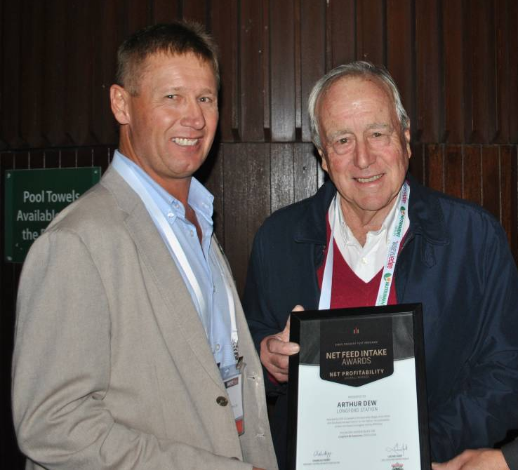
EMBRYOS
Lot 46, 47 & 48 | LFDFD12558 x LFDFB8566 | 3 x 2 A grade embryos

All embryos are sold per embryo with GST added after. Australian domestic use only.
Stored in Armidale, NSW, 2350.
The successful purchaser of Lot 46 also has the right to purchase up to the next two lots for the same price.
Decision must be made at the fall of the hammer.

LONGFORD MR AWESOME (AI) (ET) - LFDFD12558 | LONGFORD B8566 - LFDFB8566
PEDFAJ6109 SHIGEKANENAMI J6109  PEDFA10632 SHIGESHIGENAMI J10632  PEDFAJ774695 SHIGEMITSU J774695 (FB4751)  Sire: IMUFQTF148 ITOSHIGENAMI (IMP USA)  PEDFAJ10756 FUKUMASA J10756  PEDFA661 FUKUYUKI  PEDFAJ456691 YUKIZAKURA J456691  Animal: LFDFD12558 LONGFORD MR AWESOME (AI) (ET)  PEDFAJ483 ITOFUJI J483  IMUFQTF147 ITOSHIGEFUJI (IMP USA)  PEDFAJ920752 DAI 30 NOBORU J920752  Dam: LFDFZ0570 LONGFORD LFDB570 (AI) (ET)  IMJFAJ2810 KITATERUYASUDOI J2810 HONGEN (IMP JAP)  LFDFV0078 LONGFORD 0078 (AI) (ET)  LFDFT0479 LONGFORD IKEDA (AI) (ET) | PEDFA201 MONJIRO J11550  WKSFM0164 WORLD K'S MICHIFUKU  PEDFA215 MICHIKO J655635 (AI)  Sire: LFDFT0476 LONGFORD ZAKI (AI) (ET)  PEDFA211 TANISHIGE 1526 - KURO KOH  WKSFMJ913 WORLD K'S RIKITANI J913 (ET)  PEDFAJ608671 SHIGEKANE J608671  Animal: LFDFB8566 LONGFORD B8566  PEDFAJ1742 TERUNAGADOI 1742  IMJFAJ2810 KITATERUYASUDOI J2810 HONGEN (IMP JAP)  PEDFAJ601124 YOSHIMI 3 601124  Dam: LFDFZ1065 LONGFORD LFDB1065 (AI) (ET)  IMJFAJ2703 ITOMORITAKA J2703 HONGEN (IMP JAP)  LFDFU0691 LONGFORD TAISHA (AI) (ET)  PEDFNJ1950283 HATSUHI J1950283 - R18

NOTES: These embryos are full siblings to the “perfect carcass” in Japan as shown on Mr Awesome’s Japanese data. It had a BMS of 12 & EMA of 96 at the 5 / 6th rib (equivalent to approximately 140 at the 11 / 12th rib) & a carcass weight of 547kgs. Refer to Japanese Carcass Score Card.
Mating Predictor
Name | GL  (days) | BW  (kg) | 200  (kg) | 400  (kg) | 600  (kg) | MCW  (kg) | Milk  (kg) | SS  (cm) | CW  (kg) | EMA  (sqcm) | RF  (mm) | RBY  (%) | MS | MF  (%) | WBI  ($) | SRI ($) | FTI ($) | F1TI  ($)
SIRE: LONGFORD MR AWESOME (AI) (ET) | +0.7 | +2.4 | +19 | +23 | +35 | +19 | +4 | -0.8 | +16 | +5.9 | -2.4 | +1.4 | +2.8 | +0.14 | +$ 280 | +$ 284 | +$ 241 | +$ 221
DAM: LONGFORD B8566 | +0.2 | +2.8 | +22 | +31 | +37 | +42 | -1 | +0.4 | +14 | +0.4 | +0.3 | +0.1 | +0.9 | +0.21 | +$ 193 | +$ 181 | +$ 137 | +$ 115
Predicted progeny figures | +0.4 | +2.6 | +21 | +27 | +36 | +31 | +2 | -0.2 | +15 | +3.2 | -1.1 | +0.8 | +1.9 | +0.18 | +$ 237 | +$ 233 | +$ 189 | +$ 168
Inbreeding Coefficient: 6%. Min./(Avg.) generation: 5/(8.1)

Lot 46 | LFDFD12558 x LFDFB8566 | 2 A grade embryos

Australian domestic use only.
Donor Sire name - Longford Mr Awesome (AI)(ET)
Donor Sire AWA ID - LFDFD12558
Donor Dam name – LONGFORD B8566
Donor Dam AWA ID - LFDFB8566

Buyer - _____________________________ Price $__________________

Lot 47 | LFDFD12558 x LFDFB8566 | 2 A grade embryos

Australian domestic use only.
Donor Sire name - Longford Mr Awesome (AI)(ET)
Donor Sire AWA ID - LFDFD12558
Donor Dam name – LONGFORD B8566
Donor Dam AWA ID - LFDFB8566

Buyer - _____________________________ Price $__________________

Lot 48 | LFDFD12558 x LFDFB8566 | 2 A grade embryos

Australian domestic use only.
Donor Sire name - Longford Mr Awesome (AI)(ET)
Donor Sire AWA ID - LFDFD12558
Donor Dam name – LONGFORD B8566
Donor Dam AWA ID - LFDFB8566

Buyer - _____________________________ Price $__________________

Lot 49 | LFDFD12558 x LFDFB8643 | 2 A grade embryos

LONGFORD MR AWESOME (AI) (ET) - LFDFD12558 | LONGFORD B8643 -
PEDFAJ6109 SHIGEKANENAMI J6109  PEDFA10632 SHIGESHIGENAMI J10632  PEDFAJ774695 SHIGEMITSU J774695 (FB4751)  Sire: IMUFQTF148 ITOSHIGENAMI (IMP USA)  PEDFAJ10756 FUKUMASA J10756  PEDFA661 FUKUYUKI  PEDFAJ456691 YUKIZAKURA J456691  Animal: LFDFD12558 LONGFORD MR AWESOME (AI) (ET)  PEDFAJ483 ITOFUJI J483  IMUFQTF147 ITOSHIGEFUJI (IMP USA)  PEDFAJ920752 DAI 30 NOBORU J920752  Dam: LFDFZ0570 LONGFORD LFDB570 (AI) (ET)  IMJFAJ2810 KITATERUYASUDOI J2810 HONGEN (IMP JAP)  LFDFV0078 LONGFORD 0078 (AI) (ET)  LFDFT0479 LONGFORD IKEDA (AI) (ET) | PEDFAJ483 ITOFUJI J483  IMUFQTF147 ITOSHIGEFUJI (IMP USA)  PEDFAJ920752 DAI 30 NOBORU J920752  Sire: TWAFU0623 TWA YUSHO (AI) (ET)  IMUFM2100 KIKUYASU 400 (IMP JAP)  TWAFR0096 TWA MINIKU (IMP USA) (ET)  PEDFL2460 TF KINU 1  Animal: LFDFB8643 LONGFORD B8643  PEDFAJ10787 KIKUTERU DOI J10787  IMUFMTF150 KIKUTERUSHIGE (IMP USA)  PEDFAJ649744 KIKUNAKA 6 J649744  Dam: LFDFX0188 LONGFORD F X188 (AI) (ET)  WKSFM0164 WORLD K'S MICHIFUKU  LFDFT0480 LONGFORD MUTSU (AI) (ET)  IMUFP0102 KANADAGENE 102D (IMP USA) (AI) (ET)

NOTES: These embryos are full siblings to our second-best carcass in Japan as shown on Mr Awesome’s Japanese data. It had a BMS of 11, EMA of 95 & a carcass weight of 539.3kgs. Refer to Japanese Carcass Score Card.
Mating Predictor
Name | GL  (days) | BW  (kg) | 200  (kg) | 400  (kg) | 600  (kg) | MCW  (kg) | Milk  (kg) | SS  (cm) | CW  (kg) | EMA  (sqcm) | RF  (mm) | RBY  (%) | MS | MF  (%) | WBI  ($) | SRI ($) | FTI ($) | F1TI  ($)
SIRE: LONGFORD MR AWESOME (AI) (ET) | +0.7 | +2.4 | +19 | +23 | +35 | +19 | +4 | -0.8 | +16 | +5.9 | -2.4 | +1.4 | +2.8 | +0.14 | +$ 280 | +$ 284 | +$ 241 | +$ 221
DAM: LONGFORD B8643 | +0.1 | +1.7 | +9 | +11 | +16 | +5 | +2 | -1.2 | +5 | -0.4 | -1.4 | -0.3 | +0.7 | +0.09 | +$ 99 | +$ 100 | +$ 86 | +$ 77
Predicted progeny figures | +0.4 | +2.0 | +14 | +17 | +26 | +12 | +3 | -1.0 | +11 | +2.8 | -1.9 | +0.5 | +1.8 | +0.12 | +$ 190 | +$ 192 | +$ 164 | +$ 149
Inbreeding Coefficient: 8%. Min./(Avg.) generation: 5/(8.1)

Australian domestic use only.
Donor Sire name - Longford Mr Awesome (AI)(ET)
Donor Sire AWA ID - LFDFD12558
Donor Dam name – LONGFORD B8643
Donor Dam AWA ID - LFDFB8643

Buyer - _____________________________ Price $__________________

Lots 50 & 51 | LFDFD12558 x LFDFE1018 | 2 x 2 A grade embryos

LONGFORD MR AWESOME (AI) (ET) - LFDFD12558 | LONGFORD 1018 (AI) - LFDFE1018
PEDFAJ6109 SHIGEKANENAMI J6109  PEDFA10632 SHIGESHIGENAMI J10632  PEDFAJ774695 SHIGEMITSU J774695 (FB4751)  Sire: IMUFQTF148 ITOSHIGENAMI (IMP USA)  PEDFAJ10756 FUKUMASA J10756  PEDFA661 FUKUYUKI  PEDFAJ456691 YUKIZAKURA J456691  Animal: LFDFD12558 LONGFORD MR AWESOME (AI) (ET)  PEDFAJ483 ITOFUJI J483  IMUFQTF147 ITOSHIGEFUJI (IMP USA)  PEDFAJ920752 DAI 30 NOBORU J920752  Dam: LFDFZ0570 LONGFORD LFDB570 (AI) (ET)  IMJFAJ2810 KITATERUYASUDOI J2810 HONGEN (IMP JAP)  LFDFV0078 LONGFORD 0078 (AI) (ET)  LFDFT0479 LONGFORD IKEDA (AI) (ET) | PEDFA505 ITOHARUNAMI J766  PEDFAYUKI YUKIHARUNAMI  PEDFAHIEYUK HIEYUKIFUJI J618874  Sire: IMUFQ2599 TF YUKIHARUNAMI 4 (IMP USA)  PEDFA500 ITOMICHI J1158  PEDFB2427 TF CHIYOTAKE 8/1  PEDFL549 TF CHIYOTAKE 8A J847344  Animal: LFDFE1018 LONGFORD 1018 (AI)  WKSFM0164 WORLD K'S MICHIFUKU  LFDFT0476 LONGFORD ZAKI (AI) (ET)  WKSFMJ913 WORLD K'S RIKITANI J913 (ET)  Dam: LFDFB8555 LONGFORD B8555  IMUFQTF147 ITOSHIGEFUJI (IMP USA)  LFDFZ0570 LONGFORD LFDB570 (AI) (ET)  LFDFV0078 LONGFORD 0078 (AI) (ET)

NOTES: Longford E1018 has Yukiharunami 4 on the paternal side & T0476 Zaki (a Michifuku son bred by Longford) on the maternal side, as well as TF147 Itoshigefuji. This female is showing potential in Japan with one of her steers achieving a BMS of 10. By crossing her with Mr Awesome we hope to produce more “perfect carcasses”. The maternal Grand Dam LFDFZ0570 is also the Dam of Mr Awesome. Also, B8555’s Dam achieved good carcass data in Japan with one BMS of 10.
Mating Predictor
Name | GL  (days) | BW  (kg) | 200  (kg) | 400  (kg) | 600  (kg) | MCW  (kg) | Milk  (kg) | SS  (cm) | CW  (kg) | EMA  (sqcm) | RF  (mm) | RBY  (%) | MS | MF  (%) | WBI  ($) | SRI ($) | FTI ($) | F1TI  ($)
SIRE: LONGFORD MR AWESOME (AI) (ET) | +0.7 | +2.4 | +19 | +23 | +35 | +19 | +4 | -0.8 | +16 | +5.9 | -2.4 | +1.4 | +2.8 | +0.14 | +$ 280 | +$ 284 | +$ 241 | +$ 221
DAM: LONGFORD 1018 (AI) | -2.3 | +0.2 | +16 | +19 | +18 | +5 | +3 | -0.8 | +3 | +1.5 | -1.0 | +0.6 | +1.0 | -0.01 | +$ 175 | +$ 179 | +$ 144 | +$ 135
Predicted progeny figures | -0.8 | +1.3 | +18 | +21 | +27 | +12 | +4 | -0.8 | +10 | +3.7 | -1.7 | +1.0 | +1.9 | +0.07 | +$ 228 | +$ 232 | +$ 193 | +$ 178
Inbreeding Coefficient: 11%. Min./(Avg.) generation: 5/(8.0)

Lot 50 | LFDFD12558 x LFDFE1018 | 2 A grade embryos

Australian domestic use only.
Donor Sire name - Longford Mr Awesome (AI)(ET)
Donor Sire AWA ID - LFDFD12558
Donor Dam name – LONGFORD 1018 (AI)
Donor Dam AWA ID - LFDFE1018

Buyer - _____________________________ Price $__________________

Lot 51 | LFDFD12558 x LFDFE1018 | 2 A grade embryos

Australian domestic use only.
Donor Sire name - Longford Mr Awesome (AI)(ET)
Donor Sire AWA ID - LFDFD12558
Donor Dam name – LONGFORD 1018 (AI)
Donor Dam AWA ID - LFDFE1018

Buyer - _____________________________ Price $__________________

World Ks Yasufuku Jr
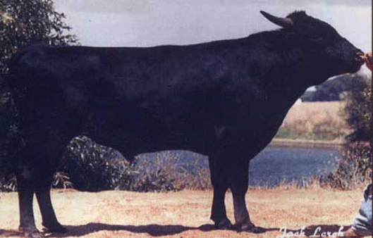

“There are three main characteristics I am looking for
in our bloodstock: high and fine marbling which is
distributed evenly throughout the meat, a large eye
muscle area and the animal's capacity to produce a
carcase weight up to 450 to 500 kilograms.”

- Arthur Dew, Longford Station Wagyu

LONGFORD F D12758 & D12759 SONS OF YASUFUKU JR

2020 Australian Carcass Data (Fullblood steers)

Tag | Sire | Dam | Sex | Breed | Marbling | Rib Fat | MC | EMA | HCW | DOF
P6933 | LFDFD12758 | LFDFJ1080 | S | FB | 9 | 14 | 1C | 88 | 395 | 490
P6935 | LFDFD12758 | LFDFJ1116 | S | FB | 10 | 19 | 1C | 111 | 428 | 490
P6937 | LFDFD12758 | LFDFJ1153 | S | FB | 9 | 16 | 1C | 83 | 380 | 490
P6942 | LFDFD12758 | LFDFJ0929 | S | FB | 9 | 14 | 2 | 89 | 419 | 490
P6945 | LFDFD12758 | LFDFJ1111 | S | FB | 10 | 12 | 1C | 108 | 503 | 490
P6947 | LFDFD12758 | LFDFJ1128 | S | FB | 8 | 14 | 1C | 109 | 409 | 490
 |  |  |  |  | 9 | 15 | 1C | 98 | 422 | 490
Tag | Sire | Dam | Sex | Breed | Marbling | Rib Fat | MC | EMA | HCW | DOF
P0469 | LFDFD12759 | LFDFD12698 | S | FB | 7 | 15 | 1C | 89 | 448 | 490
P0516 | LFDFD12759 | LFDFD12690 | S | FB | 10 | 14 | 1C | 98 | 377 | 490
P0518 | LFDFD12759 | LFDFB8508 | S | FB | 9 | 14 | 1C | 103 | 446 | 490
P0525 | LFDFD12759 | LFDFC11832 | S | FB | 9 | 16 | 1C | 97 | 437 | 490
P0526 | LFDFD12759 | LFDFB8527 | S | FB | 9 | 12 | 1C | 79 | 409 | 490
P6822 | LFDFD12759 | LFDFM0928 | S | FB | 9 | 9 | 1C | 102 | 427 | 490
P6863 | LFDFD12759 | LFDFM0379 | S | FB | 9 | 10 | 1C | 83 | 365 | 490
P6874 | LFDFD12759 | LFDFM0913 | S | FB | 10 | 15 | 1C | 97 | 427 | 490
P6877 | LFDFD12759 | LFDFM0223 | S | FB | 10 | 15 | 1C | 82 | 410 | 490
P7087 | LFDFD12759 | LFDFM0918 | S | FB | 10 | 15 | 1C | 100 | 422 | 490
 |  |  |  |  | 9 | 14 | 1C | 93 | 417 | 490

World Ks Michifuku
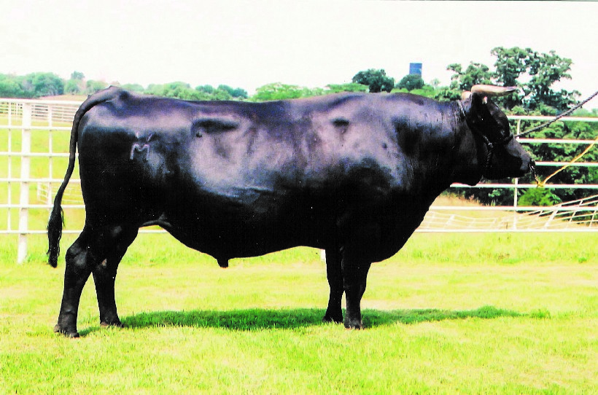

BUYERS DELIVERY INSTRUCTIONS
- Longford Station PIC NI022089
- One form per bid card.
- Must be completed in full and emailed to shane.rule@elders.com.au immediately at
- the conclusion of the auction.
- Verbal instructions will not be accepted.

AuctionsPlus Number:
Buyer:
Postal Address:
Contact Name:
Phone Number:
Mobile Number:
Email Address:
Buyers AWA ID:
Agents Name:
Agents Company:
Agents Number:
Agents Address:
Lots Purchased:
Total Number of Lots Purchased:
Delivery Day:
Delivery Date:
Destination PIC:
Destination Address:
Contact Details at Destination:
Carrier’s Name and Number:
Insurance required: |  |  |  |  |  | Yes / No
Signature:
Date:
Form Completed by: | Buyer / Agent

NOTES:

