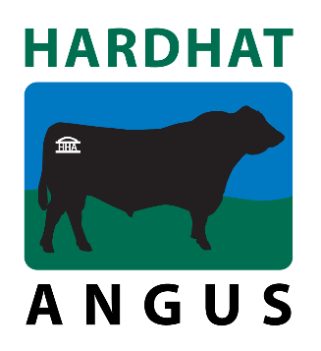
HARDHAT ANGUS 2022 BULL SALE
SUPPLEMENTARY SHEET
Lot | ID | Weight | Recommended use
1 | DKKR56 | 792 | Cow bull. Premium feeder steer market
2 | DKKR54 | 894 | WITHDRAWN
3 | DKKR83 | 906 | Stud sire prospect. Cow or heifer bull
4 | DKKR95 | 940 | Cow bull
5 | DKKR92 | 928 | Cow or heifer bull. Premium feeder steer market
6 | DKKR58 | 802 | High fertility. Great cow maker
7 | DKKR52 | 786 | High growth. Cow or heifer bull
8 | DKKR53 |  | WITHDRAWN
9 | DKKR65 | 800 | High marbling. Cow or heifer bull
10 | DKKR30 | 836 | Used in stud as yearling. Cow or heifer bull
11 | DKKR84 | 838 | Stud sire prospect. Cow or heifer bull
12 | DKKR104 | 790 | High growth. Cow or heifer bull
13 | DKKR79 | 744 | Specialist heifer bull. Bomb proof calving ease.
14 | DKKR119 | 820 | Specialist heifer bull. Bomb proof calving ease.
15 | DKKR110 | 880 | Cow bull.
16 | DKKR75 | 705 | Specialist heifer bull. Bomb proof calving ease.
*17 | R102 | 902 | Non registered. Kodak Grandson. Cow bull with huge capacity
*18 | R49 | 808 | Non registered. SS Niagara X XXP. Cow bull
*19 | R97 | 780 | Non registered. SAV Renown Grandson. Cow bull
20 | DKK21S41 |  | WITHDRAWN (DECEASED)
21 | DKK21S75 | 618 | See updated EBVs. Cow bull with high growth
22 | DKK21S78 | 636 | See updated EBVs. Cow or heifer bull
*22A | DKK21S36 | 624 | See updated EBVs. High muscle and yield
23 | DKK21S1 | 670 | Cow or heifer bull
24 | DKK21S2 | 690 | High marbling. Cow or heifer bull
25 | DKK21S4 | 764 | Cow or heifer bull
26 | DKK21S18 | 644 | Cow bull
27 | DKK21S19 | 632 | Cow bull
28 | DKK21S8 | 750 | PEDIGREE UPDATE after DNA results. S8’s actual sire is Hardhat McLaren M125. Cow or heifer bull
*28A | DKK21S12 | 788 | Cow bull. High growth
*29 | DKK21S16 | 716 | Cow bull
* DENOTES SUPPLEMENTARY LOTS NOT INCLUDED IN CATALOGUE

