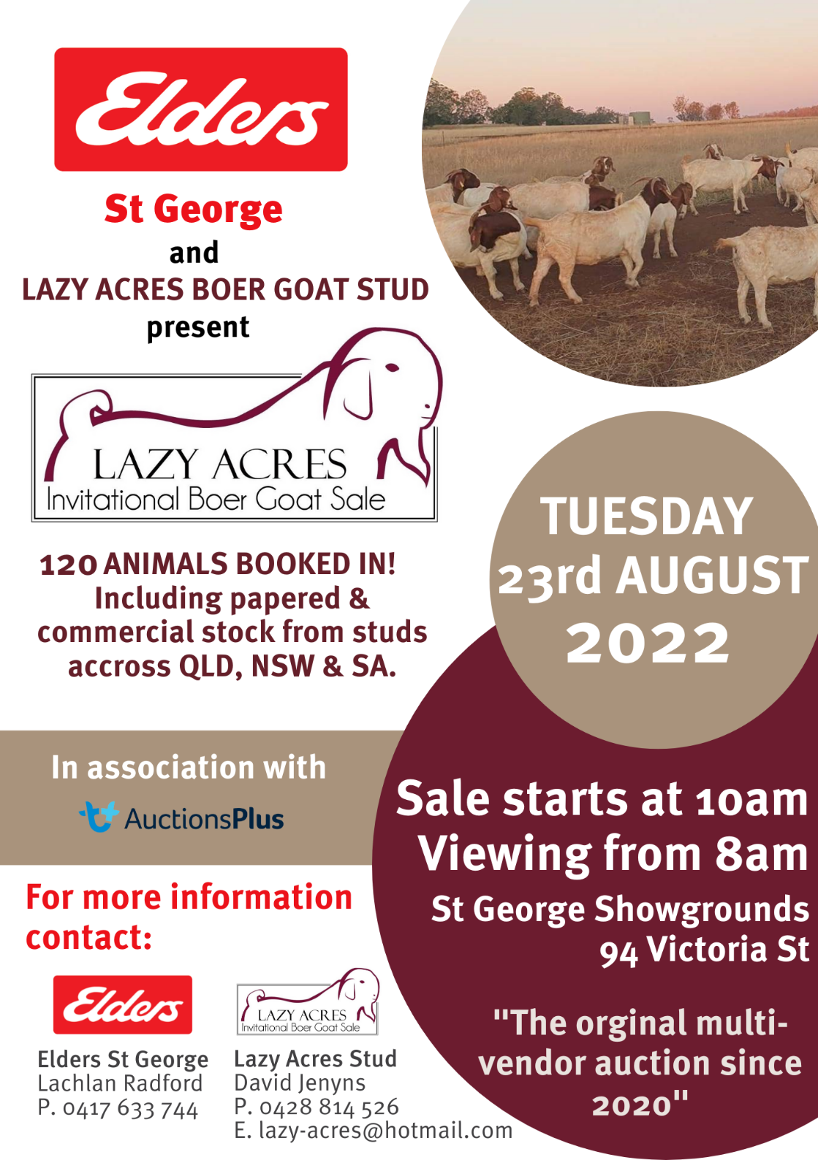
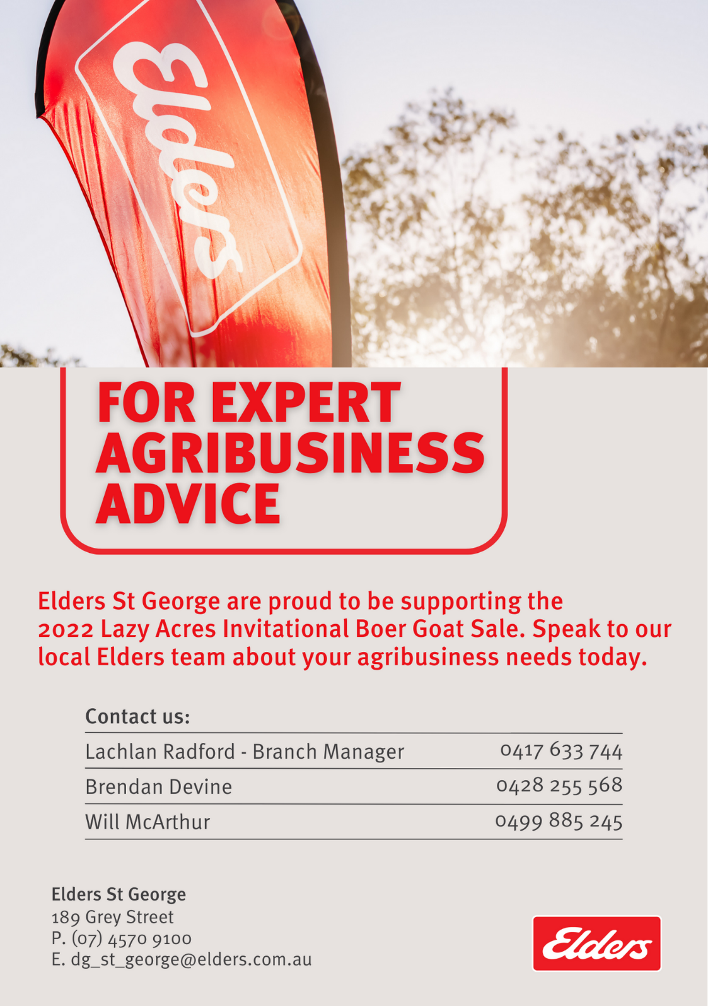
Vendor Index

Stud Name | Trading As |  | Phone |  | GST
Lazy Acres Boer Goats |  | David Jenyns Family Trust |  | 0428 814 526 | Yes
Kennedy Creek Boer Goats |  | TL Wood |  | 0411 707 020 | Yes
Balmoral Boer Goats |  | S & J Lake |  | 0447 975 772 | Yes
Springfield Boer Goats |  | Springfield Farm Tenterfield |  | 0439 886 905 | Yes
Burstow Park Farm |  | Irene and Peter Hanmar |  | 0401 742 796 | Yes
Ballyporeen Boer Goats |  | RD & RM Cox |  | 0459 055 253 | Yes
Kaylen Boer Goats |  | B & V Taylor |  | 0413 692 616 | Yes
Karbo Boer Goats |  | Nupey Pty Ltd |  | 0427 758017 | Yes
Cloverhill Boer Goats |  | Tristan White |  | 0431 443 632 | No

