2021 Drop Sires | MP+ | FP+ | Sire of Sire
Tallawong 150280 | 192.9 | 188.8 | HAZELDEAN-003542
Tallawong 180085 | 193.5 | 187.6 | TALLAWONG-150280
Tallawong 180371 | 169.3 | 171.5 | GREENDALE-150113
Tallawong 180523 | 154.5 | 157.2 | GREENDALE-150029
Tallawong 190016 | 159.1 | 167.4 | TALLAWONG-170369
Tallawong 190788 | 215.5 | 196.6 | YARRAWONGA -150114
Tallawong 190862 | 197.0 | 189.0 | YARRAWONGA -150114
Tallawong 190867 | 166.4 | 172.7 | YARRAWONGA -150114
Tallawong 191021 | 229.7 | 205.1 | TALLAWONG-150280
Tallawong 191031 | 191.4 | 187.0 | TALLAWONG-150280
Tallawong 191063 | 182.0 | 176.9 | TALLAWONG-150280
Tallawong 191189 | 196.1 | 184.0 | TALLAWONG-150280
Tallawong 191197 | 176.3 | 179.3 | TALLAWONG-150280
Grassy Creek 180553 | 199.5 | 172.8 | CENTRE PLUS POLL-607300
Wattle Dale 190730 | 228.9 | 198.0 | POOGINOOK POLL-140961
Woodpark Poll 160058 | 196.1 | 174.8 | WOODPARK POLL-140204

Option 2
Merino Production Index (MP) & Merino Production Plus Index (MP+)
The MP and MP+ indexes are for a self-replacing Merino flock where the income is a combination of wool and surplus Merino sheep sales. Improvement of wool income is focused on a balance of increasing fleece weight and reducing fibre diameter, with a small degree of emphasis on maintaining or slightly increasing staple strength in the MP+ index.
Typical trait changes with the MP index:
- increasing clean fleece weight
- reducing fibre diameter
- maintaining CV
- increasing yearling weight
- increasing adult weight*
Typical trait changes with the MP+ index:
- increasing clean fleece weight
- reducing fibre diameter
- maintaining CV
- increasing yearling weight
- increasing adult weight*
- increasing number of lambs weaned
- increasing staple strength
The Figure below illustrates which traits are in each index and how much they contribute to the overall balance of the indexes. The longer the bar, the greater the impact on the index, and the greater impact on the profitability of the production system.
* Adult weight makes a negative contribution to the index when considered on its own because bigger ewes have higher feed costs. However, bigger ewes also produce more lambs which reach sale weight faster, so the index makes a trade-off to achieve an optimal balance across all traits.
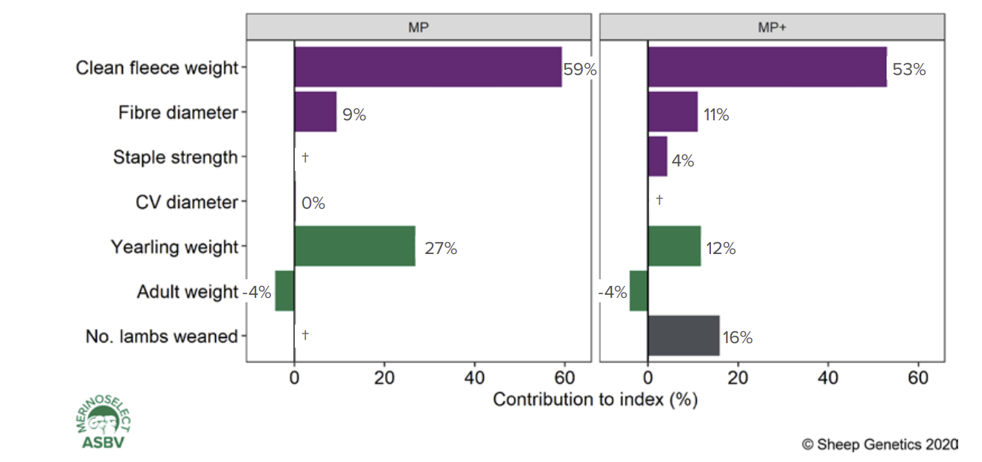

Fibre Production (FP) & Fibre Production Plus Index (FP+)
The FP and FP+ indexes are for a self-replacing Merino flock where the majority of income is from the wool clip. As this production system is commonly used in high rainfall zones where internal parasites cause significant economic losses, worm egg count is included in the FP+ index. Reproduction and staple strength are also included in the FP+ index.
Typical trait changes with the FP index:
- increasing clean fleece weight
- reducing fibre diameter
- reducing CV of diameter
- small increase in yearling weight
- maintaining adult weight
Typical trait changes with the FP+ index:
- increasing clean fleece weight
- reducing fibre diameter
- reducing CV of diameter
- small increase in yearling weight
- maintaining adult weight
- increasing worm resistance
- increasing number of lambs weaned
- increasing staple strength
The Figure below illustrates which traits are in each index and how much they contribute to the overall balance of the indexes. The longer the bar, the greater the impact on the index, and the greater impact on the profitability of the production system.
