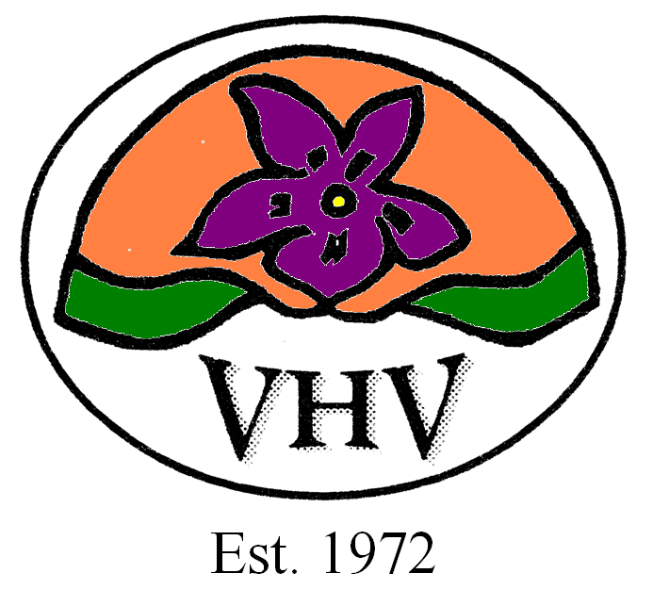Violet Hills On Farm Sale 2021
Corrections

Lot 2 Violet Hills Q206E (P) VHVQ206E

Violet Hills Gaelic Warrior (P) VHVG16E

Violet Hills Neville (P) VHVN68E

Violet Hills Gadfly (P) VHVG15E

Violet Hills Jacquard (P) VHVJ163E

Violet Hills Mandy 25 (P) VHVM25E

Violet Hills Gingersnaps (P) VHVG183E

March 2021 Australasian Charolais BREEDPLAN Analysis
CE Dir CE Dtrs GL BW 200D 400D 600D MCW Milk SS
EBV +12.10 +10.60 -4.3 -2.0 +7 +14 +17 +21 +3 +1.8
Acc 37% 30% 37% 53% 62% 63% 59% 53% 42% 73%
Domestic Index +$44 Export Index +$62
Note The photo, video and description are correct

LOT 46 This lot will consist of 8 unjoined heifers.

