




Established 1944

1545 Princes Hwy, Flynn

LEADING NEW ZEALAND
GENETICS


SALE Friday 30th March @1.30pm

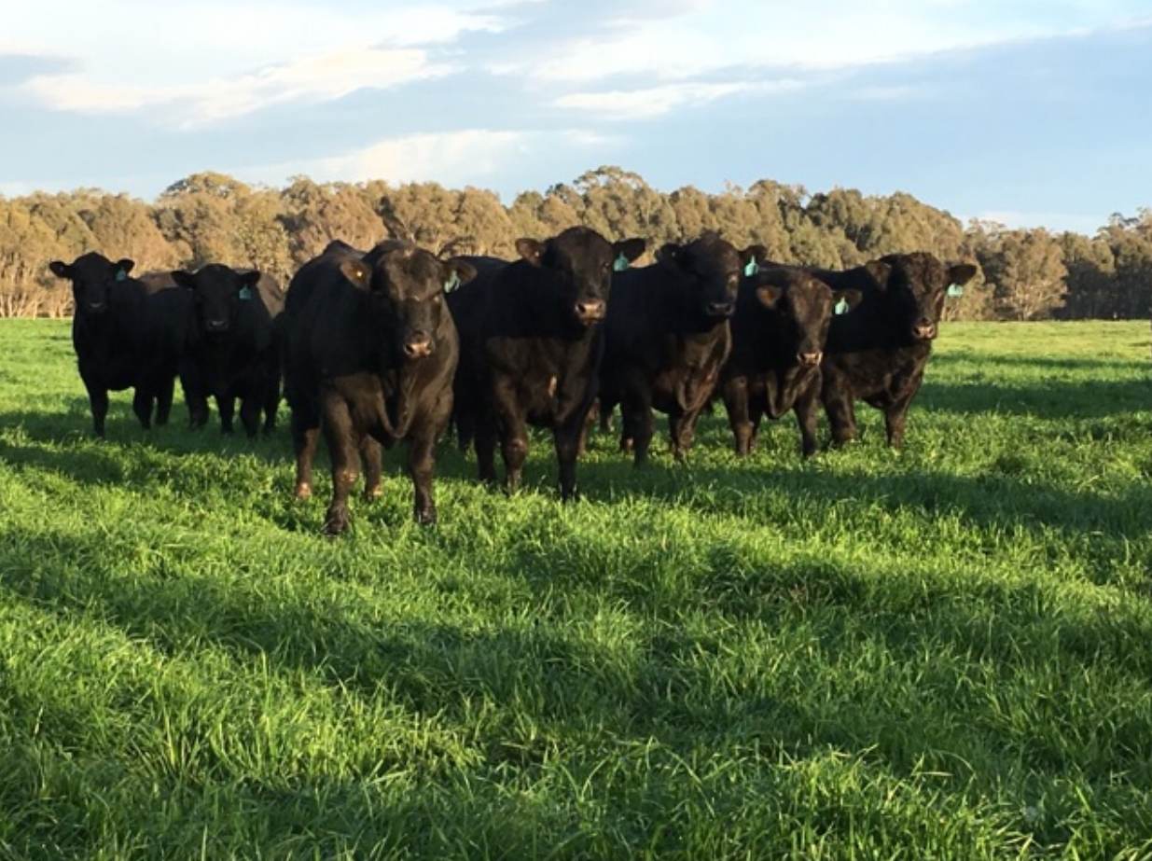

40 Bulls 18 Mths
50 Commercial Females

Graeme mob: 0429 992 683 Luke mob: 0474 992 683

OPEN DAY
20th March 11.00am-3.00pm

