Sale Commences - 12PM
18 Lots

JAN-A-REE WHITE SUFFOLK STUD
EWE DISPERSAL
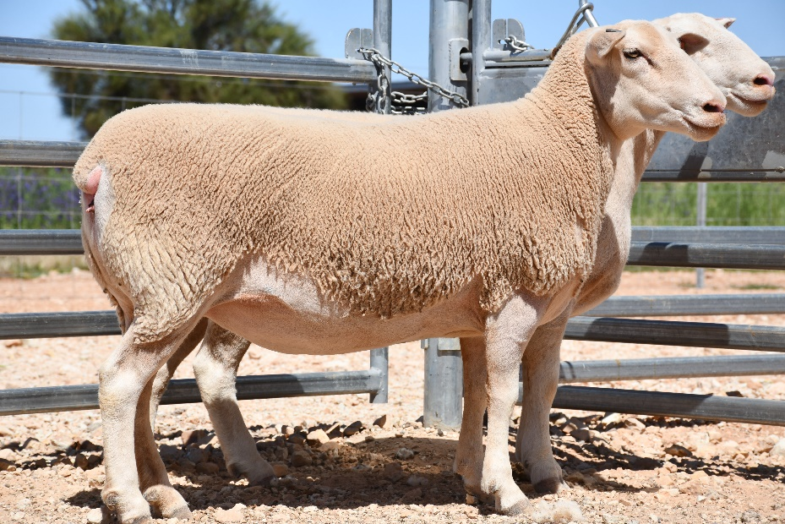
Sale Consists of:
- 56 - 2019 DROP EWES
- 19 - 2018 DROP EWES
- 25 - 2016 DROP EWES
- 21 - 2015 DROP EWES
- 53 - 2014 DROP EWES
- 33 - 2013 DROP EWES
- 13 - MIXED AGE EWES
AGENTS:
Nutrien Russell Cobar.
Luke Scales
Mobile: 0447 769 588
Email: Livestock@landmarkrussell.com.au

History of Jan – A – Ree White Suffolk’s.
The Harrison Family of Nullawarra Station, Cobar are offering 220 elite selected
stud ewes for dispersal due to a shift in production practices.

The Jan-A-Ree white Suffolk stud has been in operation since establishment
in 1993 and is stud #229. The stud has been based on selected genetics from the
Alyesbury farm stud - one of the founding White Suffolk studs in Australia.

To date, the stud has sold more than 3000 rams to both northern and southern
Lamb producers, targeting length and constitution with high growth
rates and structural correctness.

Jan-A-Ree Stud has enjoyed high lambing percentages throughout
the past 28 years, ranging from 130-150% in the hot climate of
the Western Division. A true testament to the constitution of the breed.

Approx. 6 years ago the Harrison family introduced a bare breeched white
Suffolk Ram line into a selected group of matrons to target wool removal
From the belly, face, pizzle and points. As seen in the dispersal group,
the bare breech, belly and points is a prominent feature of this line of ewes.

The ewes are offered in smaller groups within their age categories.
Ewes where shorn on the 27th of July 2020 and presented as non-station mated.
A scanning certificate is available to verify ewes scanned empty.

Any successful purchaser will be offered up to $100 freight subsidy
from the vendor and is applicable “per lot” purchased.

VENDOR –
Mr. David Harrison
JAN – A – REE White Suffolk Stud
“Nullawarra Station”
Cobar, NSW
0428 855 335

LOT | NUMBER | AGE / WEIGHT

1 | 9 EWES | ORANGE TAG 2018 DROP  AVERGAE 100KG
2 | 10 EWES | ORANGE TAG 2018 DROP  AVERAGE 87.5KG
3 | 12 EWES | GREEN TAG 2019 DROP  AVERAGE 90KG
4 | 12 EWES | GREEN TAG 2019 DROP  AVERGAE 89.5KG
5 | 10 EWES | GREEN TAG 2019 DROP  AVERAGE 92KG
6 | 11 EWES | GREEN TAG 2019 DROP  AVERGAE 92KG
7 | 11 EWES | GREEN TAG 2019 DROP  AVERAGE 78KG
8 | 13 EWES | WHITE TAG 2017 DROP  AVERAGE 97KG
9 | 12 EWES | WHITE TAG 2017 DROP  AVERAGE 84KG
10 | 12 EWES | BLACKTAG 2016 DROP  AVERAGE 96KG
11 | 9 EWES | BLACK TAG 2016 DROP  AVERAGE 86KG
12 | 15 EWES | BLUE TAG 2015 DROP  AVERAGE 103KG
13 | 15 EWES | BLUE TAG 2015 DROP  AVERAGE 86KG
14 | 15 EWES | BLUE TAG 2015 DROP  AVERAGE 101KG
15 | 10 EWES | BLUETAG 2015 DROP  AVERAGE 73KG
16 | 16 EWES | RED TAG 2014 DROP  AVERAGE 97KG
17 | 17 EWES | RED TAG 2014 DROP  AVERAGE 73KG
18 | 13 EWES | AGED EWES -SHORT SOUND MOUTH. YELLOW, GREEN PURPLE TAGS. AVERAGE 94KG.

