SWAMP ROAD DORPER & White Dorper’s stud 4th RAM SALE this year at Balranald racing club N.S.W
FRIDAY 16TH October 2020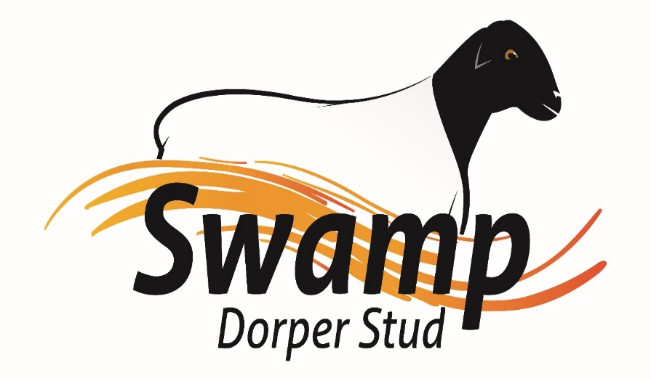
Bruco Accredited 2465
Swamp Dorper Stud along with Bunnerungie White Dorper’s are offering
8 Type 5 Dorper’s Rams
5 Type 5 White Dorper’s, Rams
18 Type 4 Dorper’s, Rams
30 Type 4 White Dorper’s Rams
49 Type 3 Commercial Dorper & White Dorper Rams
Viewing 10:30am Auction starts 1pm interfaced with Auctions plus Agents are Br & C Darren Old
Rebate to agents introduce prior to sale at 3%
B.B.Q Lunch and drinks supplied.
Rams classed and Typed by Danny Teskera
.
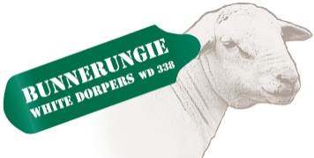
Darren Old 0459 980 591 Phil Larwood 03 50270220
Mikeal Freckleton 0429 948 502

AUCTION SELLING TERMS AVAILABLE AT REGISTRATION OFFICE
Auction terms & Conditions are available at the office on the day of sale.
SALE CATALOGUE DISCLAIMER
All reasonable care has been taken by the vendor, selling agent and publisher to ensure the information provided in this catalogue is correct at the time of publication. However, neither the vendor, selling agent and publisher makes no representations about the accuracy, reliability or completeness of any information provide in this catalogue and do not assume any responsibility for the use or interpretation of the information in the catalogue.
All Rams have been Brucellosis Blood Tested Negative. They also come from a regional biosecurity area. Purchasers need to determine their property status before making purchasers for suitability to their area.

SAFETY DISCLAIMER
The owners, employees and representative of each stud the manager of the venue and selling Agents do not accept liability for any incident that may occur at the venue or surrounds. Although such occurrences are rare any persons attending the Sale or Inspection do so at their own risk.

TRANSIT INSURANCE
Agents will be in attendance to supply Transit Insurance separately upon purchasing livestock with three levels available, Mortality, Accident & Illness with minimum being 14 days Mortality (including Transit).
DELIVERY
We take care in the efficient delivery of all stock after the sale. BR&C Agents will be handling the delivery of all stock at the conclusion of the sale. Swamp Dorper’s will not be delivering any rams this year as COVID 19 makes it to hard
No Stock will be loaded until the sale has been completed.

GUARANTEE
All Rams are guaranteed to breed. Any claim against the breeding ability of an animal purchased should be made within six months of the date of sale. The guarantee covers the purchase value of the Ram. This does not cover the infertility due to injury, misadventure or disease contracted since the sale of the ram. A veterinary certificate may also be requested at the vendor’s discretion. The Ram shall be replaced with an animal of comparable value or credit to the full purchase price will be given at the following sale or on a private sale animal.

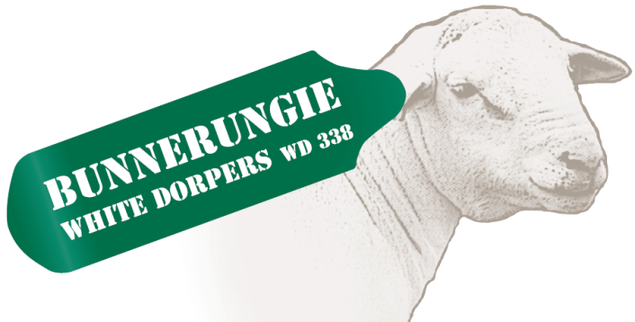

Bruco Accred No Y242

Swamp Dorper Stud & Bunnerungie White Dorpers would like to thank you for attendance and please join us for BBQ lunch & drinks.
We would also like to thank BR&C Agents and Auctions Plus for all their work, and Balaranald Jockey Club also all the hard workers how helped setting up and on the day.

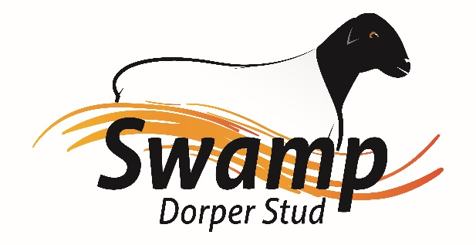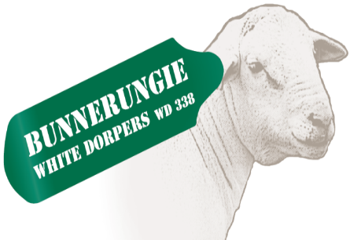

A big thank you to everyone who has helped us put this together.
We look forward to seeing everyone next year for our Ram sale at our new farm 1629 Millewa Road Koorlong Friday 15th October 2021

First numbered even page

