Swamp Dorper & White Dorper Stud & Bunnerungie White Dorper
4th Annual Ram sale
held at Balranald Race Club
FRIDAY 16TH Oct 2020
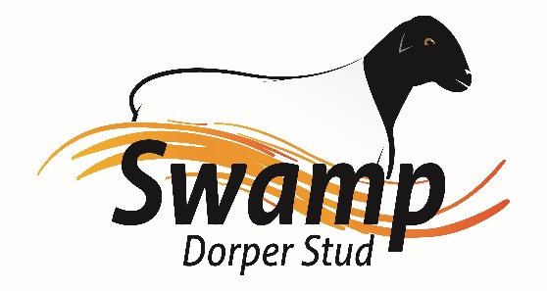
Swamp Dorper Stud along with Bunnerungie White Dorper’s are offering 109 rams
7 Type 5 Dorper Rams
5 Type 5 White Dorper Rams
18 Type 4 Dorper Rams
30 Type 4 White Dorper Rams
49 Type 3 Commercial Dorper & White Dorper Rams
Viewing from 10:30am Auction starts 1pm interfaced with Auctions plus
Agents are BR & C Agents Darren Old
Rebate to agents introduce prior to sale at 3%
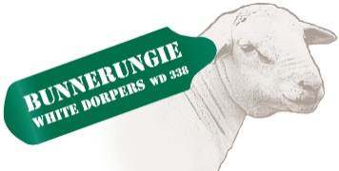
Lunch and drinks supplied.

Darren Old 0459 980 591 Phil Larwood 03 50270220
Mikeal Freckleton 0429 948 502

