SWAMP ROAD DORPER & WHITE DORPER STUD
4th Annual Ram sale held at Balaranald Race Club
FRIDAY 16TH Oct 2020
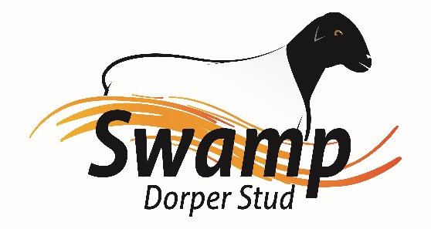
Swamp Dorper Stud along with Bunnerungie White Dorper’s are offering
7 Type 5 Dorper’s Rams
5 Type 5 White Dorper’s, Rams
18 Type 4 Dorper’s, Rams
30 Type 4 White Dorper’s Rams
49 Type 3 Commercial Dorper & White Dorper Rams
Viewing 10:30am Auction starts 1pm interfaced with Auctions plus
B.B.Q Lunch and drinks supplied.

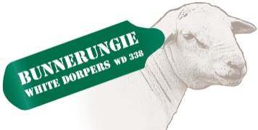
Darren Old 0459 980 591 Phil Larwood 03 50270220
Mikeal Freckleton 0429 948 502

