30th August 2019
Certificate of Pregnancy Diagnosis

On the 30th August 2019 I pregnancy tested 61 commercial Speckle Park heifers for Minnamurra Pastoral Company at “Mt Mill”, Coolah, NSW.
Of these, 46 were found to be pregnant from 5-12 weeks gestation.

Sincerely,
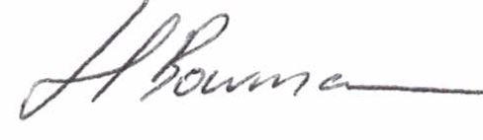
John Bowman BSc BVMS
0418 481 073

